Software Requirements Specification
ComiVerse - A Digital Comic Platform with Integrated Translation and Content Distribution Tools
CVP - Report 3

Project Name | ComiVerse
Vision & Scope Ref | Vision & Scope Document v1.0.0
RTW Ref | SEP490_G37_Report 3.1_RTW
SRS Version | v1.0.0
Date Created | 25/5/2026
Last Updated | 09/08/2026
Authors | Bùi Quang Hiệp - HE171337  Bùi Việt Hùng - HE163146  Chu Tuấn Ngọc - HE186006  Nguyễn Xuân Hanh - HE180944  Đặng Ngọc Thành - HE186611
Reviewer | Lê Thị Tú Kiên - Instructor
Status | Approved

Document Change History
Version | Date | Changes | Author
v1.0.0 | 25/05/2026 | Initial SRS baseline ,do part 0,and part 2 | Bùi Quang Hiệp  Đặng Ngọc Thành
v1.0.0 | 26/05/2026 | Fix part 1 and part 2 | Team Members
v1.0.0 | 28/05/2026 | Add Scenario diagram and fix part 2 | Team Members
v1.0.0 | 02/06/2026 | Add Business Rule and NFR  Fix Part 2 and part 1 | Chu Tuấn Ngọc  Đặng Ngọc Thành  Bùi Quang Hiệp
v1.0.0 | 04/06/2026 | Add Function Description and fix part 2 | Đặng Ngọc Thành
v1.0.0 | 19/06/2026 | Add new part and format from new template  Do part 1 and part 3 | Team Members
v1.1.0 | 1/09/2026 | Update Business Flows, Roles, UCs and Data Requirements | Team Members
v1.1.0 | 2/09/2026 | Update Modules, Screens, APIs and Business Rules | Team Members
v1.1.0 | 3/09/2026 | Revise UC Index and Scenario mappings | Team Members
v1.1.0 | 4/9/2026 | Refine Feature Descriptions and Business Rules | Team Members
v1.1.0 | 5/09/2026 | Update UC traceability and NFRs | Team Members
v1.1.0 | 7/09/2026 | Review Data Requirements and Business Rules | Team Members
v1.1.0 | 8/09/2026 | Finalize Screen, Feature and UC mappings | Team Members

Part 0 — Document Overview

0.1 Document Ecosystem Context
This Software Requirements Specification serves as the primary technical blueprint for the system's development. It bridges the high-level business objectives outlined in the Vision & Scope Document with the actionable execution guidelines detailed in the Project Management Plan .
While Report 1 focuses on the “Why” and Report 2 focuses on the “How” , this document focuses explicitly on the “What.” It defines the detailed functional scenarios, feature descriptions, data requirements, and non-functional requirements (NFRs) necessary to build the proposed solution.

0.2 Companion Documents and Out-of-Scope Content
To maintain a single source of truth and avoid version-control conflicts, this SRS assumes the reader is familiar with its companion documents. The following project information is explicitly NOT duplicated in this SRS and should be referenced in their respective reports:
What is NOT in this SRS — see Report 1 (Vision & Scope):
- Business Context & Justification: Background on the problem space, existing solutions, and high-level expected business contributions .
- High-Level Scope Constraints: Broad project limitations, strategic exclusions, and out-of-scope business features .
What is NOT in this SRS — see Report 2 (Project Management Plan):
- Project Logistics & Timelines: Cost, time estimations, and overarching project risks.
- Execution & Quality Governance: QA processes, training plans, and management methodologies .
- Team Logistics: Responsibility assignments (RACI) and communication plans.
- Infrastructure Management: Configuration management, document repositories, and source code control protocols.

Part 1 — System Overview

1.1 System Objective & Business Context
The system aims to provide a centralized digital comic ecosystem that supports secure multilingual localization, creator-controlled distribution, quality-controlled translation workflows, and integrated monetization services.
For full business context and proposed solution analysis, refer to the Vision & Scope Document (Report 1).

1.2 Technical Scope
Dimension | In Technical Scope | Notes
Modules | User Management; Authentication & Authorization; Comic Discovery & Search; Comic Reader; Personal Library & Reading Progress; Translation Workspace; Project Team Management; Author Publishing; Forum & Community; Notification System; Moderation & Content Governance; Revenue & Wallet Management; Administration & Reporting | Core functional modules of ComiVerse
Integrations | Stripe Sandbox / Payment Gateway API (Read/Write);  Firebase Authentication (Token Verification, User Identity Read/Write);  Cloudinary Media API (Read/Write);  Email Notification Service (Send);  Push Notification Service (Send) | External services integrated with the platform
Tech Stack | Frontend: React + JavaScript + Tailwind CSS; Backend: Firebase Cloud Functions; Database: Cloud Firestore; PostgreSQL: Firebase Auth; Storage: Firebase Storage. | MVP implementation architecture
Data Boundary | Owned by ComiVerse: Users, Roles, Comics, Chapters, Chapter Assets, Translation Projects, Translation Tasks, Translation Groups, Reading History, User Libraries, Comments, Reviews, Forum Threads, Forum Posts, Notifications, Wallet Transactions, Revenue Records, Payout Requests, Reports, Audit Logs | Core business and operational data managed by the system
Excluded (Tech) | Payment transaction settlement; Credit card and banking information storage; Email delivery infrastructure; Push notification infrastructure; Real banking payout execution; External media CDN uptime control | Delegated to external providers. Refer to Vision & Scope limitations and assumptions

a. Context Diagram
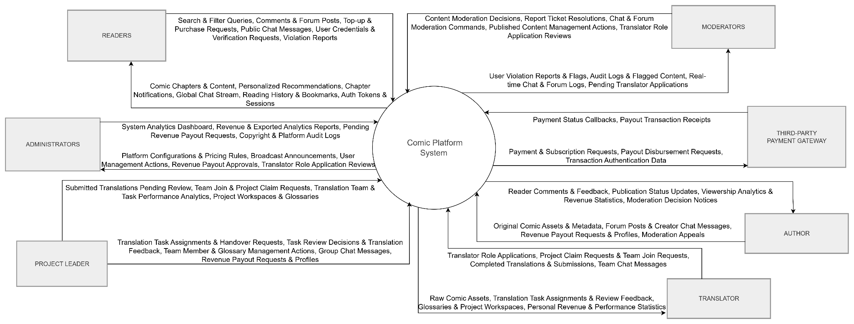

b. Business Flow Index

BF-ID | Flow Name | Primary Actors | Trigger | End Condition
BF-01 | User Authentication & Profile Management | Guest, Reader, Translator, Author, Moderator, Admin | The user authenticates or manages account settings and preferences. | User account and authentication session are successfully managed
BF-02 | Comic Discovery & Reading | Guest, Reader | User searches, browses, or reads comic content | Reading activity and user progress are successfully recorded
BF-03 | Translation Project Management | Translation Project Leader, Translator, Moderator | A translation project is created or localization work is assigned | Localized chapter is completed and submitted for moderation review
BF-04 | Comic Publishing & Moderation | Author, Moderator | Author submits comic content for publication | Content is approved and published or rejected with feedback
BF-05 | Community Interaction & Compliance | Reader, User, Moderator, Admin | User creates comments, forum posts, chat messages, or reports content | Content is moderated and compliance actions are completed
BF-06 | Payment & Revenue Management | Reader, Author, Translator, Admin, Payment Gateway | User purchases premium content or submits a payout request | Payment or payout process is completed and status is recorded
BF-07 | Analytics & Reporting | Author, Translator, Admin, Moderator | User accesses analytics dashboards or exports reports | Analytics information is displayed or exported successfully
BF-08 | Platform Administration | Admin, Moderator | Administrative governance or configuration action is required | Platform configuration and management tasks are completed successfully

1.2.1 BF-01: User Authentication & Profile Management
Trigger: A guest or registered user accesses the platform and performs authentication or profile management activities.
End condition: User account information and authentication session are successfully managed.

Step | Actor | Action | UC-ID
1 | Guest | Logs into the platform | UC-01
2 | User | Verifies email address using OTP when required | UC-04
3 | User | Completes multi-factor authentication if required | UC-03
4 | User | Accesses personal account settings | UC-03
5 | User | Updates profile information and preferences | UC-03
6 | User | Manages notification settings | UC-25
7 | System | Saves updated account preferences | UC-03
8 | User | Logs out of the platform | UC-02

Exception paths:
Invalid credentials: Login denied.
Registration details conflict: (Email/Username already exists) -> System prompts for correction.
MFA validation fails: Authentication rejected.
Multiple failed login attempts: Account temporarily locked.
Session timeout: User must re-authenticate.

1.2.3 BF-02: Comic Discovery & Reading
Trigger: User searches for or selects a comic from the catalog.
End condition: Reading progress and user engagement activities are successfully recorded.

Step | Actor | Action | UC-ID
1 | User | Searches comics using keywords, tags, or filters | UC-05
2 | User | Views comic details and chapter list | UC-06
3 | User | Opens a chapter for reading | UC-07
4 | User | Changes reading mode if desired | UC-08
5 | User | Switches translation version if available | UC-09
6 | Reader | Synchronizes reading progress | UC-10
7 | Reader | Manages bookmarks | UC-11
8 | Reader | Follows comic series | N/A (UC gap)
9 | Reader | Clears selected or all reading history if requested | UC-12
10 | Reader | Views reading history | UC-13
11 | Reader | Views personalized feed | UC-14

Exception paths:
- Premium chapter is locked: Redirect to purchase/subscription upgrade flow (BF-06).
- Comic is unavailable or removed: Access denied, redirect to 404 page.
- Progress synchronization fails: System stores progress locally and retries synchronization.

1.2.4 BF-03: Translation Project Management
Trigger: A translation project is created or localization work is assigned.
End condition: Localized chapter is completed and submitted for moderation review.

Step | Actor | Action | UC-ID
1 | Translation Project Leader | Creates or updates a translation project | UC-15
2 | Translation Project Leader | Manages translation tasks from the chapter backlog | UC-15
3 | Translation Project Leader | Manages project team members and task assignments | UC-41
4 | Translator | Translates chapter content | UC-16
5 | Translator | Sends project communication messages | UC-40
6 | Moderator | Manages translation project teams | UC-42
7 | Translator | Submits completed translation for review | UC-52

Exception paths:
- Simultaneous update conflict detected: System rejects outdated save and requires reload.
- Translator removed from project: Assigned tasks returned to backlog / reassigned.
- Required source assets/raws are missing: Translation cannot proceed, ticket opened.
- Project violates platform rules: Returned/flagged for correction.

1.2.5 BF-04: Comic Publishing & Moderation
Trigger: Author submits comic content for publication.
End condition: Content is approved and published or rejected.

Step | Actor | Action | UC-ID
1 | Author | Creates or updates comic information | UC-17
2 | Author | Uploads or manages a chapter | UC-18
3 | System | Adds submitted content to the moderation queue | UC-19
4 | Moderator | Reviews submitted content | UC-19
5 | Moderator | Approves or rejects publication request | UC-19
6 | System | Records and sends publication status result | UC-19

Exception paths:
- Content violates platform policies: Rejected, status updated, reason recorded.
- Upload validation fails: (Invalid file types, size limits) -> Author must resubmit.
- Moderator requests revisions: Content status set to "Revision Needed", returned to author.

1.2.6 BF-05: Community Interaction & Compliance
Trigger: User creates comments, forum posts, chat messages, or reports content.
End condition: Community content is moderated and compliance actions are completed.

Step | Actor | Action | UC-ID
1 | Reader | Rates and likes a comic series | UC-20
2 | Reader | Creates, edits, or deletes personal comments | UC-21
3 | User | Creates a forum thread or reply | UC-22
4 | User | Manages owned forum posts | UC-23
5 | User | Sends public community chat messages | UC-39
6 | Translator | Sends project team messages | UC-40
7 | Reader | Reports violating content | UC-26
8 | Moderator | Manages forum content | UC-24
9 | Moderator | Manages community chat moderation | UC-46
10 | Moderator / Project Leader | Reviews and resolves report tickets | UC-27
11 | System | Records moderation result notification/status | UC-27

Exception paths:
- Spam or abusive content detected: Content automatically hidden, user warned.
- Invalid report submission: Ticket closed without action.
- Severe policy violation: Account suspended/banned by Moderator.

1.2.7 BF-06: Payment & Revenue Management
Trigger: User purchases premium content or submits a payout request.
End condition: Payment or payout process is completed successfully.

Step | Actor | Action | UC-ID
1 | Reader | Selects an available premium subscription plan | UC-29
2 | Reader | Initiates payment transaction | UC-29
3 | Payment Gateway | Processes payment request | UC-29
4 | System | Activates the premium subscription period after successful payment | UC-29
5 | User | Views transaction history | UC-31
6 | Author or Translator | Sets up and verifies payout profile | UC-57
7 | Author or Project Leader | Submits payout request | UC-30
8 | Admin | Reviews payout request | UC-44
9 | Admin | Approves, rejects, or completes payout | UC-44
10 | System | Records payout status and related notification | UC-44

Exception paths:
- Payment transaction fails: Content remains locked, user urged to retry.
- Payment gateway unavailable: Transaction postponed, error message displayed.
- Payout threshold not reached: Request cannot be submitted.
- Invalid payout details: Admin rejects request, comments added.

1.2.8 BF-07: Analytics & Reporting
Trigger: Creator, moderator, or administrator accesses analytics information.
End condition: Analytics data is displayed or exported successfully.
Step | Actor | Action | UC-ID
1 | Author or Translation Project Leader | Opens content performance analytics | UC-33
2 | Author or Project Leader | Views content performance metrics | UC-33
3 | Author or Translator | Views revenue statistics | UC-34
4 | Author, Translator, Admin, Moderator,  Project Leader | Exports analytics reports | UC-35

Exception paths:
- No analytics data available: Empty dashboard/charts displayed.
- Export generation fails: User receives error notification.
- Data aggregation service unavailable: Metrics temporarily unavailable.

1.2.9 BF-08: Platform Administration
Trigger: Administrative governance or configuration action is required.
End condition: Platform configuration and management tasks are completed successfully.

Step | Actor | Action | UC-ID
1 | Moderator | Manages content tags and genres | UC-36
2 | Admin | Manages user accounts | UC-37
3 | Admin | Reviews translator role applications | UC-48
5 | Moderator | Manages published platform content | UC-43
6 | Admin | Broadcasts platform announcements | UC-28

Exception paths:
- Insufficient permissions: Action denied, security log recorded.
- Validation errors detected: Changes not saved.
- Configuration conflict detected: Latest valid configuration retained.

1.3 System Roles
Role | Access Level | Primary Feature Areas
Guest | Public | Browse comic catalog, search titles, read free chapters, view public forum threads, and register a new user account.
Reader | Internal | All Guest actions, plus managing personal library, bookmarking progress, writing forum, posts comments and unlocking premium chapters.
Translator | Internal | All Reader actions, plus accessing the collaborative Localization Workspace, uploading localized comic chapters, and tracking dashboard analytics.
Project Leader | Internal | Provides all Translator functionalities, plus project team management, payroll management, and task assignment for project members.
Author | Internal | The Author module enables creators to create official comic series, upload original comic chapters, and protect their digital copyrights. It provides a secure platform for managing original works while preserving ownership and intellectual property rights.
Moderator | Internal | The Moderator module provides advanced administrative tools for platform governance, translation quality auditing, and scanlation team onboarding. It features a multi-stage validation pipeline that allows managers to perform side-by-side quality checks on localized text layers against original raw panels before public release.
Admin | Internal | Full system backend access, configuring system settings, managing global roles/permissions, onboarding translation groups/authors, and manual financial reconciliation for wallet deposits/payouts.

1.4 Use Case Diagrams

a. UCs for Guest
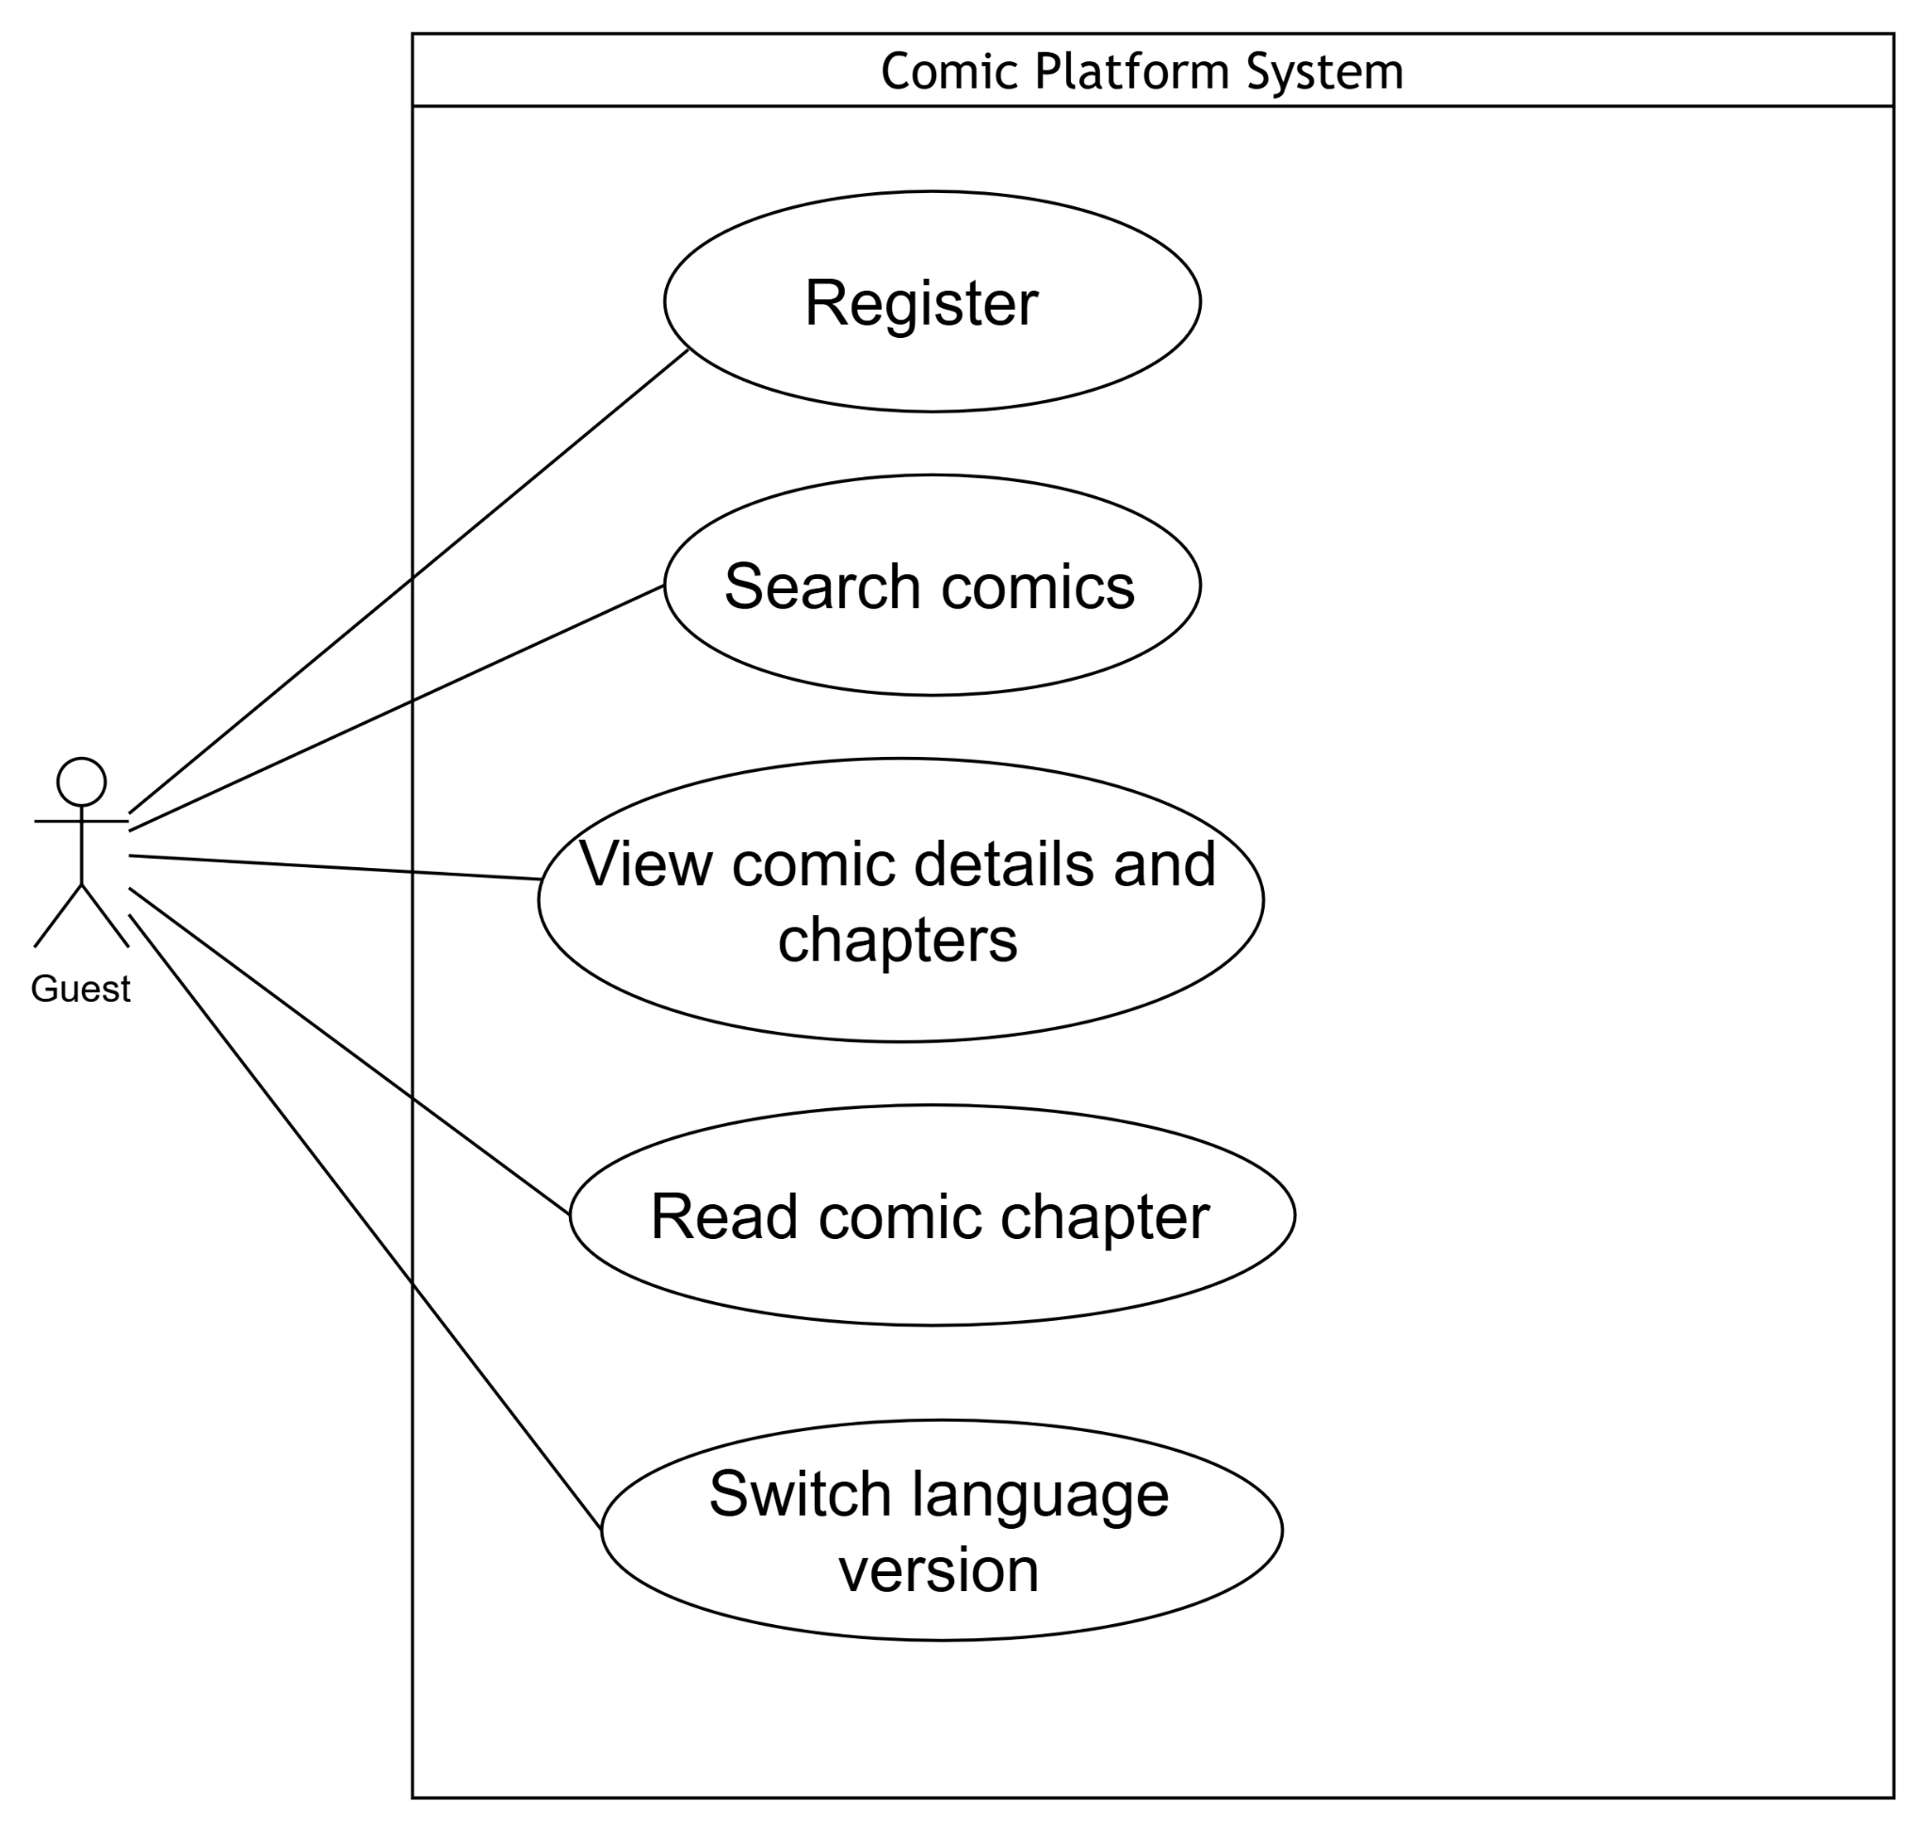

b. UCs for Logined_User
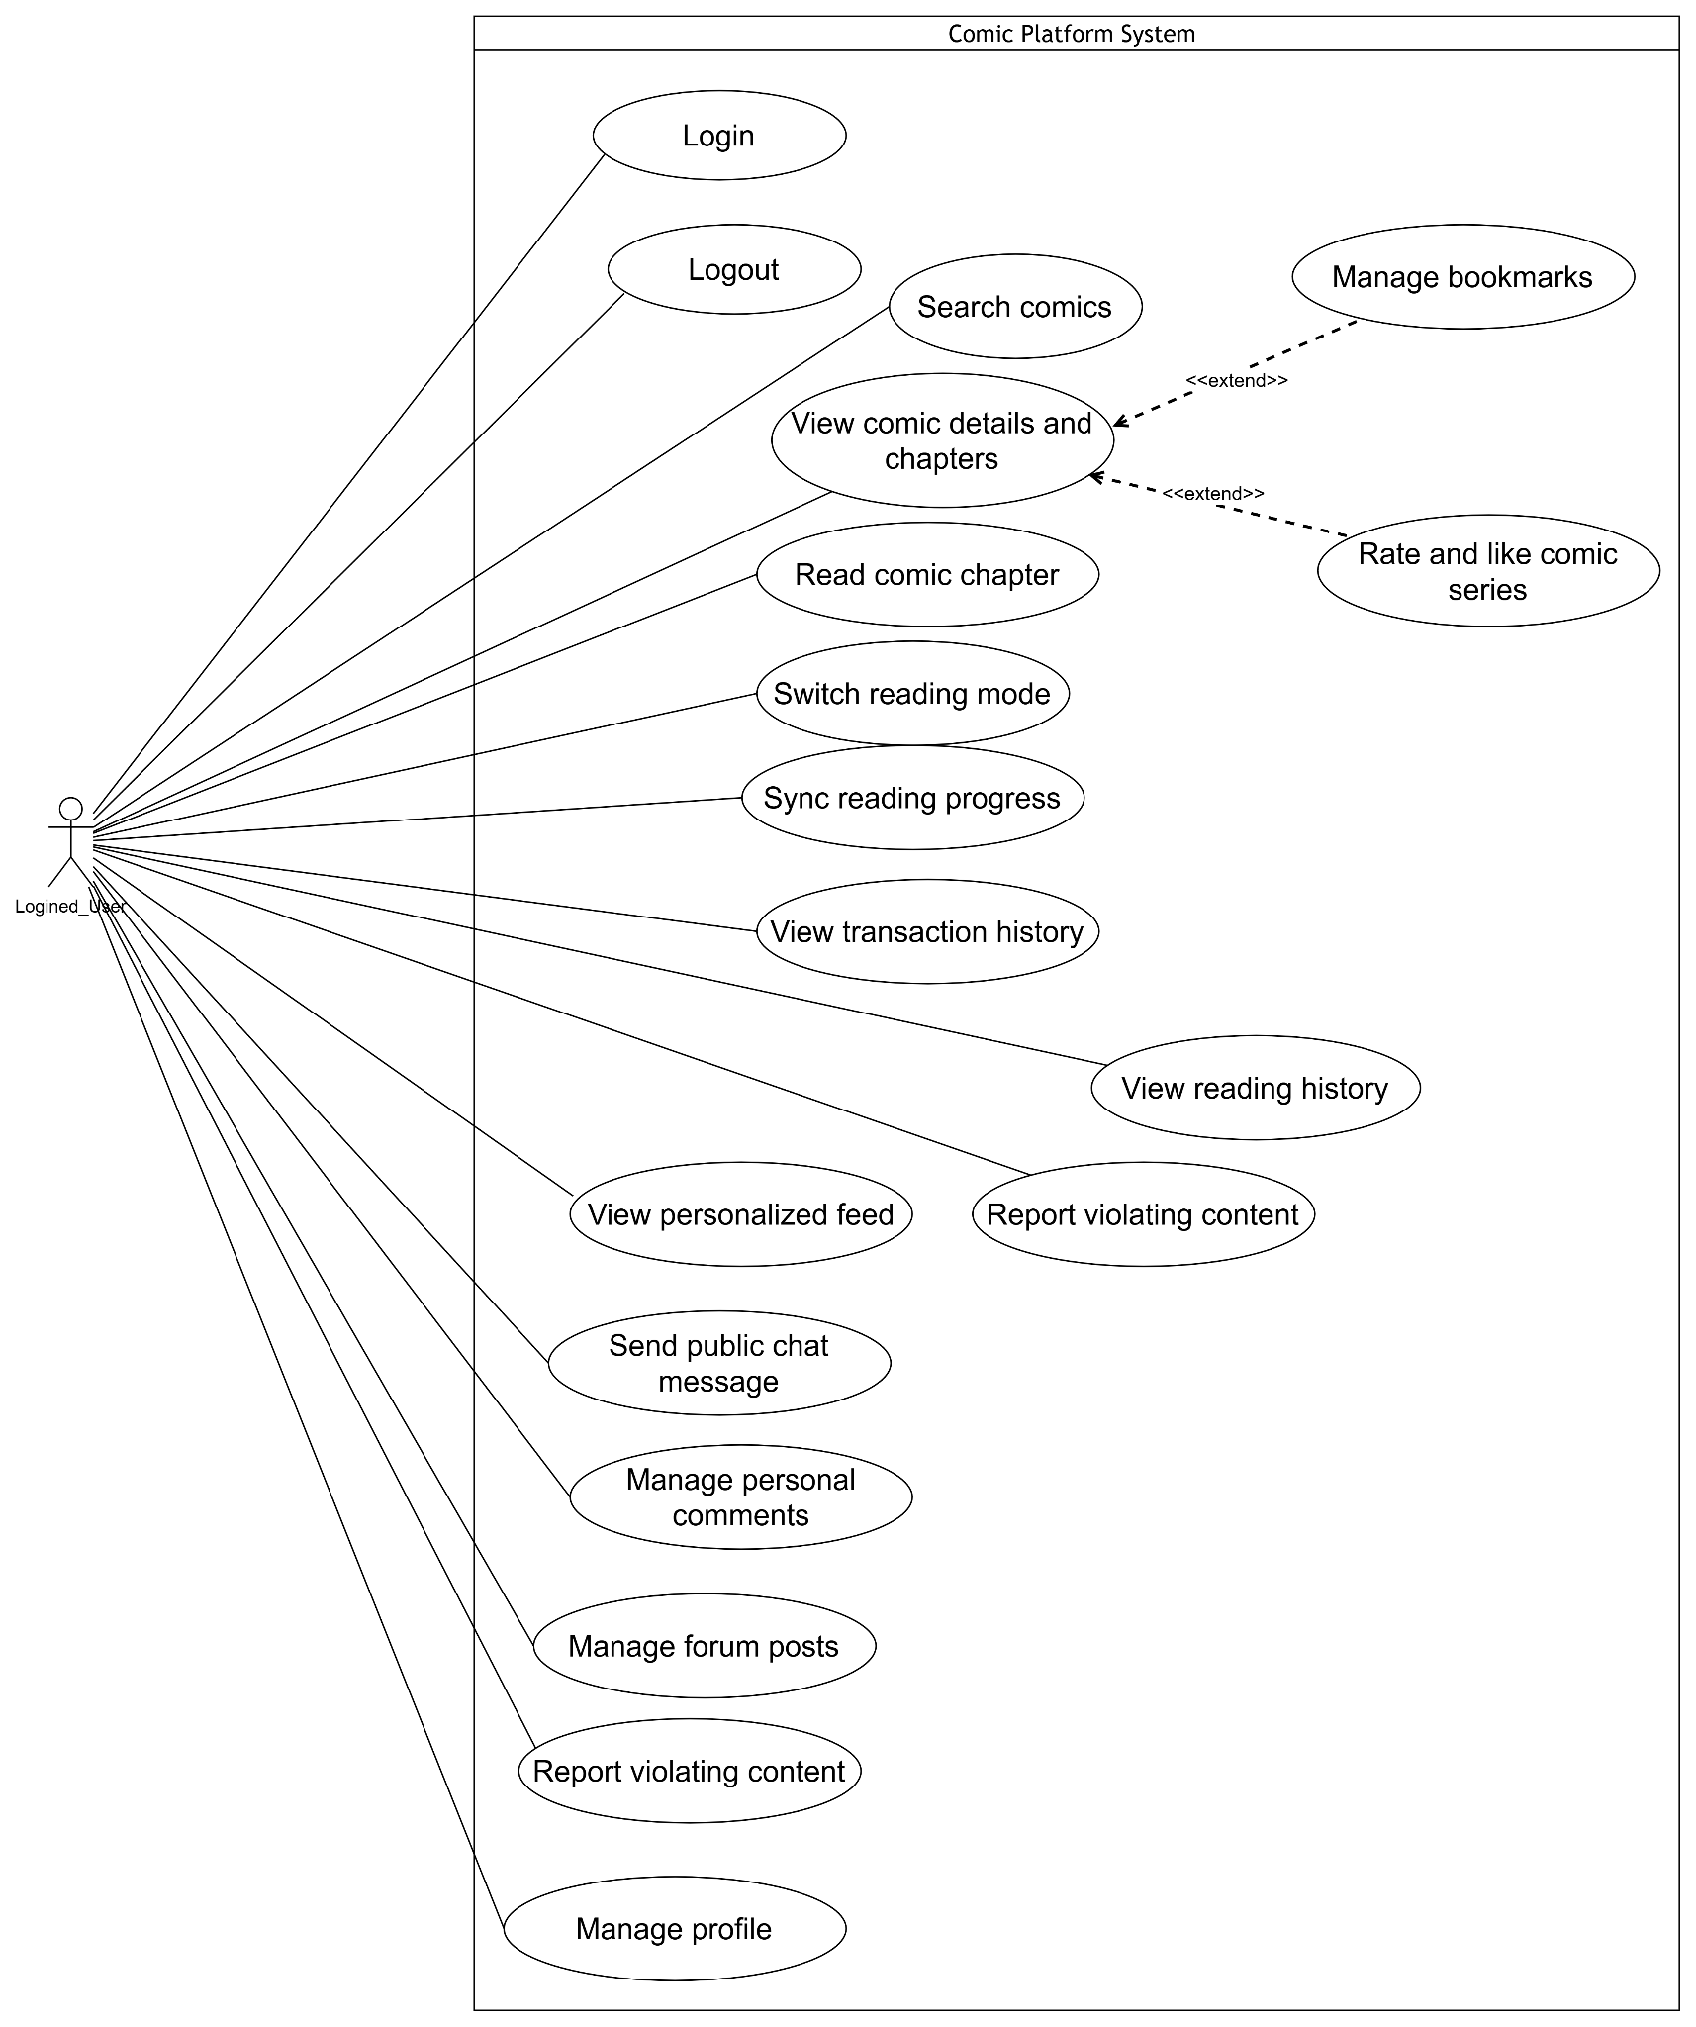

c. UCs for Reader
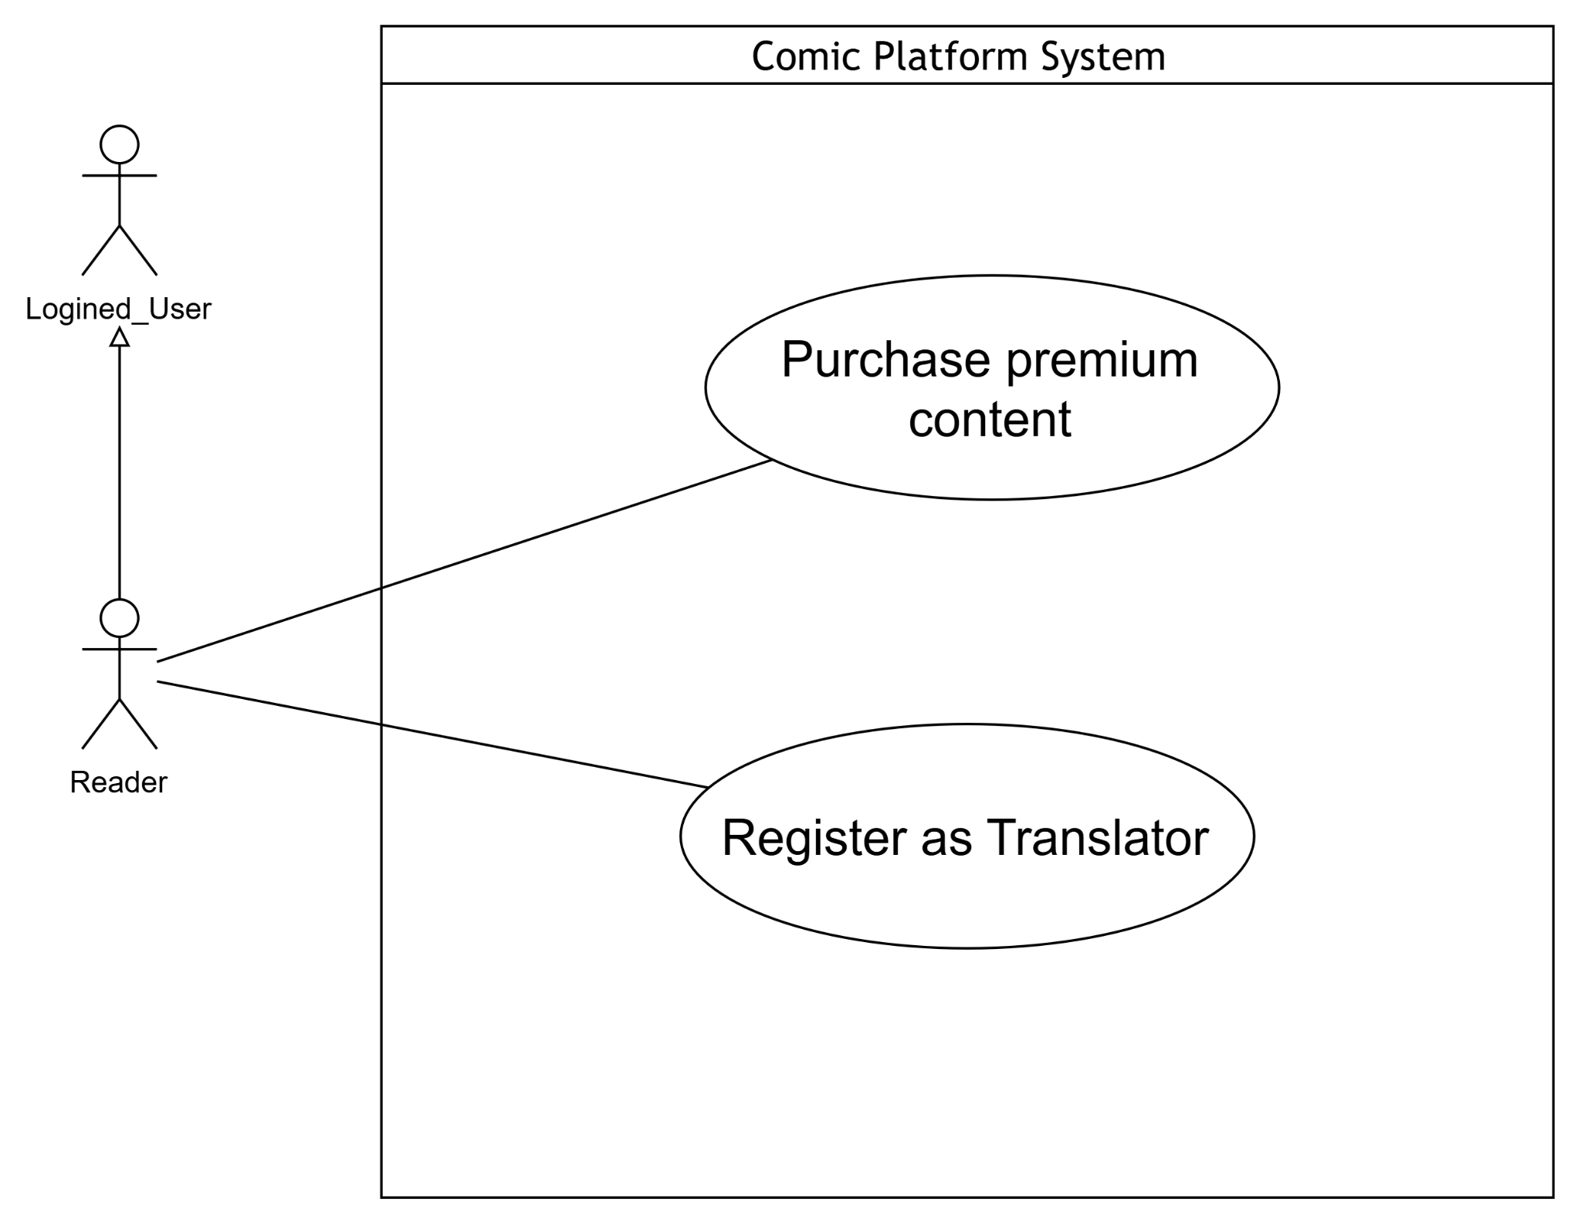

d. UCs for Translator
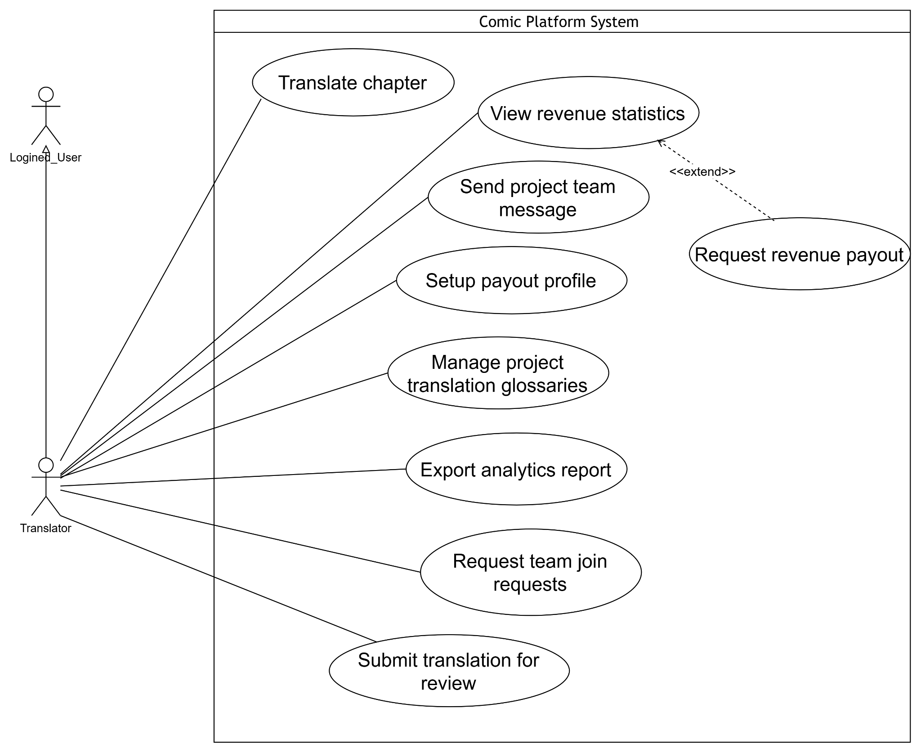
e. UCs for Project Leader
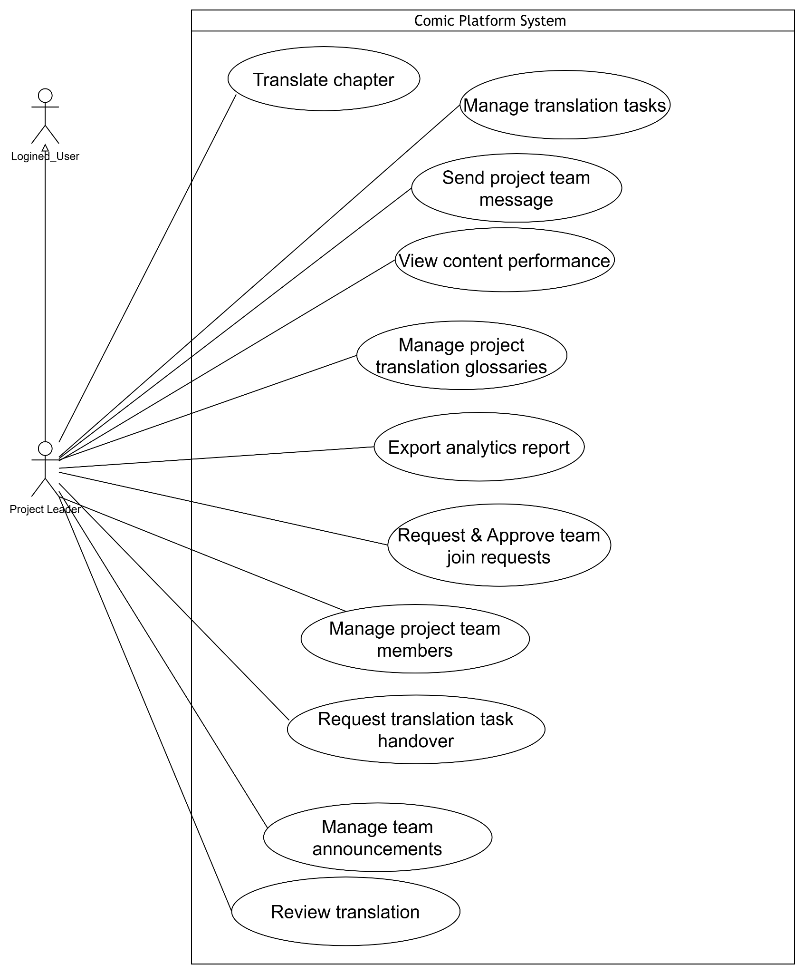

f. UCs for Author
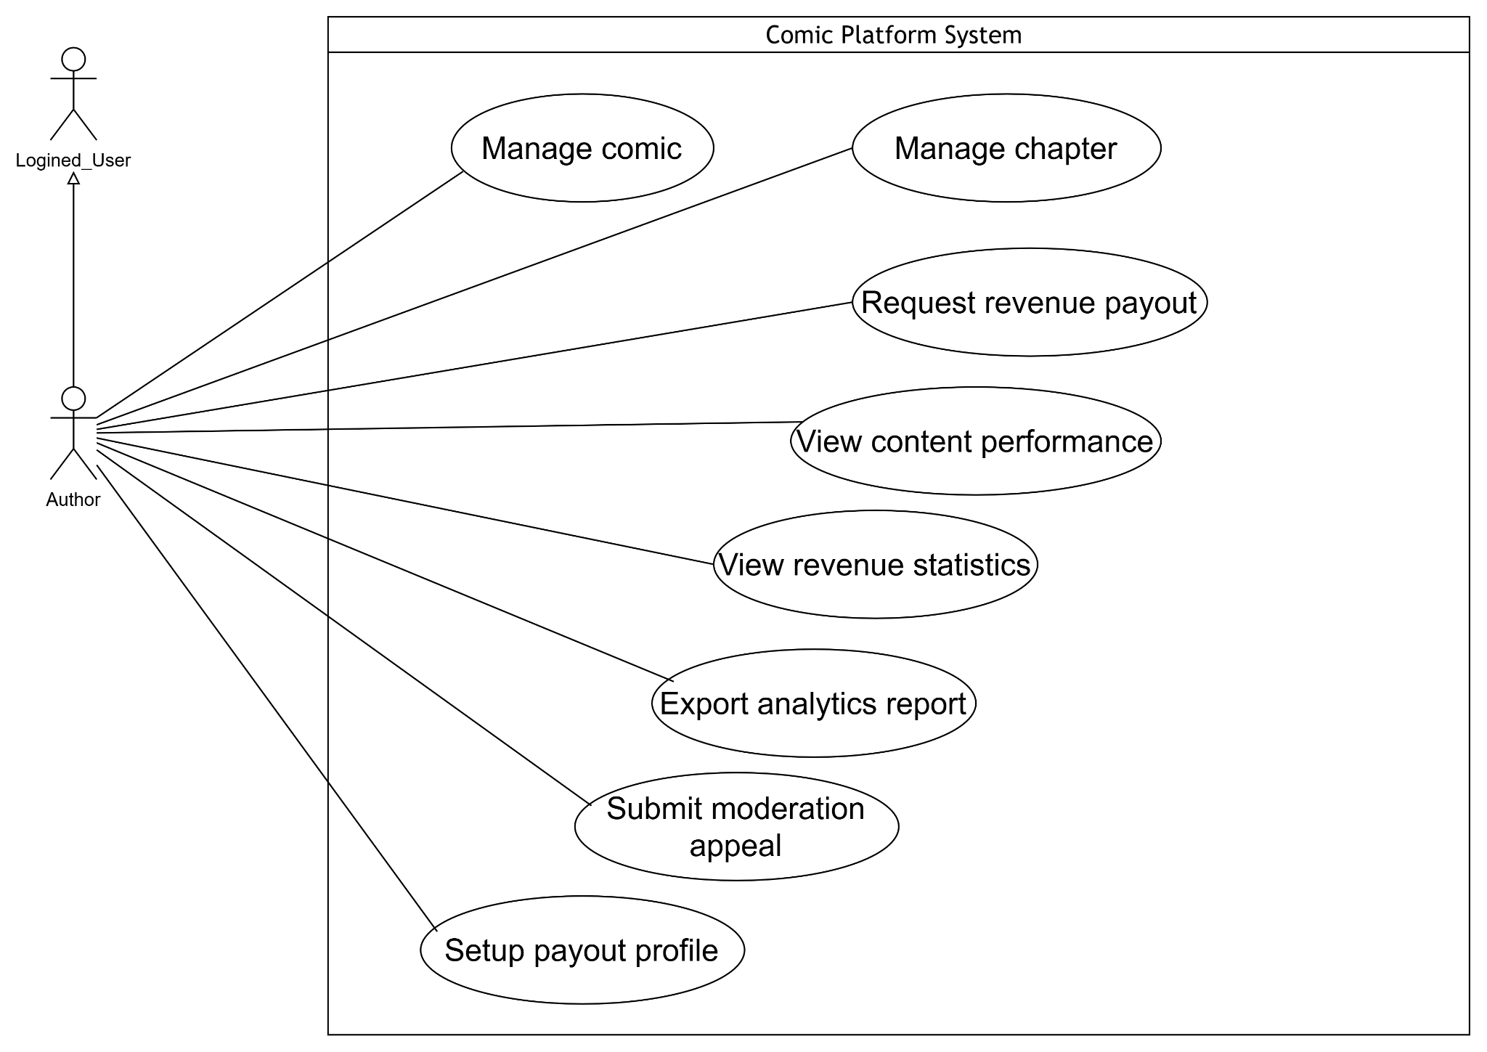

g. UCs for Moderator
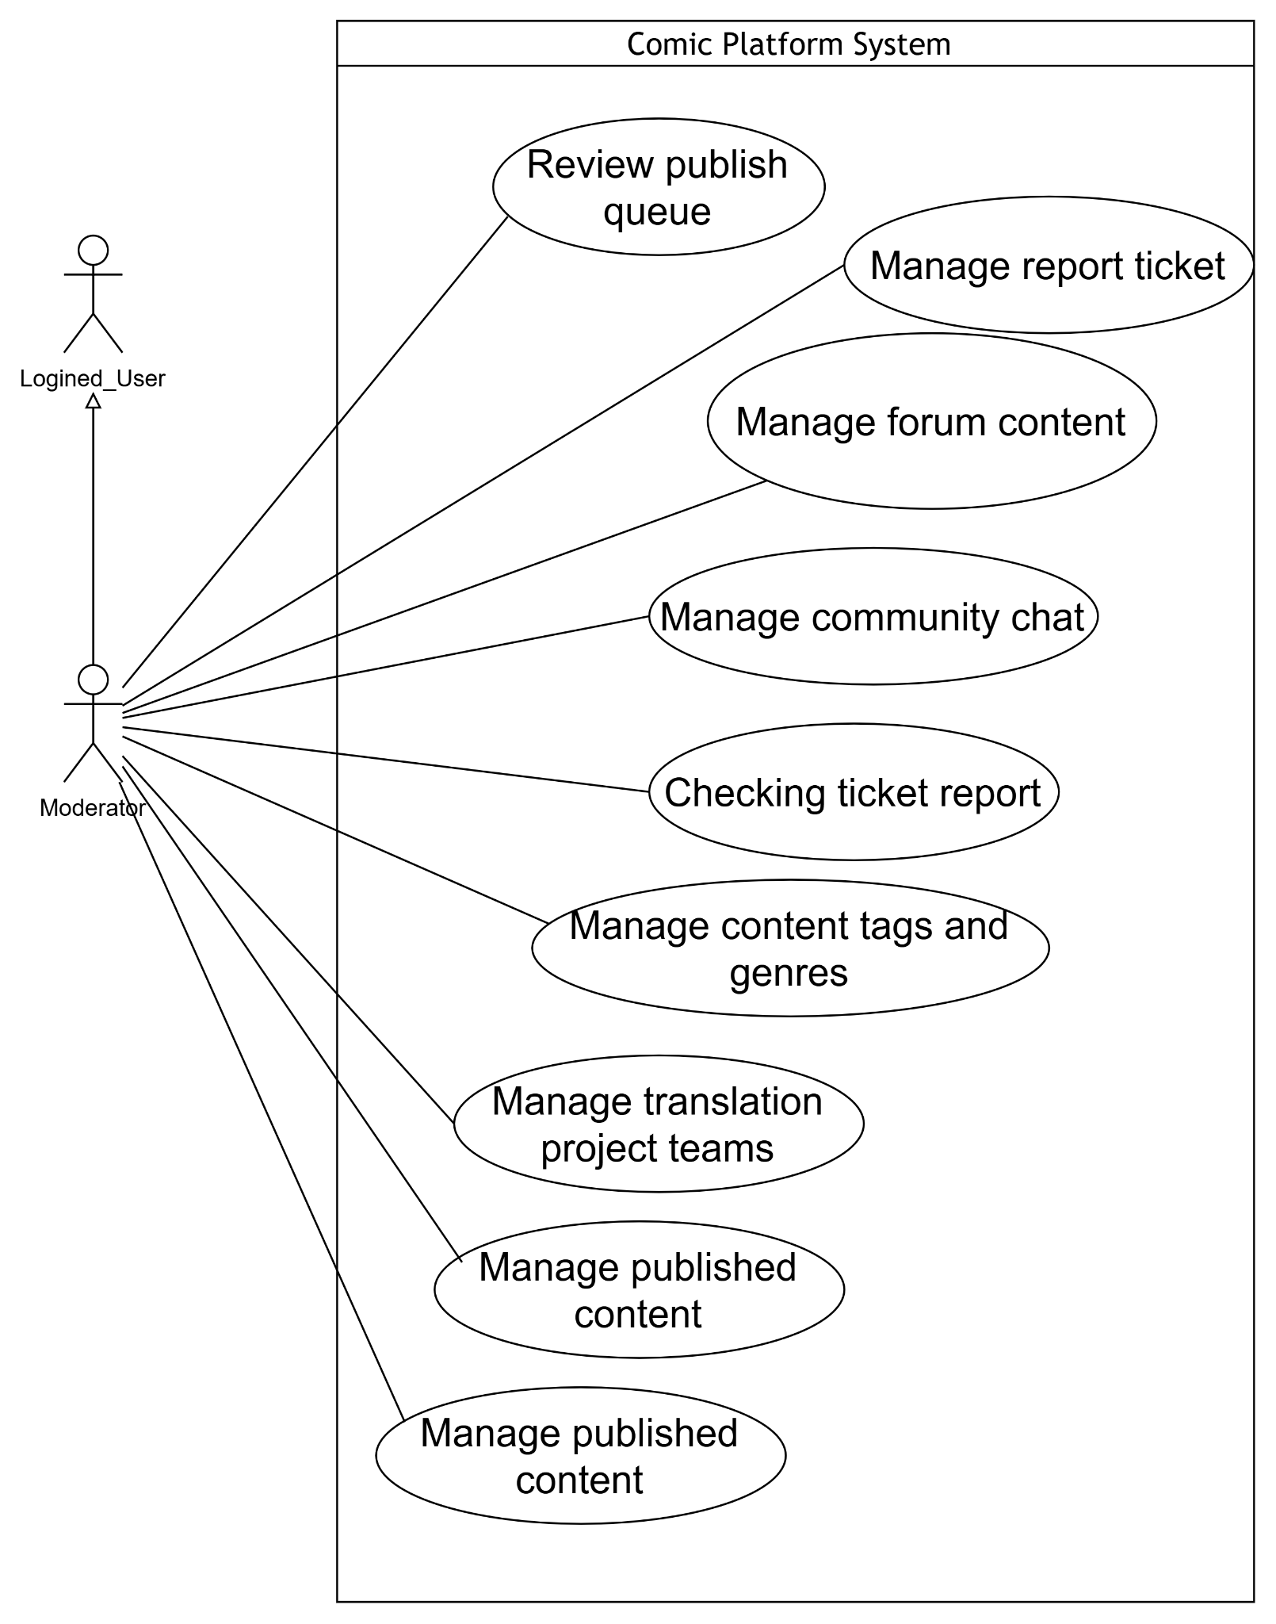

h. UCs for Admin
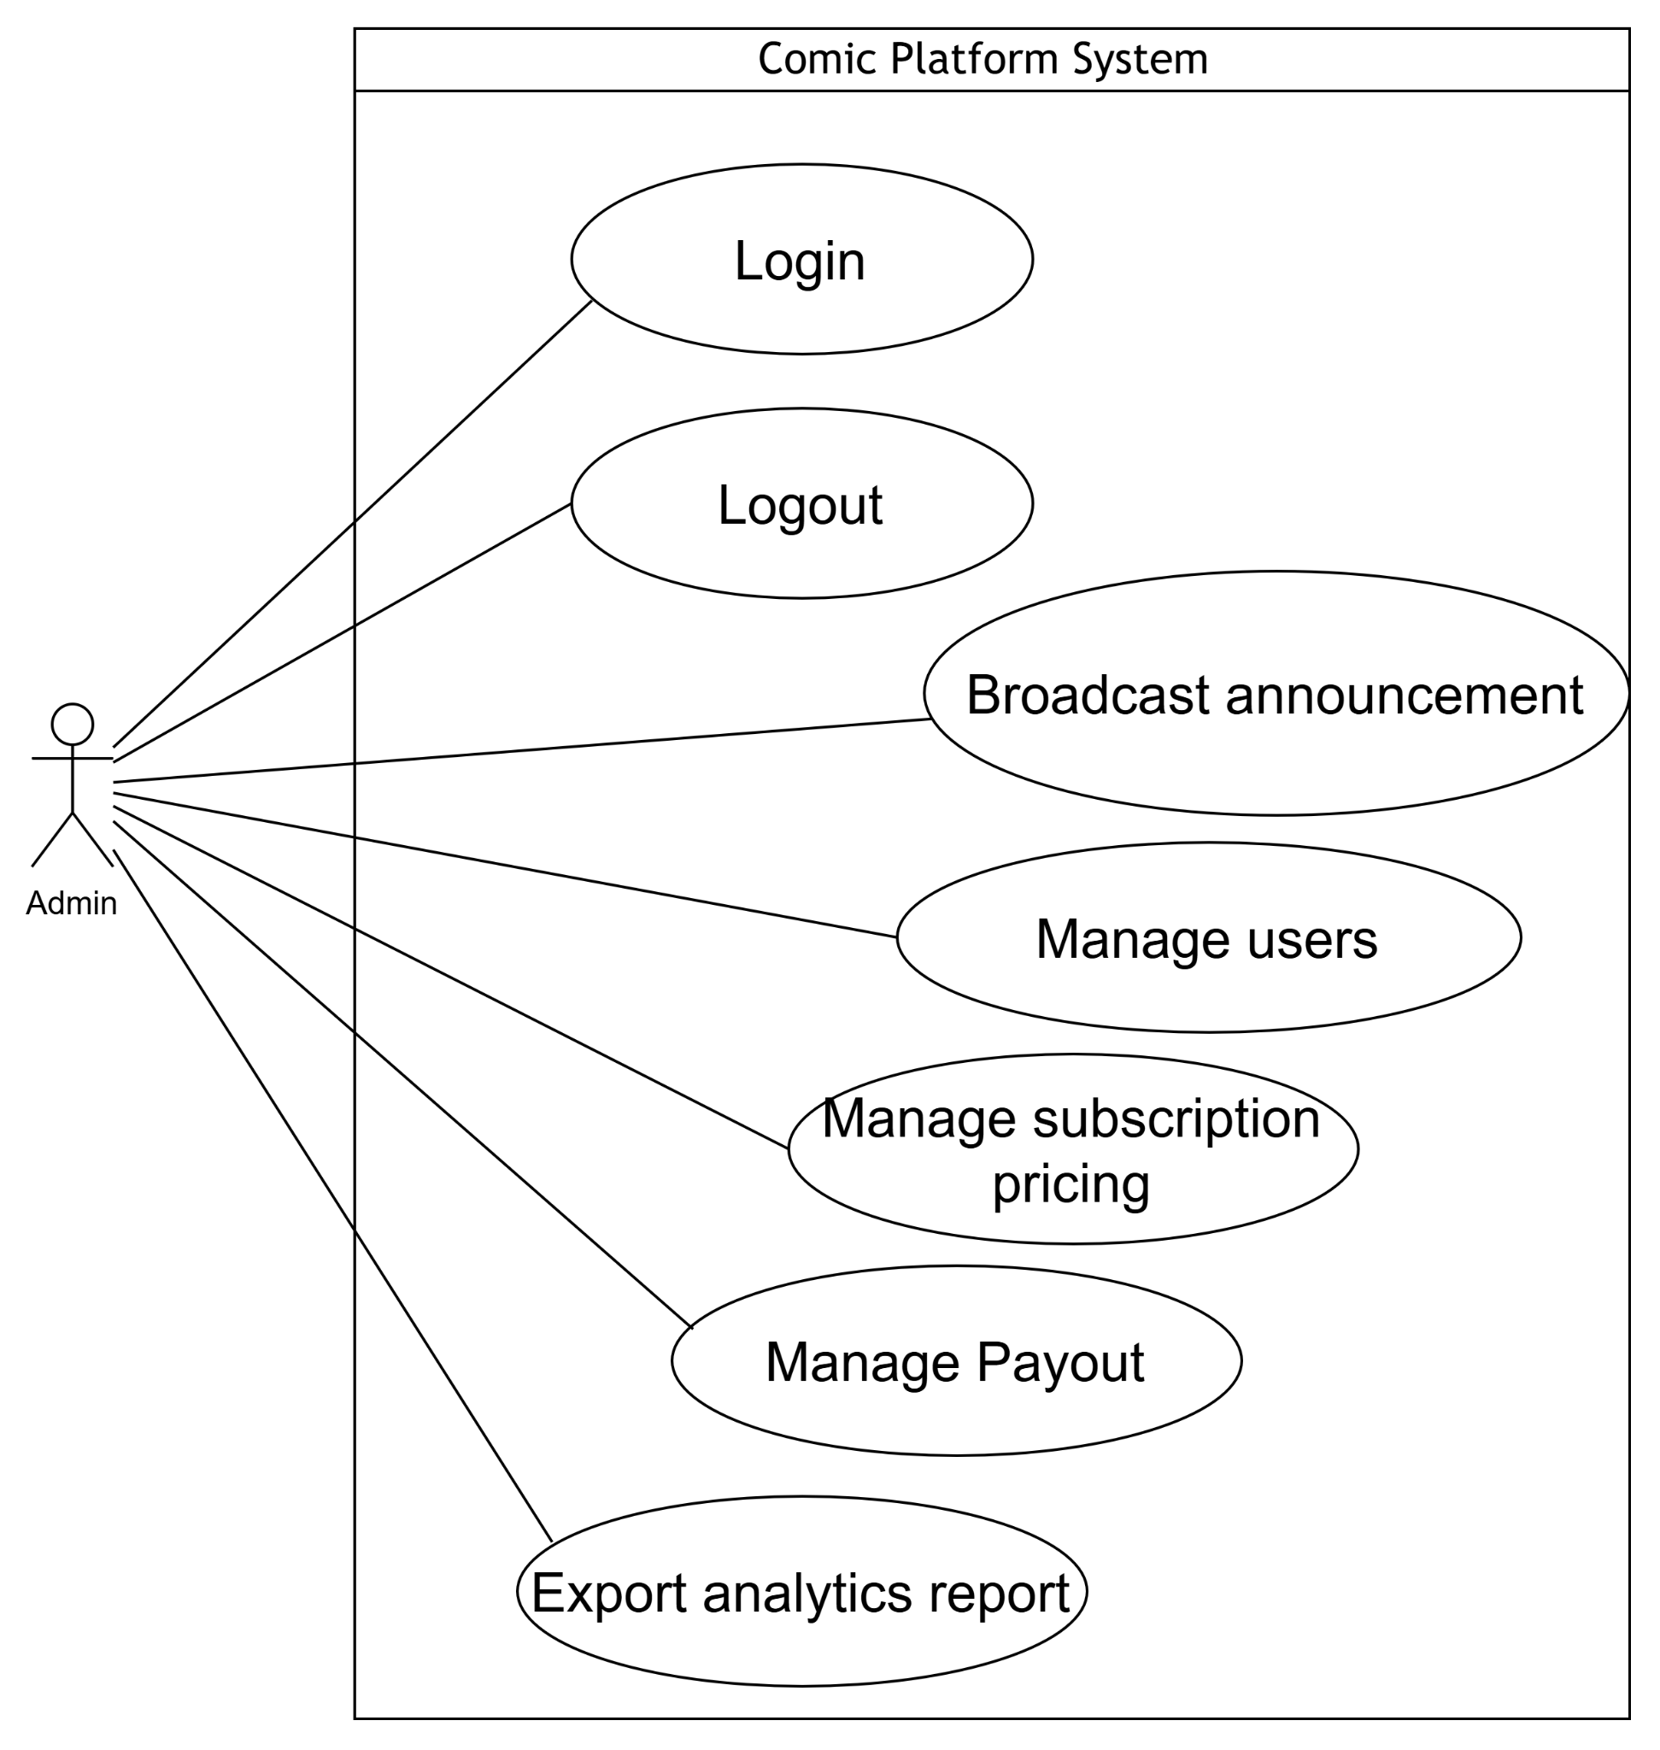

1.5 Use Case Index

UC-ID | Use Case Name | Type | Primary Actor | Description
Reader & General User
UC-01 | Log in | UI | Guest | Allows guests to log in and start a secure authentication session.
UC-02 | Log out | UI | User | Terminates the current authentication session securely.
UC-03 | Manage profile | UI | User | Allows users to view and update personal profile information and settings.
UC-04 | Verify email address | UI | User | Verifies a newly registered account via an email OTP.
UC-05 | Search comics | UI | User | Interface to search, filter by tags/genres, and sort the comic catalog.
UC-06 | View comic details and chapters | UI | User | Shows full comic metadata, summary, and the paginated chapter list.
UC-07 | Read comic chapter | UI | User | The primary viewer interface for reading comic chapter images.
UC-09 | Switch language version | UI | User | Allows readers to switch between available translations within the viewer.
UC-10 | Sync reading progress | System | User | Background process that saves the user's latest reading position.
UC-11 | Manage bookmarks | UI | Reader | Manages saved bookmarks within the user's personal library.
UC-12 | Clear reading history | UI | Reader | Allows readers to delete specific or all past reading history records.
UC-13 | View reading history | UI | Reader | Tracks and displays the user's past reading history.
UC-14 | View personalized feed | UI | Reader | Landing page displaying personalized content and updates for followed series.
UC-20 | Rate and like comic series | UI | Reader | Allows readers to submit star ratings and like comic series.
UC-21 | Manage personal comments | UI | Reader | Allows users to create, edit, or delete their own comments on comics.
UC-22 | Create forum thread & replies | UI | User | Allows users to post new discussion threads and reply in the forum.
UC-23 | Manage forum posts | UI | User | Allows users to edit or soft-delete their own forum threads and replies.
UC-25 | Manage notification settings | UI | User | Allows users to configure email and in-app notification preferences.
UC-26 | Report violating content | UI | Reader | Allows readers to report inappropriate comics, chapters, or comments.
UC-29 | Subscribe to premium plan | UI | Reader | Screen to purchase or extend a premium subscription plan.
UC-31 | View transaction history | UI | User | Displays the user's past financial records (payments and payouts).
UC-32 | Register account | UI | Guest | Interface for new users to create an account on the platform.
UC-39 | Send community chat message | UI | User | Allows users to send messages in the public World Chat.
UC-45 | Reset password | UI | Guest | Allows users to recover account access by resetting their password via OTP.
UC-50 | Register as Translator | UI | Reader | Allows readers to apply for the Translator role.
Author
UC-17 | Manage comic | UI | Author | Central view for an author to create, edit, or archive their comic series.
UC-18 | Manage chapter | UI | Author | Form to submit, edit, replace, or delete chapter assets before moderation.
UC-30 | Request revenue payout | UI | Author | Interface to manage revenue withdrawals and request payouts.
UC-33 | View content performance | UI | Author | Analytics overview showing chapter retention and engagement metrics.
UC-34 | View revenue statistics | UI | Author | Displays income summary and financial statistics for authors/translators.
UC-35 | Export analytics report | UI | Author | Compiles and exports analytics data into a downloadable CSV/XLSX file.
UC-54 | Submit moderation appeal | UI | Author | Allows authors to appeal a rejected submission decision.
UC-57 | Setup payout profile | UI | Author, Translator | Creates and verifies a Stripe Connect payout profile for revenue withdrawals.
Translator
UC-16 | Translate chapter | UI | Translator | Interface to map translated text layers and manage glossaries in the Studio.
UC-40 | Send project team message | UI | Translator | Allows translators to chat internally within a project workspace.
UC-49 | Request & Approve team join requests | UI | Translator | Allows translators to apply to recruiting teams (and leaders to approve).
UC-51 | Claim translation project | UI | Translator | Allows eligible translators to claim an available project from the Job Pool.
UC-52 | Submit translation for review | UI | Translator | Submits a completed translation task to the Project Leader for review.
Project Leader
UC-15 | Manage translation tasks | UI | Project Leader | Allocates chapter backlog into tasks and assigns them to team translators.
UC-41 | Manage project team members | UI | Project Leader | Manage user assignments and remove members from a project team.
UC-47 | Manage project translation glossaries | UI | Project Leader | Creates and manages localized glossary terms for a specific project.
UC-53 | Review translation | UI | Project Leader | Approves translator work (triggering payout) or requests changes.
UC-55 | Manage team announcements | UI | Project Leader | Creates, edits, pins, likes, or deletes team announcements and manages comments.
UC-56 | Request translation task handover | UI | Project Leader | Reassigns a translation task to a new translator while preserving completed work for fair revenue split.
Moderator
UC-19 | Review publish queue | UI | Moderator | Screen to approve or reject content submitted by creators.
UC-24 | Manage forum content | UI | Moderator | Control panel to lock, hide, or remove violating forum discussions.
UC-27 | Manage report ticket | UI | Moderator | Reviews user violation reports and marks tickets as resolved/closed.
UC-36 | Manage content tags and genres | UI | Moderator | Main overview to create, update, or deprecate catalog taxonomies.
UC-42 | Manage translation project teams | UI | Moderator | Establish official translation projects and assign Project Leaders globally.
UC-43 | Manage published content | UI | Moderator | Administrator/Moderator view to quarantine or hide violating comics.
UC-46 | Manage community chat | UI | Moderator | Monitors live chat, warns users, and updates the banned keyword dictionary.
UC-48 | Review translator role applications | UI | Moderator | Approves or rejects incoming applications for the Translator role.
Administrator
UC-28 | Broadcast announcement | UI | Admin | Tool to create and push global platform announcements to all users.
UC-37 | Manage users | UI | Admin | Interface to view, elevate roles, or ban user accounts globally.
UC-38 | Manage subscription pricing | UI | Admin | Top-level console to configure premium plans and token exchange rates.
UC-44 | Manage Payout | UI | Admin | Queue for admins to manually approve creator and translator payouts.

1.6 Glossary
Term | Definition | Used in
AC-xx | Acceptance Criterion — a positive, testable condition for feature completion. | All FT-xx
NAC-xx | Negative Acceptance Criterion — failure/rejection/boundary-breach test condition. | All FT-xx
BV-xx | Boundary Value note — defines valid/invalid ranges for a specific constraint. | All FT-xx
BR-xx | Business Rule ID — A unique identifier mapping a feature constraint back to its formal policy definition maintained in RTW.xlsx Sheet 6. | All FT-xx, Part 6
DC-xx | Data Constraint ID — A low-level data integrity rule enforced at the database layer (e.g., database uniqueness, non-null fields, cascading deletions). | Part 5.2
NFR-xx | Non-Functional Requirement ID — A measurable quality constraint governing system performance, security, availability, or resource metrics. | Part 1.2, Part 7
UC-xx | Use Case Identifier — Represents a distinct user or system interaction sequence. | Part 1.4, Part 1.5, Part 2
FT-xx | Feature Identifier — Maps to specific functional modules and system capabilities. | Part 1.7, Part 3.1, Part 4
FE-xx | Vision & Scope Feature Identifier — The original high-level feature reference from the V&S Document. | Part 1.7, Part 4
BF-xx | Business Flow Identifier — Denotes a high-level sequence of steps achieving a core business objective. | Part 1.2b
SC-xx | Scenario Identifier — Maps to narrative user stories and activity workflows. | Part 2
SCR-xx | Screen Identifier — Represents a distinct user interface layout or page. | Part 3.2
API-xx | External API Identifier — Denotes a third-party service integration endpoint. | Part 3.3
JOB-xx | Background Job Identifier — Represents an automated or scheduled backend task. | Part 3.4
SRS | Software Requirements Specification — The primary technical blueprint document detailing system requirements. | Part 0.1
RTW | Requirements Traceability Workbook — The companion spreadsheet for tracking detailed matrices and logs. | Part 0.2, Appendix A
RBAC | Role-Based Access Control — The security framework restricting system access based on user roles. | Part 7.4
2FA / MFA | Two-Factor Authentication / Multi-Factor Authentication — Required secondary security verification for privileged accounts. | Part 4 (FT-01), Part 7.4
PII | Personally Identifiable Information — Sensitive user data protected by privacy laws and encrypted at rest. | Part 7.4, Part 7.7
GDPR | General Data Protection Regulation — Data privacy framework regulating the collection and processing of personal data. | Part 4 (FT-16), Part 7.7

1.7 Feature Traceability Bridge
V&S Feature | Feature Name in V&S | Maps to SRS | Status
FE-01 | Comic Reading System | FT-09 | Pending
 |  | FT-10 | Pending
 |  | FT-11 | Pending
FE-02 | Translation Management | FT-08 | Pending
FE-03 | Translation Project Team Member Management | FT-05 | Pending
 |  | FT-06 | Pending
 |  | FT-07 | Pending
FE-04 | Comic Management | FT-04 | Pending
 |  | FT-03 | Pending
FE-05 | Forum & Real-time Chat System | FT-13 | Pending
FE-06 | Notification & Compliance Audit Core | FT-14 | Pending
 |  | FT-15 | Pending
FE-07 | Payment Management | FT-16 | Pending
FE-08 | Comic Statistic | FT-17 | Pending
FE-09 | Platform Management Subsystem | FT-18 | Pending
FE-10 | User Management Subsystem | FT-01 | Pending
 |  | FT-02 | Pending

Part 2 — Scenario / Narrative

SC-01 — Reader customizes reading experience and saves reading progress
Business Flow | Reader interacts with the comic viewer, synchronizes progress, and switches between multiple translation versions.
Primary Actor | Reader
Pre-condition | The reader is authenticated with an active session. The targeted comic chapter has been published and contains multiple translation group forks.
Post-condition | The reader successfully reads the chapter with the selected translation version, and their last read position is saved directly to the system database.
Related Feature | FT-01, FT-10, FT-11
Related UC | UC-01, UC-06, UC-07, UC-08, UC-09, UC-10, UC-13

Narrative:
Minh is commuting home and opens the ComiVerse mobile web app to read "Solo Leveling". He accesses the chapter and begins reading vertically. As he reads down to page 5, he feels the current translation style is too formal. Without leaving the viewer, Minh opens the reading toolbar and selects the "Switch Language Translation Version" option. He selects an alternative fan-translation group. The system dynamically swaps the image text layers for the new group's version while retaining his exact scroll position on page 5.
Wanting to compare specific terminology, Minh later activates the continuous vertical scroll mode to streamline his view. Once he finishes reading and closes the browser application, the frontend captures his final reading coordinates . The Backend processes this event and securely updates his progress record in the data schema, ensuring he can check his history and resume from the exact spot on his desktop computer later.
Key Exception Flows:

- [Trigger - Network Disruption]: The user attempts to switch versions while experiencing temporary internet loss — The system displays a localized toast message "Connection lost. Retrying to load selected version..." while retaining the already-cached default panels on screen — The user can continue reading the previously loaded version without a broken UI.
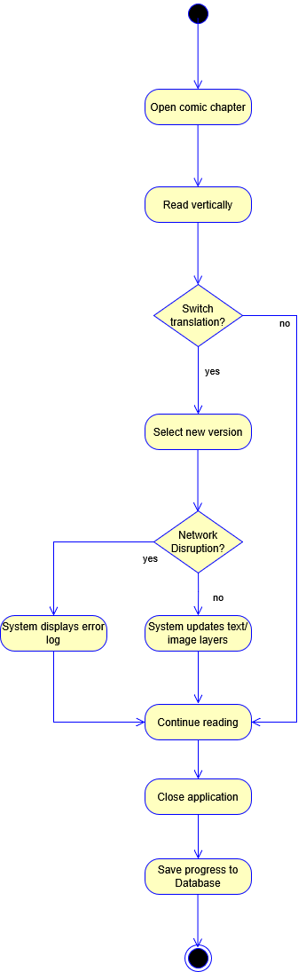
Figure 2.1 SC-01 activity diagram

SC-02 — Collaborative translation group manages workflow and publishes a chapter
Business Flow | Translation group manages raw assets, translates text directly onto comic pages via Canvas Editor, tracks task progress across 4 Kanban states (Backlog, In Progress, Under Review, Completed), checks project glossaries, passes Quality Gate, and completes chapter release.
Primary Actor | Translator, Project Leader (Group Leader)
Pre-condition | The translation group holds verified group rights on the comic series. A new chapter raw draft asset package is available in the project workspace.
Post-condition | The translation task transitions through Under Review to Completed, all chapter pages pass internal quality gate audit (BR-04), the translated chapter becomes published and available to readers, and system logs are recorded.
Related Feature | FT-03, FT-05, FT-06, FT-07, FT-08
Related UC | UC-15, UC-16, UC-40, UC-41, UC-47, UC-51, UC-52, UC-53

Narrative:
Minh, the Project Leader of an assigned translation group, logs into the Translator Dashboard (P-15) and accesses the workspace for a newly claimed comic project (UC-51). Minh creates a new translation task for Chapter 12 on the Chapter Production Tracker Kanban Board (FT-07 / UC-15). The task is created in the Backlog column and assigned to Hoang (UC-41).
Hoang, the assigned Translator, picks up the task and moves its card from Backlog to In Progress (UC-15). He then opens the chapter inside the Translator Workspace Canvas (FT-08 / UC-16). The canvas renders the raw comic page images (RawImage). Hoang interacts directly with the canvas by adding text bounding boxes over the original page layout and typing the translated text directly onto the image. Throughout the translation process, Hoang uses and updates the shared Project Translation Glossary (UC-47) to maintain consistent terminology, and uses Project Team Messaging (UC-40) to coordinate with Minh and teammates.
Once Hoang finishes translating all pages of the chapter, he moves the task card from In Progress to Under Review (UC-52), submitting the chapter for leader audit.
Minh (Project Leader) receives the submission and opens the Task Review interface (P-25 / UC-53) to audit the translated pages directly on the canvas preview. The system automatically evaluates the Quality Gate (BR-04) to confirm that all pages of the chapter have been translated and checked. Upon verifying translation quality, Minh approves the task and transitions its status from Under Review to Completed (UC-15 / FT-03). The system immediately publishes the translated chapter, making it visible and accessible to platform readers.

Key Exception / Alternate Flows:

- [Trigger - Glossary Term Conflict]: Two translators attempt to update the exact same Glossary entry in the project database simultaneously — The system enforces optimistic concurrency locking, saving the first request payload while rejecting the second with an HTTP 409 Conflict error alert ("Terminology has been updated by another user") — Preserves data consistency across the project.
- [Triger — Workspace Canvas Mutation Lock on Completed Task]: A translator attempts to modify text boxes on the canvas for a task that has already reached the Completed state — The canvas engine blocks text writes, switches the layout to Read-Only mode, and returns an HTTP 409 Conflict status code (CANVAS_LOCKED) — Prevents unauthorized data mutation on completed releases.
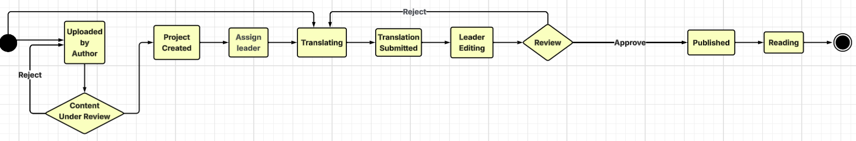
Figure 2.2 - SC-02 activity diagram

SC-03 — Moderator audits community forum and processes violation reports

Business Flow | Moderator reviews user-generated reports and executes disciplinary actions on forum threads.
Primary Actor | Moderator
Secondary Actor | Admin
Pre-condition | Platform readers have submitted report tickets regarding a specific forum thread.
Post-condition | The violating content is removed, the report ticket is resolved, and the action is immutably logged.
Related Feature | FT-01, FT-04, FT-13, FT-15
Related UC | UC-01, UC-22, UC-24, UC-26, UC-27

Narrative:
Hanh, a platform Moderator, accesses the User Reports Dashboard to review the daily moderation queue. He notices a high-priority report ticket submitted by a Reader against a newly created forum thread for containing inappropriate external links.
Hanh opens the reported thread context alongside the user's history. Confirming the violation of community guidelines, Hanh executes the "Takedown" action on the forum content. The system updates the database to hide the thread from public view and closes the associated report tickets. Simultaneously, the system generates an immutable record of Hanh’s moderation action and stores it in the database logs, allowing higher-level Admins to audit the decision later.
Key Exception / Alternate Flows:

- [Trigger - Mass False Reporting]: A group of malicious users submits automated spam reports against a legitimate thread — The system's rate-limiting logic detects the anomaly, temporarily ignoring the duplicate reports and flagging the submitters — The Moderator Dashboard is not flooded, and the legitimate thread remains visible.
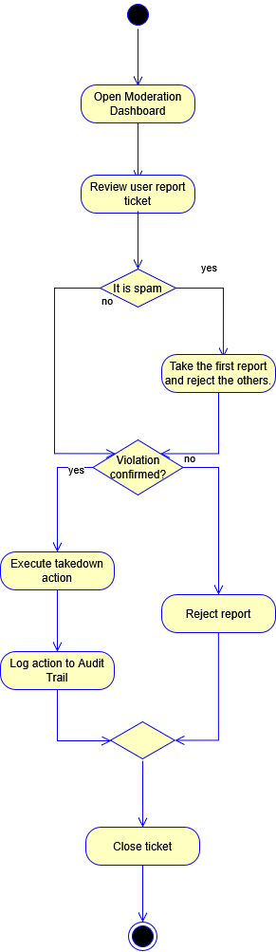
Figure 2.3 - SC-03 activity diagram

SC-04 — Reader scans payment QR code to purchase premium chapter directly

Business Flow | Reader requests content access, uses bank dynamic QR codes to pay instantly, and unlocks premium content.
Primary Actor | Reader
Secondary Actor | Payment System
Pre-condition | The user encounters a locked chapter that requires direct payment to access.
Post-condition | The transaction signature is validated, permanent chapter access permission is linked to the user account ID, and the chapter content panel renders successfully.
Related Feature | FT-01, FT-09, FT-10, FT-16
Related UC | UC-01, UC-06, UC-07, UC-29, UC-31

Narrative:
Lan is following an ongoing webtoon and encounters a newly released premium chapter. She attempts to access it, but the system prompts her with a lock panel stating that the chapter requires a direct payment of 5,000 VND to view. Lan selects the "Purchase via VietQR Code" option. The system dynamically generates a unique transaction invoice and interfaces with the external Bank API to display a dynamic QR code on her screen.
She completes the 5,000 VND transfer directly using her mobile banking application. The integrated Payment System detects the successful transfer and instantly routes a secure callback webhook back to ComiVerse. The backend validates the payment reference signature, records the event logs inside her persistent Transaction History, appends a permanent content access permission row for her account ID, and immediately refreshes her interface to display the fully unlocked chapter panels.

Key Exception / Alternate Flows:

- [Trigger - Payment Hook Callback Failure]: The user completes the banking payment on her mobile app, but the callback fails or is delayed due to an external network timeout. The system relies on a background reconciliation cron job to query the bank status every 5 minutes (or via a "Verify Payment" client request button) and eventually credits the permanent chapter access permission to prevent loss of user funds.
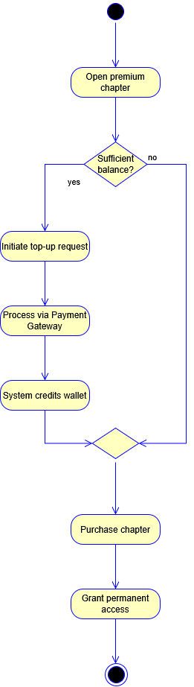
Figure 2.4 - SC-04 activity diagram

SC-05 — Reader manages personal library and receives notifications

Business Flow | Reader organizes their comic library and configures preferences to receive chapter updates.
Primary Actor | Reader
Pre-condition | The user is authenticated and actively browsing the comic catalog.
Post-condition | The comic is added to the user's library, and push notifications are delivered upon new releases.
Related Feature | FT-01, FT-02, FT-09, FT-14
Related UC | UC-01, UC-05, UC-11, UC-12, UC-14, UC-25

Narrative:
While browsing the catalog, Tuan clicks the "Bookmark Comic" button for an action comic he enjoys. However, the title has already been saved in his Personal Library. Instead of adding a duplicate entry, the system notifies him that the comic is already in his Favorites collection.
Later, Tuan enables push notifications for new chapter releases. Although the preference is saved successfully, notifications are disabled on his device. When a new chapter is published, the push alert cannot be delivered. To prevent Tuan from missing the update, the system stores the notification in his in-app notification center, where he sees it the next time he logs in.
Key Exception / Alternate Flows:

- [Trigger - Duplicate Bookmark]: The user clicks the "Bookmark Comic" button for a comic that already exists in their Personal Library. The system detects the duplicate entry and prevents it from being added again. A notification is displayed informing the user that the comic is already saved in their Favorites collection.
- [Trigger - Push Notification Delivery Failure]: A new chapter is released and the system attempts to send a push notification, but the user's device is offline or has notifications disabled . The Notification Service marks the push delivery as failed and stores the notification in the user's In-App Notification Center. The user receives the update the next time they log into the platform.
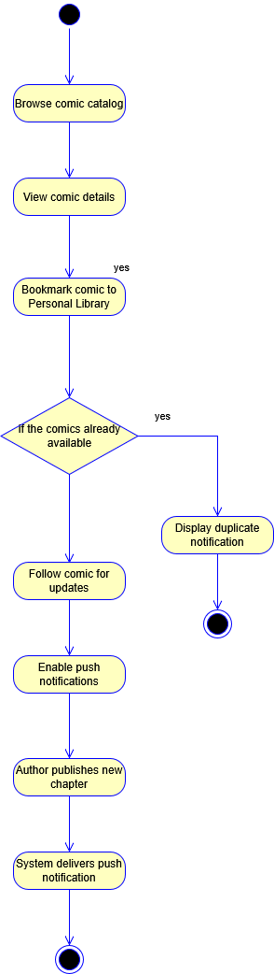
Figure 2.5 - SC-05 activity diagram

SC-06 — Author manages comic metadata and views revenue reports

Business Flow | The author updates comic details and accesses analytical dashboards to track monetization.
Primary Actor | Author
Pre-condition | The Author's comics exist in the database and have generated premium sales.
Post-condition | Comic metadata is updated, and the Author successfully views graphical revenue reports.
Related Feature | FT-01, FT-03, FT-17
Related UC | UC-01, UC-17, UC-33, UC-34

Narrative:
At the beginning of a new story arc, the Author logs into their Creator Dashboard to update the comic's synopsis and upload a new cover image. They access the "Manage Comic Metadata" module and submit the new details, which the system immediately saves to the database.
Curious about the financial performance of their recent premium chapters, the Author navigates to the "View Revenue Reports" section. The Analytics Engine queries the payment system records and renders an interactive line chart displaying the daily coin revenue generated from Fast Pass unlocks. Using this data, the Author can track their monetization success over time.
Key Exception / Alternate Flows:

- [Trigger - Invalid Metadata Format]: The Author attempts to upload a cover image that exceeds the 5MB file size limit — The frontend intercepts the request and displays a validation error "File size exceeds the maximum limit of 5MB" — The system rejects the upload, protecting server storage capacity.
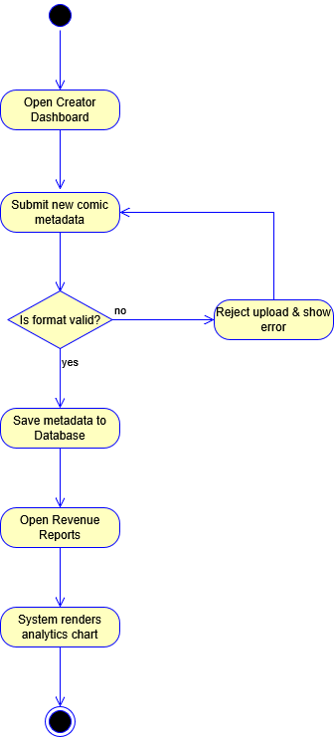
Figure 2.6 - SC-06 activity diagram

SC-07 — Admin configures system settings and broadcasts global announcements

Business Flow | System Administrator updates platform-wide configurations and utilizes the notification service to alert users.
Primary Actor | Admin
Pre-condition | The Admin is securely authenticated with high-level access permissions
Post-condition | Platform settings are updated, and a global announcement is distributed to all active users.
Related Feature | FT-01, FT-14, FT-18
Related UC | UC-01, UC-28, UC-38

Narrative:
Due to an upcoming database migration, the System Administrator needs to configure a scheduled maintenance window. The Admin logs into the backend dashboard and accesses the "Configure Platform Settings" module (UC-45). They input the scheduled downtime parameters (from 2:00 AM to 4:00 AM) and save the configuration, updating the core system variables in the database.
To ensure users are informed, the Admin navigates to the "Manage System Announcements" section. They draft a global notice detailing the maintenance schedule. Upon publishing (UC-46), the system interfaces with the Notification Service to instantly broadcast a high-priority banner announcement across the frontend application for all Guests and logged-in Readers.
Key Exception / Alternate Flows:

- [Trigger - Unauthorized Configuration Access]: A Moderator attempts to access the URL for Platform Settings — The system's RBAC middleware intercepts the request, verifies the lack of "Admin" privileges, and returns an HTTP 403 Forbidden error — System integrity is maintained.
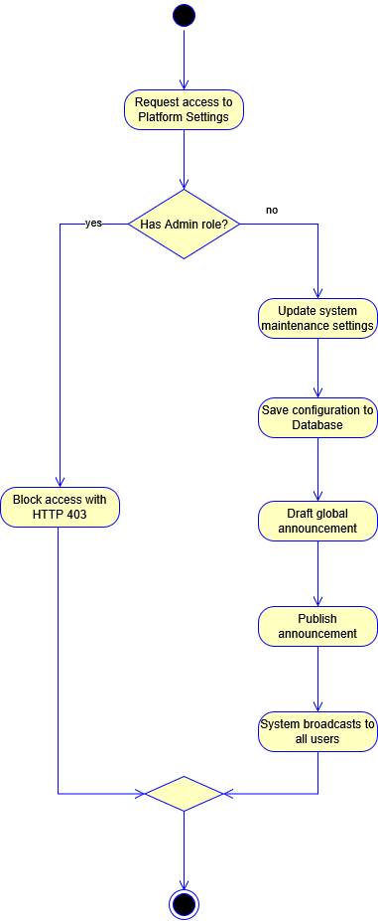
Figure 2.7 - SC-07 activity diagram

SC-08 — Creator requests revenue payout and Admin executes financial system audit

Business Flow | Creator requests financial revenue payout, and Admin utilizes the audit console to verify ledger stability before approval.
Primary Actor | Author / Translator
Secondary Actor | Admin
Pre-condition | The creator's comic chapters have generated paid direct purchase transactions, and their aggregate balance meets minimum thresholds.
Post-condition | The payout request row transitions to a locked state, the accounting ledger logs match transaction receipts, and final manual check distribution is initialized.
Related Feature | FT-01, FT-16, FT-17, FT-18
Related UC | UC-01, UC-30, UC-31, UC-34, UC-44

Narrative:
An established comic Author logs into their specialized creator metric studio panel to evaluate their monthly earnings. Seeing that their accumulated direct purchase revenue has surpassed the platform's minimum threshold requirements, the Author accesses the financial module and submits a formal "Request Revenue Payout" form. The integrated Payment System freezes the specified amount inside their virtual profile ledger and appends a transaction status entry marked as "Pending Administrative Review".
On the backend console, the platform Admin logs into the business reporting subsystem hub to process the monthly payout queues. Before approving any external payout funds distribution, the Admin initiates the "Audit Financial System" module to cross-reference the Author's requested payout data against the historic raw transaction history logs database. The Monolithic Payment System cross-checks the cryptographic signatures of every direct VietQR purchase receipt to verify that no ledger tampering or software bugs occurred. The audit passes smoothly with zero discrepancies, and the Admin authorizes the payout row for processing.
Key Exception / Alternate Flows:

- [Trigger - Ledger Balance Discrepancy]: The system's automated audit tool flags an abnormality where the Author's requested payout balance is higher than the total direct bank transaction logs linked to their series ID.
  - System Response: The payment block system triggers an immediate transactional freeze loop. The Admin dashboard flags the payout request entry as "CRITICAL ANOMALY: FAILED AUDIT", halts the automatic balance mutation scripts, and logs the incident to the platform security center for specialized manual troubleshooting.
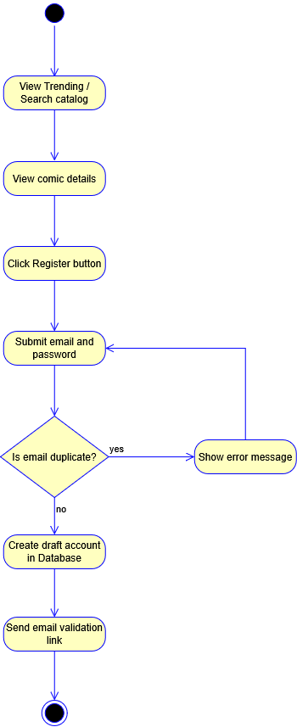

Figure 2.8 - SC-08 activity diagram

Scenario List
ID | Scenario Name | Primary Actor | Maps to Features | Priority
SC-01 | Reader customizes reading experience and saves reading progress | Reader | FT-01, FT-02, FT-09, FT-10, FT-11, FT-12 | High
SC-02 | Collaborative translation group manages workflow and publishes a chapter | Translator | FT-01, FT-03, FT-04, FT-05, FT-06, FT-07, FT-08 | High
SC-03 | Moderator audits community forum and processes violation reports | Moderator | FT-01, FT-04, FT-12, FT-13, FT-15 | High
SC-04 | Reader tops up digital wallet and purchases premium chapter | Reader | FT-01, FT-09, FT-16 | High
SC-05 | Reader manages personal library and receives notifications | Reader | FT-01, FT-02, FT-09, FT-11, FT-14 | Medium
SC-06 | Author manages comic metadata and views revenue reports | Author | FT-01, FT-03, FT-17 | Medium
SC-07 | Admin configures system settings and broadcasts global announcements | Admin | FT-01, FT-14, FT-15, FT-17, FT-18 | Medium
SC-08 | Creator requests revenue payout and Admin executes financial system audit | Author / Translator | FT-01, FT-16, FT-17 | High

Part 3 — Module Description

3.1 Module and Features

a. Module List

Module | Purpose | Primary Actors
Authentication | Authentication, profile management, and account preferences | All
Comic Discovery | Browse, search, and discover comics | Guest, Reader
Comic Reader | Read comics and synchronize reading progress | Guest, Reader
Personal Library | Manage bookmarks, follows, and reading history | Reader
Translation Workspace | Create and manage translation projects, localization tasks, and team collaboration | Translator , Project Leader
Author Publishing | Publish comics, chapters, and manage comic information | Author
Forum & Community | Discussions, comments, reviews, and community engagement | Guest, Reader, Translator, Author
Moderation | Content review, report handling, quality assurance, and policy enforcement | Moderator, Admin
Revenue Payment | Premium content purchases, transaction history, earnings, and payouts | Reader, Translator, Author, Admin , Project Leader
Administration | User, taxonomy, pricing, and platform management | Admin
Dashboard & Reporting | Analytics, monitoring, revenue statistics, and reporting | Translator, Author , Moderator , Admin, Project Leader

b. Module: Authentication

FT-ID | Feature | Priority | Description | UC-ID Ref | BF-ID Ref
FT-01 | User Authentication & Access | Must | Authenticate user credentials, handle OAuth logins, terminate sessions, and enforce Multi-Factor Authentication. | UC-01, UC-02, UC-04 | BF-01
FT-02 | Account Settings & Assets | Must | Update user profile metadata, manage avatars, change secure passwords, and configure notification preferences. | UC-03, UC-25, UC-45 | BF-01

c. Module: Author Publishing

FT-ID | Feature | Priority | Description | UC-ID Ref | BF-ID Ref
FT-03 | Comic Submission Pipeline | Must | Enable authors to construct comic profiles, upload cover art, and submit raw chapter assets into the production pipeline. | UC-17, UC-18 | BF-04

d. Module: Moderation

FT-ID | Feature | Priority | Description | UC-ID Ref | BF-ID Ref
FT-04 | Content Moderation Gate | Must | Empower moderators to review the chapter publish queue, approve content for public rendering, or reject submissions with feedback. | UC-19 , UC-26, UC-54 | BF-05
FT-15 | Policy & Content Audit | Must | Process user report tickets, hide toxic comments, and lock violating forum content to enforce safety guidelines. | UC-22, UC-24, UC-26, UC-27, UC-26, UC-54 | BF-05

e. Module: Translation Workspace

FT-ID | Feature | Priority | Description | UC-ID Ref | BF-ID Ref
FT-05 | Translator Onboarding | Must | Manage translator applications, assign roles, and administer group memberships within the workspace. | UC-48, UC-50 | BF-03
FT-06 | Translation & Localization Portal | Must | Initialize translation projects and facilitate real-time internal communication among project team members. | UC-15, UC-40 | BF-03
FT-07 | Chapter Production Tracker | Should | Manage chapter production workflows using a Kanban board system | UC-15, UC-51, UC-52, UC-53 | BF-03
FT-08 | Creator Cloud Studio | Should | Provide a cloud-based canvas for translators to edit raw images, map text layers, and manage glossaries. | UC-16 | BF-03

f. Module: Comic Discovery

FT-ID | Feature | Priority | Description | UC-ID Ref | BF-ID Ref
FT-09 | Search & Recommendation Engine | Must | Search comics by keywords, filter by taxonomy (genres/tags), and view comic metadata, synopses, and chapter lists. | UC-05, UC-06 | BF-02

g. Module: Comic Reader

FT-ID | Feature | Priority | Description | UC-ID Ref | BF-ID Ref
FT-10 | Comic Reader & Version Switcher | Must | Render image assets sequentially, allow users to switch between vertical/horizontal reading modes, and select translation forks. | UC-07, UC-08, UC-09 | BF-02

h. Module: Personal Library

FT-ID | Feature | Priority | Description | UC-ID Ref | BF-ID Ref
FT-11 | Cross-Platform Progress Sync | Must | Track real-time reading coordinates, manage bookmarks, follow series, and compile personalized dashboards based on user history. | UC-10, UC-11, UC-12, UC-13, UC-14 | BF-02

i. Module: Forum & Community

FT-ID | Feature | Priority | Description | UC-ID Ref | BF-ID Ref
FT-12 | User Engagement & Ranking System | Must | Collect reader star ratings, calculate aggregate scores, and manage user comments on specific chapters. | UC-20, UC-21 | BF-05
FT-13 | Community Forums & Messaging | Must | Facilitate public discussions through forum threads and operate the global real-time chat infrastructure. | UC-23, UC-39 | BF-05

j. Module: Administration
FT-ID | Feature | Priority | Description | UC-ID Ref | BF-ID Ref
FT-14 | Notification & User Center | Must | Broadcast global announcements, maintenance banners, and automated system alerts to target user bases. | UC-28 | BF-08
FT-18 | Global Admin Control Panel | Must | Manage taxonomy (genres/tags), user accounts, subscription pricing schemas, and system-wide comic visibility. | UC-36, UC-37, UC-38, UC-43 | BF-08

k. Module: Revenue Payment

FT-ID | Feature | Priority | Description | UC-ID Ref | BF-ID Ref
FT-16 | Monetization & Token Management | Must | Process direct payments for premium chapter unlocks, track transaction histories, and execute creator payout requests. | UC-29, UC-30, UC-31, UC-44 , UC-57 | BF-06

l. Module: Dashboard & Reporting

FT-ID | Feature | Priority | Description | UC-ID Ref | BF-ID Ref
FT-17 | Analytics & Dashboards | Must | Generate graphical reports for reader engagement, chapter performance, revenue statistics, and export data locally. | UC-33, UC-34, UC-35 | BF-07

3.2 Screen Inventory

a. Screen Flow
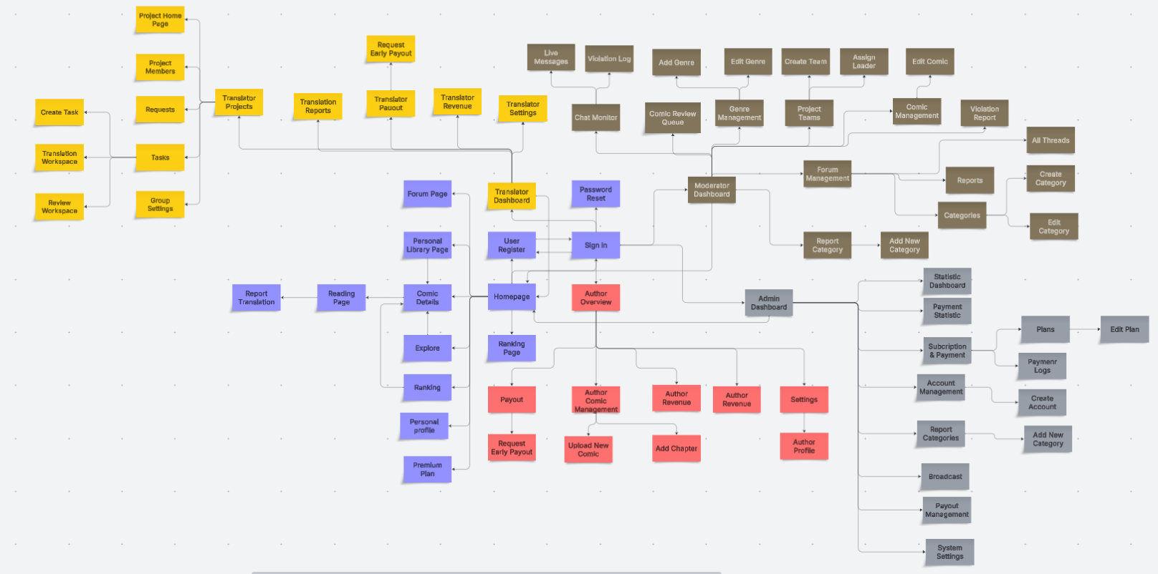

b. Screen List

SCR-ID | Screen Name | Module | Description | FT-ID | UC-ID
SCR-01 | Login Page | Authentication | Authenticate users using credentials or supported OAuth login. | FT-01 | UC-01
SCR-02 | Register Page | Authentication | Create a new user account with the default Reader role. | FT-01 | UC-32
SCR-03 | Recover Password Page | Authentication | Recover account access and reset the password through email verification. | FT-01 | UC-45
SCR-04 | Homepage | Comic Discovery | Display personalized feeds, recommendations, and comic updates. | FT-09 | UC-14
SCR-05 | Comic Details | Comic Discovery / Forum & Community | Display comic metadata, chapter list, ratings, likes, and comments. | FT-09, FT-12 | UC-06, UC-20, UC-21
SCR-06 | Comic Reader | Comic Reader / Personal Library | Read chapter images, switch translation versions, and synchronize reading progress. | FT-10, FT-11 | UC-07, UC-09, UC-10
SCR-07 | Search & Filter Page | Comic Discovery | Search and filter comics by keywords, genres, and tags. | FT-09 | UC-05
SCR-08 | Ranking Page | Comic Discovery / Forum & Community | Display ranked and trending comics based on platform engagement. | FT-12 | UC-05
SCR-09 | Personal Library | Personal Library | Manage bookmarks, reading history, and reading progress. | FT-11 | UC-10, UC-11, UC-12, UC-13
SCR-10 | Forum Page | Forum & Community | Browse forum discussions and create or manage owned forum content. | FT-13 | UC-22, UC-23
SCR-11 | Premium Plan Page | Revenue Payment | Display Premium plans and allow users to subscribe. | FT-16 | UC-29
SCR-12 | Personal Profile | Authentication | View and update personal profile information. | FT-02 | UC-03
SCR-13 | Resign Workspace Modal | Translation Workspace | Allow a translator to leave the current translation project team. | FT-06 | UC-41
SCR-14 | User Change Password | Authentication | Change the password of an authenticated account. | FT-02 | UC-03
SCR-15 | Workspace Dashboard | Translation Workspace | Display translation project and task overview. | FT-06, FT-07 | UC-15
SCR-16 | Project Overview | Translation Workspace | Display project progress, task status, backlog, and team information. | FT-06, FT-07 | UC-15, UC-41
SCR-17 | Project Workspace Homepage | Translation Workspace | Provide project communication, announcements, and workspace information. | FT-06, FT-13 | UC-40, UC-55
SCR-18 | Project Team Members | Translation Workspace | View and manage members assigned to a translation project. | FT-06 | UC-41
SCR-19 | Member Application Requests | Translation Workspace | View pending requests to join a translation project team. | FT-06 | UC-49
SCR-20 | Applicant Profile Detail | Translation Workspace | View applicant information before approving or rejecting a join request. | FT-06 | UC-49
SCR-21 | Task Management | Translation Workspace | Manage translation tasks, assignments, deadlines, rewards, progress, and handover. | FT-06, FT-07 | UC-15, UC-56
SCR-22 | Create Task Modal | Translation Workspace | Create a task from chapter backlog and assign it to a translator. | FT-06, FT-07 | UC-15
SCR-23 | View Task Detail Modal | Translation Workspace | View task details, assignment, progress, status, and handover information. | FT-06, FT-07 | UC-15, UC-56
SCR-24 | Translation Canvas Workspace | Translation Workspace | Translate chapter content, edit image/text layers, and submit translation for review. | FT-06, FT-07, FT-08 | UC-16, UC-52
SCR-25 | Leader Task Review | Translation Workspace | Review submitted translations and approve or request changes. | FT-07, FT-08 | UC-53
SCR-26 | Project Configuration Settings | Translation Workspace | Configure project glossary, terminology, names, and translation rules. | FT-06, FT-08 | UC-47
SCR-27 | Translator Wallet & Payout | Revenue Payment | Manage payout profile, earnings, payout requests, and transactions. | FT-16 | UC-08, UC-30, UC-31
SCR-28 | Request Payout Modal | Revenue Payment | Submit a payout request from eligible accumulated earnings. | FT-16 | UC-30
SCR-29 | Author Dashboard | Dashboard & Reporting | Display Author content performance and revenue summaries. | FT-17 | UC-33, UC-34
SCR-30 | Author Comic Manager | Author Publishing | Create, view, update, and delete Author-owned comics. | FT-03 | UC-17
SCR-31 | Upload Comic Modal | Author Publishing | Create a new comic and upload the required comic information. | FT-03 | UC-17
SCR-32 | Author Comic Detail | Author Publishing | View and manage comic information and associated chapters. | FT-03 | UC-17, UC-18
SCR-33 | Add Chapter Modal | Author Publishing | Add and upload a new chapter to an Author-owned comic. | FT-03 | UC-18
SCR-34 | Author Analytics Dashboard | Dashboard & Reporting | Display comic performance, revenue statistics, and analytics reports. | FT-17 | UC-33, UC-34, UC-35
SCR-35 | Author Payout & Earnings | Revenue Payment / Dashboard & Reporting | Display Author earnings, transactions, revenue statistics, and payouts. | FT-16, FT-17 | UC-08, UC-30, UC-31, UC-34
SCR-36 | Moderator Dashboard | Moderation | Display moderation workload, publish queues, and violation reports. | FT-04, FT-15 | UC-19, UC-27
SCR-37 | Chapter Submission Review Queue | Moderation | Review chapter submissions and approve or reject publication. | FT-04 | UC-19
SCR-38 | Translation Fork Comparison Screen | Moderation | Compare translation content during publication review. | FT-04, FT-08 | UC-19
SCR-39 | System Comic Management | Moderation / Administration | Manage visibility and moderation states of published comics. | FT-18 | UC-43
SCR-40 | Catalog Genre Management | Administration | Manage catalog genres and tags. | FT-18 | UC-36
SCR-41 | Edit Genre/Tag Modal | Administration | Edit an existing genre or tag. | FT-18 | UC-36
SCR-42 | Chat Monitor & Violations Panel | Moderation | Review flagged messages and manage community chat violations. | FT-13, FT-15 | UC-46
SCR-43 | Forum Content Management | Moderation | Lock, hide, restore, or moderate forum content. | FT-15 | UC-24
SCR-44 | Project Workspace Management | Translation Workspace / Administration | Create and manage translation project/team configurations. | FT-06, FT-18 | UC-42
SCR-45 | Initialize Project Workspace Modal | Translation Workspace / Administration | Initialize a translation project workspace and team configuration. | FT-06, FT-18 | UC-42
SCR-46 | Admin System Dashboard | Administration / Dashboard & Reporting | Display platform administration, analytics, user, subscription, and payout summaries. | FT-17, FT-18 | UC-35, UC-37, UC-38, UC-44
SCR-47 | Platform Revenue Management | Revenue Payment / Administration | Monitor platform transactions, revenue reports, and payout operations. | FT-16, FT-17, FT-18 | UC-31, UC-35, UC-44
SCR-48 | Platform User Management | Administration | Create, update, ban, unban, disable, and manage user accounts. | FT-18 | UC-37
SCR-49 | Global System Broadcast | Administration | Create and distribute platform-wide announcements. | FT-14 | UC-28
SCR-50 | Platform Payout Queue | Revenue Payment / Administration | Review and process Author and Translator payout requests. | FT-16, FT-18 | UC-44
SCR-51 | Subscription Pricing Settings | Administration / Revenue Payment | Configure subscription plans, prices, and availability. | FT-16, FT-18 | UC-38
SCR-52 | Report Translation Modal | Moderation | Submit a violation report for translation content. | FT-15 | UC-26
SCR-53 | Translation Reports | Moderation / Dashboard & Reporting | Review translation reports and provide report/export information. | FT-15, FT-17 | UC-27, UC-35
SCR-54 | Translator Revenue | Revenue Payment / Dashboard & Reporting | Display translator transaction history and revenue statistics. | FT-16, FT-17 | UC-31, UC-34
SCR-55 | Translator Settings | Authentication | Manage translator profile and notification preferences. | FT-02, FT-14 | UC-03, UC-25
SCR-56 | Author Settings | Authentication | Manage Author profile and notification preferences. | FT-02, FT-14 | UC-03, UC-25
SCR-57 | Author Profile | Authentication | Display and update Author profile information. | FT-02 | UC-03
SCR-58 | Add Genre Modal | Administration | Create a new catalog genre or tag. | FT-18 | UC-36
SCR-59 | Live Messages | Moderation | Monitor real-time community messages for violations. | FT-13, FT-15 | UC-46
SCR-60 | Violation Log | Moderation | Display violation tickets and moderation action records. | FT-15 | UC-27, UC-46
SCR-61 | Assign Project Leader Modal | Translation Workspace / Administration | Assign a Project Leader to a translation project. | FT-06, FT-18 | UC-42
SCR-62 | Edit Comic | Moderation / Administration | Modify administrative visibility or moderation state of published comics. | FT-03, FT-18 | UC-43
SCR-63 | Comic Violation Report | Moderation | Review and process reports involving comic content. | FT-15 | UC-27
SCR-64 | All Forum Threads | Moderation | Display forum threads for moderation and content management. | FT-15 | UC-24
SCR-65 | Forum Reports | Moderation | Review and process report tickets involving forum content. | FT-15 | UC-27
SCR-66 | Forum Categories | Moderation / Forum & Community | View and manage categories used to organize forum content. | FT-13, FT-15 | UC-24
SCR-67 | Create Forum Category Modal | Moderation / Forum & Community | Create a new forum category. | FT-13, FT-15 | UC-24
SCR-68 | Edit Forum Category Modal | Moderation / Forum & Community | Update an existing forum category. | FT-13, FT-15 | UC-24
SCR-69 | Report Category Management | Moderation | Manage categories used to classify violation reports. | FT-15 | UC-27
SCR-70 | Add Report Category Modal | Moderation | Create a category used for violation report tickets. | FT-15 | UC-27
SCR-71 | Statistic Dashboard | Dashboard & Reporting | Display aggregated platform statistics and reporting information. | FT-17 | UC-35
SCR-72 | Payment Statistic | Revenue Payment / Dashboard & Reporting | Display aggregated payment and transaction statistics. | FT-16, FT-17 | UC-31, UC-35
SCR-73 | Payment Logs | Revenue Payment | Display platform payment and transaction history. | FT-16 | UC-31
SCR-74 | Create Account Modal | Administration | Create a new platform user account. | FT-18 | UC-37
SCR-75 | Edit Subscription Plan | Administration / Revenue Payment | Edit subscription plan information, price, and availability. | FT-16, FT-18 | UC-38
SCR-76 | Create Subscription Plan | Administration / Revenue Payment | Create a new subscription plan and pricing configuration. | FT-16, FT-18 | UC-38
SCR-77 | Edit Subscription Plan | Administration / Revenue Payment | Update an existing subscription plan configuration. | FT-16, FT-18 | UC-38
SCR-78 | Become a Translator Page | Translation Workspace | Allow a Reader to submit an application to become a Translator. | FT-05 | UC-50

3.3 External API Inventory

N/A — Comiverse v1.0 does not expose any external-facing API endpoints.

Note on Future Plans: Future versions (v2.0+) may introduce public developer APIs and external partner integration webhooks.

3.4 Background Job Inventory

JOB-ID | Job Name | Group | Description | FT-ID | UC-ID
JOB-01 | Persist buffered reading activity and view counters | Scheduled | Flushes temporarily buffered comic views, chapter views, and user reading history tracking logs from Redis into PostgreSQL persistent storage. | FT-01 | UC-01, UC-02, UC-04, UC-32
JOB-02 | Clean up expired reading history logs | Scheduled | Periodically purges obsolete user reading history logs older than the retention threshold from PostgreSQL to keep database size optimized. | FT-03, FT-08 | UC-17, UC-18
JOB-03 | Compute comic view leaderboards | Scheduled | Calculates top 20 trending comics for Day, Week, and Month timeframes based on view counts and caches them in Redis for fast leaderboard API responses. | FT-03, FT-04, FT-14 | UC-18, UC-19, UC-43
JOB-04 | Synchronize user engagement and interaction metrics | Scheduled | Flushes buffered likes, saves/bookmarks, and rating statistics from Redis into PostgreSQL and recalculates average ratings to keep public engagement metrics consistent. | FT-09, FT-18 | UC-05, UC-06, UC-36, UC-43
JOB-05 | Generate missing comic embedding vectors | Scheduled | Scans for newly created or updated published comics that lack vector embeddings, constructs summary texts, and requests 768-dimensional AI embeddings from Gemini API for semantic similarity search. | FT-09 | UC-14
JOB-06 | Recalculate user preference vectors | Scheduled | Periodically recomputes user preference vectors by averaging 768-dimensional embedding vectors of comics that each user liked, saved, or read (combining PostgreSQL and un-synced Redis queues). | FT-10, FT-11, FT-12 | UC-06, UC-07, UC-10, UC-20

3.5 Inventory Summary

Type | Count | Notes
Screens | 78 | Covers Web and Mobile UI interfaces across Reader Engine, Translation Workspace, Creator Management, Moderation, and Administration modules.
Background jobs | 6 | handling View Sync, History Cleanup, Leaderboard Computation, Engagement Sync, and AI Vector Embeddings across FT-01 to FT-18 and UC-01 to UC-43

Part 4 — Feature Description

FT-01 — User Authentication & Access
Source Feature (V&S) | FE-10
Related Scenario | SC-01
Related UC | UC-01, UC-02, UC-04, UC-32, UC-45
Summary | The system authenticates user identities and manages secure, time-bound sessions via cryptographic tokens to ensure only authorized users access system features while protecting data integrity.

System Behaviour:
Trigger: A user submits login credentials through the client interface, or an active client application transmits an automated API interaction request requiring data logging.
Processing: The system evaluates the inbound payload through an inline API authentication gateway. Incoming token strings are normalized by stripping trailing white spaces and validating compliance with SHA-256 formatting within 200 milliseconds of ingestion.
- For standard user tiers, the system checks token validity against the primary data store as required by BR-01. Sessions are automatically tracked via an absolute expiration timer set to exactly 7 days (168 hours). An automated cleanup cron job executes every 3600 seconds (1 hour) to clear out expired session signatures from the fast-access cache layer.
- For privileged identities possessing 'Admin' or 'Moderator' roles, the system intercepts the lifecycle flow to verify Two-Factor Authentication (2FA) enforcement parameters as mandated by BR-11. If 2FA configurations are missing or incomplete, the system suspends active session validation and flags the state as "Pending Enrollment."
Output: Upon successful verification, the system updates the session state cache, issues an HTTP 200 OK code, and pushes the authorization claims metadata payload to the user interface within 500 milliseconds. If the session token is expired, invalid, or missing 2FA parameters, the system outputs an HTTP 401 Unauthorized or HTTP 403 Forbidden error response, invalidates the local state, and forces a client redirect to the centralized Login interface within 1.5 seconds.
Positive Acceptance Criteria (AC):
- AC-01: When an unauthenticated user submits valid account credentials, the system must generate a cryptographically secure session token and authorize access within 800 milliseconds.
- AC-02: When an authorized interaction request is made within exactly 7 days (168 hours) of token issuance, the system must permit data logging actions and maintain the session state without presenting any re-authentication prompts.
- AC-03: When a user holding an 'Admin' or 'Moderator' role logs in, the system must present a mandatory 2FA verification challenge and block access to platform control panels until a valid secondary code is provided.
Negative Acceptance Criteria (NAC):
NAC-01: Malformed Token Payload (Invalid Input)
- Condition: An interaction request is initiated using an altered, empty, or structurally malformed session token payload.
- System Response: The system rejects the transaction, blocks downstream execution, and returns an HTTP 400 Bad Request with the error payload: {"error": "MALFORMED_TOKEN", "message": "The provided session token is structurally invalid."}.
- Side Effects: No account configuration fields are read, modified, or written; no active sessions are altered.
- Audit Requirement: Log a warning-level security entry containing the source IP address and the malformed header snippet to the isolated logging partition.
NAC-02: Expired Session Token (Boundary Breach / Timer Expiry)
- Condition: A logged-in user attempts an account modification request after their session token has exceeded the 7-day (168-hour) absolute expiration lifespan.
- System Response: The system terminates the session pipeline, returns an HTTP 401 Unauthorized status code, and automatically triggers a client routing mechanism back to the Login interface.
- Side Effects: The operational transaction is blocked; no target profile modification or database logging takes place.
- Audit Requirement: Append a standard session expiration entry to the user management audit logs.
NAC-03: Missing 2FA Verification for Privileged Roles (Unauthorised Access)
- Condition: An identity possessing an 'Admin' or 'Moderator' role attempts to bypass or skip the 2FA token validation prompt during sign-in.
- System Response: The system blocks downstream routing, denies entry to administrative routes, and outputs an HTTP 403 Forbidden status code with the payload message: {"error": "MANDATORY_2FA_REQUIRED"}.
- Side Effects: Access to security controls is denied; no administrative permissions or tokens are initialized.
- Audit Requirement: Trigger a high-severity security audit event to the Immutable logging partition detailing the targeted Admin/Moderator account ID.
Boundary Value Notes (BV):
BV-01 Session Lifespan Duration:
- Valid: 1 to 168 hours | Default: 168 hours
- Invalid: 0 hours, 169 hours
- Test points: 1 hour (minimum valid boundary), 168 hours (maximum valid boundary), 0 hours (lower breach point), 169 hours (upper breach point).
BV-02 2FA Passcode Character Count:
- Valid: 6 to 6 digits | Default: N/A
- Invalid: 5 digits, 7 digits
- Test points: 6 digits (exact valid boundary), 5 digits (lower breach point), 7 digits (upper breach point).

FT-02 —Account Settings & Assets
Source Feature (V&S) | FE-10
Related Scenario | SC-05
Related UC | UC-03, UC-11, UC-12, UC-13, UC-14
Summary | The system provides an end-user layout configuration and preference engine that captures, localizes, and synchronizes client-side interface settings and real-time reading states across active sessions to deliver a seamless, personalized viewing experience.
System Behaviour:
Trigger: An authenticated user modifies their interface layout configuration (e.g., switching from light to dark mode, adjusting content magnification, or altering reading direction) or changes their viewport scroll position within the reading layout.
Processing: The configuration adjustments are intercepted locally by the front-end layout engine.
- Layout Configurations: Incoming UI updates are normalized into a standardized JSON preference payload within 50 milliseconds. The values are checked against user schema definitions (UserProfile and UserPref) to match performance parameters specified under NFR-PERF-01.
- Reading State & Offsets: For highly continuous adjustments—such as scroll offset variations, page progression metrics, and chapter transition sequence keys—the engine applies a strict 3-second (3000ms) debounce mechanism as indicated by BR-02. This prevents high-frequency network flooding by throttling pipeline write requests.
If a network disconnection is detected during processing, the client layer pauses remote server synchronization, diverts the active payload directly to the device’s secure Local Cache, and sets an automated connection listener.
Output: Upon expiration of the 3-second debounce window or the completion of a manual UI choice, the client executes an asynchronous push update to the central database server. The system commits the state adjustments to the UserPref and UserProfile entities, issues an HTTP 200 OK verification status, and updates all concurrent operational views within 400 milliseconds. If the platform is running in an offline state, updates persist in the local sandbox layout until the connection hook is re-established, triggering a background batch synchronization.
Positive Acceptance Criteria (AC):
- AC-01: When an authenticated user updates any UI preference parameter (such as toggling dark mode), the system must immediately alter the local display layout within 200 milliseconds.
- AC-02: When a user alters their configuration parameters across one application instance, the system must synchronize and distribute those changes to all other active authenticated sessions within 3 seconds of a network handshake.
- AC-03: When a user is scrolling through or navigating a comic chapter, the system must capture the exact tracking metrics (scroll offsets, chapter IDs, and timestamps) and save them to the cloud database after exactly 3 seconds of continuous reader inactivity.
Negative Acceptance Criteria (NAC):
NAC-01: Malformed Preferences Schema (Invalid Input)
- Condition: A client transmission drops or attempts to submit an asset configuration payload containing corrupted key-value types or unmapped interface parameters.
- System Response: The system rejects the layout modification request, leaves existing parameters intact, and throws an HTTP 422 Unprocessable Entity code containing structural validation errors.
- Side Effects: No attributes are committed to the remote UserPref entity; the client application retains the last verified layout parameters.
- Audit Requirement: Generate a standard system telemetry validation error outlining the failed payload attributes.
NAC-02: Complete Network Disconnection (Failure Condition)
- Condition: The active device environment loses cellular or local internet connectivity during a layout choice change or reading track event.
- System Response: The system stops remote server sync pipelines, caches the un-synchronized profile adjustments directly into the client's localized storage space, and exposes a non-intrusive background queuing icon.
- Side Effects: Remote server database layers remain completely untouched; the active reading session runs without UI blocking or content disruption.
- Audit Requirement: Queue an internal diagnostic event in the local client database layer tracking offline delta alignment.
NAC-03: Concurrent Multi-Device Adjustments (Race Condition)
- Condition: A user profile modifies conflicting interface layout settings on two distinct hardware devices simultaneously at the exact same second.
- System Response: The processing system resolves the collision by evaluating client-side transaction timestamps, prioritizing the latest atomic interaction while rejecting the older instance request with an HTTP 409 Conflict code.
- Side Effects: The database records only the absolute newest configuration; older data variants are dropped to prevent layout profile fragmentation.
- Audit Requirement: Log a data synchronization conflict resolution entry in the application database trace file.
Boundary Value Notes (BV):
BV-01 Reading Telemetry Debounce Window (Milliseconds):
- Valid: 1000 to 5000 | Default: 3000
- Invalid: 999, 5001
- Test points: 1000 ms (lower limit), 3000 ms (expected operational base), 5000 ms (upper constraint limit), 999 ms (lower breach event), 5001 ms (upper breach event).
BV-02 Text Scaling Magnification Percentage:
- Valid: 50 to 200 | Default: 100
- Invalid: 49, 201
- Test points: 50% (minimum layout compression), 100% (default scale), 200% (maximum layout extension), 49% (out-of-bounds low value), 201% (out-of-bounds high value).FT-03 — Member Governance & Agile Pipeline Task Management

FT-03 —Comic Submission Pipeline
Source Feature (V&S) | FE-04
Related Scenario | SC-02, SC-06
Related UC | UC-17, UC-18, UC-43
Summary | The system provides an ingestion pipeline for authors and creators to upload chapter assets, alter metadata configurations, and configure automated, future-dated publication schedules via secure database ownership keys.
System Behaviour:
Trigger: An author or group leader uploads content files (e.g., zip archives or bulk images) or submits configuration adjustments to a specific comic series metadata entry.
Processing: The configuration and data packages enter the platform's content ingestion gateway, which evaluates the transaction along two parallel tracks:
- Ownership Verification: The system intercepts the request payload and extracts the user identity context. It queries the data layer to match the active user identifier against the specific relational ownership keys on the target comic series record. If the identity does not match the designated Author or assigned Group Leader, the processing pipeline shuts down instantly.
- Asset Normalization & Schema Checks: Approved transactions pass directly into the media optimization processor. The system sanitizes and normalizes the incoming source assets, validating image file extensions and compressing files to align with the database performance parameters defined in NFR-STO-01.
- Scheduling Logic: If the creator chooses to define a future release date rather than an immediate publication, the system checks the targeted timestamp parameter against the active server clock (UTC+0). The scheduler validates that the date offset falls within an allowed window of exactly 30 days into the future.
Output: Upon successful verification and optimization, the system commits the binary assets to a secure storage engine, saves the chapter metadata record with an initial state designation (either "Pending Review" or "Scheduled"), and sends an HTTP 201 Created payload response to the creator interface within 1200 milliseconds. If an invalid schedule date or unauthorized identity key is discovered, the pipeline rejects the data block, drops the file buffer, and triggers a target client-side interface warning within 600 milliseconds.
Positive Acceptance Criteria (AC):
- AC-01: When a verified owner of a comic series uploads a valid set of chapter asset images, the system must process the ingestion, write the entries to the database, and return an HTTP 201 Created code within 1200 milliseconds.
- AC-02: When a creator schedules a chapter release date for a future time up to exactly 30 days from the active server timestamp, the system must successfully accept the parameter, switch the chapter state indicator to "Scheduled", and automatically distribute the content publicly at the exact target server time (UTC+0).
Negative Acceptance Criteria (NAC):
NAC-01: Unauthorized Ownership Attempt (Unauthorised Access)
- Condition: A user who is neither the verified Author nor the linked Group Leader attempts to modify metadata or upload assets to a protected comic series.
- System Response: The system rejects the inbound request immediately and outputs an HTTP 403 Forbidden status code with the payload response: {"error": "OWNERSHIP_VERIFICATION_FAILED", "message": "Permission Denied: Ownership verification failed."}.
- Side Effects: Zero metadata parameters are updated; no target binary objects or images are stored in the server file arrays.
- Audit Requirement: Log an unauthorized security validation attempt including the offender's account ID and IP address into the Immutable log layer.
NAC-02: Exceeding Maximum Schedule Window (Boundary Breach)
- Condition: An author attempts to save a future chapter publication date that is 31 days or more in advance of the current server timestamp.
- System Response: The system blocks the submission transaction and returns an HTTP 400 Bad Request error code with the payload response: {"error": "INVALID_SCHEDULE_DATE", "message": "Chapters can only be scheduled up to 30 days in advance."}.
- Side Effects: The asset batch processing is aborted; the system completely discards the upload context.
- Audit Requirement: Record a standard client validation failure entry in the user interaction history file.
NAC-03: Corrupted or Unsupported Asset File (Invalid Input)
- Condition: An author uploads malformed, corrupted, or executable files disguised within the chapter creation package.
- System Response: The system stops processing the storage sequence, blocks the file ingestion pipeline, and returns an HTTP 415 Unsupported Media Type error code.
- Side Effects: The database transaction rolls back instantly; zero bytes are written to the application's permanent cloud storage bins.
- Audit Requirement: Append a low-priority system ingestion log flag detailing the invalid format type attempt.
Boundary Value Notes (BV):
BV-01 Scheduling Window (Days in Advance):
- Valid: 0 to 30 days | Default: 0 days (Immediate release)
- Invalid: -1 day (Past date), 31 days
- Test points: 0 days (immediate publish baseline), 30 days (maximum future timeline), -1 day (past date breach event), 31 days (future runway breach event).
BV-02 Batch Asset Ingestion Volume (Images per Chapter):
- Valid: 1 to 200 images | Default: N/A
- Invalid: 0 images, 201 images
- Test points: 1 image (minimum valid deployment), 200 images (maximum volume ceiling under NFR-STO-01), 0 images (empty target breach), 201 images (over-capacity block).

FT-04 — Content Moderation Gate
Source Feature (V&S) | FE-04
Related Scenario | SC-04
Related UC | UC-19, UC-48, UC-54
Summary | The system provides a dual split-screen workspace interface for moderators to evaluate pending comic drafts, enforce platform compliance parameters, and execute emergency quarantine actions on violating public media assets.
System Behaviour:
Trigger: A platform Moderator accesses the administrative verification dashboard to review items in the AuditQueue, or triggers an emergency take-down action against a live comic asset.
Processing: The system dynamically renders a dual split-screen workspace interface designed to isolate data panels. The left panel streams the raw page media and metadata layers pulled directly from the AuditQueue, while the right panel displays compliance verification checklists and structural logs linked to the ModLog schema.
- Pending Asset Moderation: All newly uploaded series or chapter items are intercepted by the gateway and held in an unverified state within the AuditQueue under BR-05. The system displays the content for manual vetting. If the Moderator selects "Approve", the configuration status mutates to "Published" within 100 milliseconds. If "Reject" is chosen, the system forces the pipeline to capture a matching compliance reason from the platform’s community guidelines before returning the draft to the creator workspace.
- Automated Quarantine Override: When a Moderator flags a severe copyright infringement (DMCA) or malicious asset behavior, they can trigger an instant Unpublish override as outlined in BR-08. The processing node bypasses standard delete loops, instantly strips visibility configurations across all public-facing database arrays, and routes the asset metadata to a "Quarantined" state. To preserve evidence trail requirements under NFR-SEC-02, the system isolates the underlying binary file assets inside a locked, read-only storage bucket completely detached from production environments.
Output: Upon saving an approval or rejection decision, the system updates the AuditQueue, writes a row to the ModLog, and updates the author’s dashboard status within 600 milliseconds. When an emergency quarantine is executed, public visibility drops from edge search indexes within a maximum threshold of 2.0 seconds.
Positive Acceptance Criteria (AC):
- AC-01: When a Moderator loads a pending review task, the workspace interface must render the complete comic chapter pages on the left viewport and the compliance decision controls on the right viewport simultaneously within 500 milliseconds.
- AC-02: When an explicit "Approve" action is committed, the system must migrate the chapter out of the audit queue, mutate its state to public, and deliver it to the user-facing content feed within 1 second.
- AC-03: When an emergency "Unpublish" command is executed against a target asset, the system must immediately drop the content from search indexing systems and transition the files to an isolated archive partition within 2 seconds.
Negative Acceptance Criteria (NAC):
NAC-01: Missing Compliance Log on Content Rejection (Invalid Input)
- Condition: A Moderator attempts to execute a "Reject" command on a pending comic draft without picking a guideline category or entering a validation log entry.
- System Response: The system blocks the submission pipeline, retains the draft in its current view, and highlights the missing fields with a prompt message.
- Side Effects: The asset status remains "Pending Review"; no notification is transmitted to the creator dashboard, and no log entries are committed.
- Audit Requirement: No audit entry is recorded for this local interface validation block.
NAC-02: Unauthorized Workspace Moderation Attempt (Unauthorised Access)
- Condition: An account lacking 'Admin' or 'Moderator' role claims attempts to push payload packets directly to the approval or quarantine API routing addresses.
- System Response: The system immediately terminates the request network thread and returns an HTTP 403 Forbidden status code.
- Side Effects: Target comic asset states remain unchanged; zero records move within the AuditQueue.
- Audit Requirement: Trigger an immediate high-priority security log event containing the offending user identity, timestamp, and source IP address to the immutable partition.
NAC-03: Post-Quarantine Asset Modification (Forbidden Action)
- Condition: An Author or external automated script attempts to modify metadata, update images, or trigger a delete function on a chapter that sits in a "Quarantined" state.
- System Response: The system rejects the inbound transaction and returns an HTTP 409 Conflict status code with the payload message: {"error": "ASSET_LOCKED", "message": "This asset is under legal quarantine and cannot be modified."}.
- Side Effects: The binary files stored inside the isolated storage bucket remain unaltered and locked.
- Audit Requirement: Log the forbidden modification attempt as an unauthorized access event inside the ModLog database layer.
Boundary Value Notes (BV):
BV-01 Rejection Feedback Character Volume:
- Valid: 10 to 1000 characters | Default: N/A
- Invalid: 9 characters, 1001 characters
- Test points: 10 characters (minimum text length validation), 1000 characters (maximum system buffer size), 9 characters (under-length error block), 1001 characters (over-length validation block).
BV-02 Emergency Bulk Quarantine Cap (Chapters per Action):
- Valid: 1 to 50 chapters | Default: 1 chapter
- Invalid: 0 chapters, 51 chapters
- Test points: 1 chapter (standard individual node isolation), 50 chapters (maximum batch size allowed for multi-volume series takedowns), 0 chapters (empty array execution rejection), 51 chapters (bulk rate-limit block).

FT-05 — Translator Onboarding
Source Feature (V&S) | FE-03
Related Scenario | SC-02
Related UC | UC-50
Summary | The system provides an onboarding and registration mechanism for users who want to become translators and participate in translation activities within the comic platform.
System Behaviour :
Trigger:A user submits an onboarding application form to become a translator, or an authorized administrator/moderator reviews and updates the translator application status.
Processing: The registration engine receives the onboarding request and validates the submitted user information, including portfolio link, contact information, and user identity reference. The system normalizes text inputs by trimming unnecessary whitespace characters from portfolio links, contact data, and user identifiers within 150 milliseconds of ingestion.
- Translator Validation: The system checks whether the applicant is an existing platform user and whether the submitted information satisfies the platform’s translator onboarding requirements. The user must not already have an active translator profile.
- Access Mapping: After approval, the system maps the user account to a translator profile. This mapping allows the user to access translator-related workspace functions, such as viewing assigned translation tasks, submitting translated chapter content, and tracking translation progress.
Output: Upon successful verification and approval, the system creates a translator membership/profile record for the user and activates the translator workspace dashboard. The system returns an HTTP 201 Created response to the client within 500 milliseconds. If validation fails, the system returns an HTTP 422 Unprocessable Entity status code and blocks the onboarding process.

Positive Acceptance Criteria (AC):
- AC-01: When an unlinked user submits a valid translator onboarding application form, the system must create a translator profile and update the related user record within 600 milliseconds.
- AC-02: When a newly approved translator logs into the platform workspace, the interface must expose only translator-related functions, assigned translation tasks, and permitted upload/submission areas.
Negative Acceptance Criteria (NAC):
NAC-01: Invalid Translator Application Data
- Condition: An onboarding request is submitted with missing, invalid, or malformed required information, such as an invalid user reference, empty contact information, or an invalid portfolio link.
- System Response: The system rejects the onboarding request and returns an HTTP 422 Unprocessable Entity error code with the explicit payload:
{"error": "INVALID_TRANSLATOR_APPLICATION", "message": "Translator onboarding information is incomplete or invalid."}
- Side Effects: No translator profile is created, and no user access permission is changed.
- Audit Requirement: Log a standard validation failure event containing the source user account, failure reason, and request timestamp.
NAC-02: Unauthorized Translator Workspace Access
- Condition: A user who has not been approved as a translator attempts to access translator-only workspace functions, such as submitting translated chapters or viewing assigned translation tasks.
- System Response: The workspace API blocks the request and returns an HTTP 403 Forbidden status code.
- Side Effects: No translation task, chapter content, or workspace data is modified.
- Audit Requirement: Log an unauthorized access event containing the user ID, attempted action, target resource ID, and action timestamp.
Boundary Value Notes (BV):
BV-01 Translator Application Status
- Valid: Pending, Approved, Rejected
Default: Pending
Invalid: Empty status, unknown custom status
- Test points: Pending status when the user first submits an application; Approved status after moderator/admin confirmation; Rejected status when the application does not meet requirements; unknown custom status as invalid input.
BV-02 Portfolio Reference Text Link Volume
- Valid: 15 to 500 characters
Default: N/A
Invalid: 14 characters, 501 characters
- Test points: 15 characters as the minimum valid portfolio reference length; 500 characters as the maximum valid storage length; 14 characters as under-length input; 501 characters as over-length input.

FT-06 — Translation & Localization Portal
Source Feature (V&S) | FE-06
Related Scenario | SC-02
Related UC | UC-15, UC-16, UC-41, UC-42, UC-47, UC-49, UC-51, UC-52, UC-53, UC-55, UC-56
Summary | The system provides a collaborative workspace foundation that governs localization workflows by mapping user identities to specialized pipeline roles, enforcing operational boundaries on chapter assets, and tracking shared production states.
System Behaviour:
Trigger: A translation group member attempts to open, edit, or check in a specific localization asset inside the collaborative Workspace, or a team leader modifies an active step assignment configuration.
Processing: The workspace routing gateway intercepts the action request and executes an inline authorization look-up within 100 milliseconds to preserve high-availability uptime targets dictated under NFR-AVA-01.
- Role-Based Pipeline Boundaries: The system pulls the user's active configuration profiles and cross-references them with the 4 pipeline roles enforced by BR-03 (Translator, Cleaner, Redrawer, and Typesetter). The system looks up the target Task Entity to confirm that the member's unique ID matches the designated actor assignment for that exact pipeline milestone.
- State Interlocking: If the member credentials map correctly to the active step scope, read/write access is unlocked. If a user attempts to operate on an asset that belongs to an unassigned step, or if the asset has already transitioned to a downstream stage, the system freezes the interaction channel.
Output: Upon verifying the assignment alignment, the system updates the resource state to "In Progress", locks the asset from multi-user cross-writes, and renders the localization editing interface within 400 milliseconds. If the identity context drops or does not match the active step scope, the workspace denies read/write access, returns an HTTP 403 Forbidden payload response, and alerts the user interface within 300 milliseconds.
Positive Acceptance Criteria (AC):
- AC-01: When an assigned Translator commits a translation text layer layout update to an asset currently processing through the Translation pipeline step, the system must authorize the interaction and save the text matrix within 300 milliseconds.
- AC-02: When a Group Manager reassigns an active step property on a localization asset, the system must process the transaction atomically and update the workspace dashboard across all concurrent team sessions.
- AC-03: When a production milestone transitions to the Moderator checking phase, the platform must automatically seal the preceding asset layers against any subsequent writes from the local production track.
Negative Acceptance Criteria (NAC):
NAC-01: Out-of-Scope Milestone Interaction (Unauthorised Access)
- Condition: A member explicitly assigned to the Translator track attempts to commit changes or write data to an asset currently processing through the Redrawer pipeline step.
- System Response: The system blocks the data transaction, restricts layout modifications, and returns an HTTP 403 Forbidden status code with the payload message: {"error": "ROLE_SCOPE_MISMATCH", "message": "Access denied: Member identity does not match the assigned role scope of the active Task Entity."}.
- Side Effects: The asset's current state, binary files, and metadata records remain completely unmodified.
- Audit Requirement: Log a critical role enforcement failure entry containing the member's account ID and targeted task node to the system tracking file.
NAC-02: Simultaneous Step Update Collision (Race Condition)
- Condition: Two group managers attempt to reassign or modify the active step properties of the exact same localization asset at the exact same millisecond.
- System Response: The database infrastructure executes an atomic operation lock, processing the first request payload successfully while dropping the secondary request with an HTTP 409 Conflict error.
- Side Effects: Only the first state mutation is committed; the secondary actor's interface refreshes to display the updated system baseline.
- Audit Requirement: Append a standard data concurrency warning trace entry into the local system performance log layer.
NAC-03: Action on Closed/Locked Milestone (Stale / Duplicate)
- Condition: A member tries to push an asset modification update for a production pipeline step that has already been verified, closed, and pushed to the Moderator checking phase.
- System Response: The platform gateway rejects the inbound packet and returns an HTTP 400 Bad Request error payload highlighting that the resource state is locked.
- Side Effects: Zero bytes are written to production arrays; downstream review tasks are not affected.
- Audit Requirement: Capture a low-priority application telemetry log noting an out-of-sync client update attempt.

Boundary Value Notes (BV):
BV-01 Concurrent Task Assignees (Actors per Milestone Node):
- Valid: 1 to 1 actor | Default: 1 actor
- Invalid: 0 actors, 2 actors
- Test points: 1 actor (strict individual ownership design), 0 actors (unassigned drop rejection block), 2 actors (multi-owner asset allocation collision block).
BV-02 Workspace Asset Bulk Allocation Size (Tasks Selected for Assignment):
- Valid: 1 to 100 chapters | Default: 1 chapter
- Invalid: 0 chapters, 101 chapters
- Test points: 1 chapter (standard localized update configuration), 100 chapters (maximum batch size allowed for group management optimization operations), 0 chapters (empty array interaction refusal), 101 chapters (over-capacity rate block).

FT-07 — Chapter Production Tracker
Source Feature (V&S) | FE-03
Related Scenario | SC-02
Related UC | UC-15, UC-52, UC-53, UC-56
Summary | The system provides interactive Group Kanban boards that visualize localization progress, manage sub-task tracking states, and enforce strict leadership approvals before chapter data can transition to administrative moderation queues.
System Behaviour:
Trigger: A translation team member moves a sub-task card across the KanbanBoard columns, or a Group Leader triggers a "Submit to Moderator" command on a chapter node.
Processing: The tracking engine intercepts the card state adjustment or submission payload. To preserve seamless cross-team interaction under NFR-USX-01, front-end adjustments render instantly, while asynchronous backend validation executes in the background within 150 milliseconds.
- Sub-Task State Tracking: Each chapter node tracks constituent sub-tasks (Task entities covering Clean, Typeset, Translate, and Redraw sub-steps). Moving a card updates the corresponding sub-task state array records in real time.
- Quality Gate Enforcement: When a Group Leader attempts to advance a chapter translation project status to "Submit to Moderator," the system intercepts the database write and evaluates state matrices under BR-04. The system verifies that every sub-task under the specific chapter parent node has been internally audited and marked as completed. If any constituent sub-task remains unapproved or sits outside the "Ready for Check" state, the system halts status modification.
Output: Upon verifying that all sub-tasks pass the quality gate criteria, the system mutates the chapter status to "Submit to Moderator," flags the parent node as locked from further local workspace edits, and surfaces the item on the administrative moderation pipeline within 500 milliseconds. If any child sub-task fails verification, the system blocks the transition, updates the interface to display a validation warning listing the incomplete sub-steps, and returns an HTTP 422 Unprocessable Entity status code within 300.
Positive Acceptance Criteria (AC):
- AC-01: When a user moves a sub-task card to a new column on the Kanban board layout, the system must update the sub-task state entry in the database and synchronize the card position across all concurrent group interfaces within 400 milliseconds.
- AC-02: When a Group Leader executes the "Submit to Moderator" command for a chapter where all constituent sub-tasks are approved and in the "Ready for Check" state, the system must update the parent chapter status and route it to the moderator queue within 600 milliseconds.
Negative Acceptance Criteria (NAC):
NAC-01: Quality Gate Breach with Incomplete Tasks (Boundary Breach)
- Condition: A Group Leader attempts to submit a chapter translation project to the Moderator pool while one or more constituent sub-tasks (e.g., Typeset) remain in an incomplete or unapproved status.
- System Response: The tracking engine blocks the status change, flags the offending sub-tasks in red on the interface, and returns an HTTP 422 Unprocessable Entity code with the payload: {"error": "QUALITY_GATE_FAILED", "message": "Submission blocked: Outstanding sub-tasks must be internally audited and approved by the Group Leader."}.
- Side Effects: The parent chapter status remains unmodified in the production workspace; it is not pushed to the moderation stream.
- Audit Requirement: Record a standard workflow validation failure log entry outlining the unresolved sub-task IDs.
NAC-02: Non-Leader Status Override Attempt (Unauthorised Access)
- Condition: A standard pipeline member (e.g., Cleaner) attempts to directly trigger the "Submit to Moderator" status transformation on a project node.
- System Response: The system gateway terminates the operation thread and outputs an HTTP 403 Forbidden status response code.
- Side Effects: Zero chapter state configurations are mutated; the asset remains fully owned by the local workspace.
- Audit Requirement: Log a high-severity unauthorized state mutation attempt detailing the user ID, chapter ID, and timestamp into the isolated log partition.
NAC-03: Stale State Card Manipulation (Race Condition)
- Condition: Two workspace users attempt to transition or drag the exact same sub-task card into different progress columns simultaneously.
- System Response: The data layer resolves the collision using optimistic concurrency locks, processing the first request payload successfully while rejecting the out-of-date instance with an HTTP 409 Conflict code.
- Side Effects: The database registers only the wining atomic transaction; the losing user's interface automatically forces a refresh to match the real-time card position.
- Audit Requirement: Log a standard data concurrency mitigation warning in the application performance monitor tracking array.
Boundary Value Notes (BV) :
BV-01 Tracking Capacity (Sub-Tasks per Chapter Node):
- Valid: 1 to 20 tasks | Default: 4 tasks (Translate, Clean, Redraw, Typeset)
- Invalid: 0 tasks, 21 tasks
- Test points: 1 task (minimum custom pipeline setup), 4 tasks (standard expected operational baseline), 20 tasks (maximum complex pipeline breakdown capacity), 0 tasks (empty project array rejection), 21 tasks (over-capacity layout block).
BV-02 Batch Quality Check Volume (Chapters submitted simultaneously):
- Valid: 1 to 10 chapters | Default: 1 chapter
- Invalid: 0 chapters, 11 chapters
- Test points: 1 chapter (standard individual folder check), 10 chapters (maximum bulk leader processing capability limit), 0 chapters (empty payload rejection), 11 chapters (bulk rate-limit cap restriction).

FT-08 — Creator Cloud Studio
Source Feature (V&S) | FE-02
Related Scenario | SC-02
Related UC | UC-16, UC-47, UC-52
Summary | The system provides a high-performance web canvas editor tool that lets assigned production actors manipulate raw comic images, view synchronized typesetting overlays, and access cross-reference translation glossaries concurrently.

System Behaviour
Trigger: An authorized group member opens a chapter asset inside the high-performance canvas editor tool, or modifies an asset layout parameter (e.g., updating a text layer or searching a translation term).
Processing: The workspace layer instantiates an active editing sandbox session. To guarantee rapid rendering latency under NFR-PERF-02, the engine separates visual image rendering arrays from the text metadata layer updates.
- Canvas Image Handling: The editor pulls raw image files (RawImage) and maps them to a hardware-accelerated canvas interface. Translation teams interact with layers using role-restricted tools (e.g., Redrawers clear background artifacts, Typesetters modify typography constraints).
- Glossary & State Checking: When a text modification occurs, the engine cross-checks phrases against the centralized project Glossary array. Concurrently, if a user attempts to save or check in their localized canvas progress, the system verifies the chapter's parent status node against BR-04. If the parent node has already been locked, approved, or changed to a downstream verification state by a Group Leader, the engine locks out remote transactional changes to safeguard data integrity.
Output: Upon verifying the task is open, text additions, line coordinates, and bounding box arrays are committed to the data store, returning an HTTP 200 OK status code and distributing the visual delta updates to all active workspace participants within 300 milliseconds. If the chapter state is locked or unassigned, the platform switches the canvas interface to a read-only layout view and blocks remote pipeline writes within 200 milliseconds.
Positive Acceptance Criteria (AC)
- AC-01: When an assigned workspace user opens a raw comic page node, the canvas editor tool must render the background images, layer guidelines, and current localized text bounding boxes concurrently within 700 milliseconds.
- AC-02: When an editor highlights a word mapped inside the project glossary dataset, the system must display the configured translation translation rules and contextual notes inside an inline overlay tool window within 250 milliseconds

Negative Acceptance Criteria (NAC)
NAC-01: Asset Mutation on Closed Quality Gate (Stale / Duplicate State)
- Condition: A Typesetter attempts to push structural text changes or canvas modifications back to a chapter node that a Group Leader has already validated and moved to the "Submit to Moderator" track under BR-04.
- System Response: The canvas pipeline terminates the write operation, reverts the local text adjustments on the interface, and throws an HTTP 409 Conflict status code with the payload error: {"error": "CANVAS_LOCKED", "message": "The workspace is read-only because this chapter project has already passed the internal quality gate review."}.
- Side Effects: The underlying database coordinates and text records remain exactly as they were prior to the submission attempt.
- Audit Requirement: Log an operational warning entry noting the out-of-sync update target, account ID, and timestamp into the tracking log partition.
NAC-02: Payload Oversize Bounding Box Dimensions (Invalid Input)
- Condition: An operator sends malformed text coordinates or an abnormally scaled layer transformation payload that falls completely outside the pixel boundary dimensions of the original RawImage.
- System Response: The system blocks backend integration execution, ignores the positioning telemetry, and responds with an HTTP 422 Unprocessable Entity error.
- Side Effects: The structural drawing layers are not saved; the front-end canvas repositions the active component back to its last known valid pixel baseline coordinates.
- Audit Requirement: Append a low-severity layout engine validation failure trace entry to the platform performance analytics array.
NAC-03: Unauthorized Workspace Canvas Interaction (Unauthorised Access)
- Condition: A registered platform user who has not been assigned to the active translation group tries to inject image mutation requests directly into the Studio canvas API endpoint.
- System Response: The core gateway blocks connection validation and routes an HTTP 403 Forbidden status error payload back to the sender.
- Side Effects: Zero bytes are altered within the asset database; the active production stream runs completely unaffected.
- Audit Requirement: File a high-priority system perimeter security notification tracking the invalid user profile context and incoming request network signatures.
Boundary Value Notes (BV)
BV-01 Bounding Box Text Font Size (Points):
- Valid: 6 to 120 points | Default: 12 points
- Invalid: 5 points, 121 points
- Test points: 6 points (minimum micro-text layout constraint), 12 points (standard baseline tracking format), 120 points (maximum headline expansion cap), 5 points (under-scale size error rejection), 121 points (over-scale text container breach).
BV-02 Live Concurrent Workspace Editors (Active Users per Page Node):
- Valid: 1 to 15 users | Default: N/A
- Invalid: 0 users, 16 users
- Test points: 1 user (isolated individual execution standard), 15 users (maximum simultaneous workspace collaboration footprint under NFR-PERF-02), 0 users (null session error processing), 16 users (session performance overflow rate-limit limit).

FT-09 — Search & Recommendation Engine
Source Feature (V&S) | FE-01
Related Scenario | SC-05
Related UC | UC-05, UC-06, UC-14
Summary | The system provides a unified search, advanced metadata filtering, and automated recommendation engine that indexes the platform catalogue and curates promotional sections based on series performance thresholds.
System Behaviour
Trigger: A reader submits a search query, updates advanced metadata filtration toggles (e.g., genre, status, update frequency), or requests the homepage layout.
Processing: The query engine routes requests into the high-performance search and discovery framework. To fulfill search latency requirements under NFR-PERF-03, direct transactions evaluate against an optimized database memory abstraction layer (SearchIndex) rather than hitting the primary transactional relational catalog (Catalog).
- Search and Filter Normalization: Text query payloads are stripped of special characters, lowercased, and processed within 100 milliseconds. Filter arrays evaluate precise categorical index intersections (e.g., matching tags like "Action" AND "Completed").
- Recommendation Matrix Compilation: When compiling the homepage layout—specifically the premium promotional "Featured" section—the recommendation engine isolates qualifying data clusters by enforcing the performance thresholds defined in BR-19. The algorithm queries the catalog and strips out any comic series that possesses fewer than 5 published chapters or drops below a minimum average rating of 4.0 out of 5.0. These exclusion rules operate directly inside the database query construction layer.
Output: Upon executing the compiled filtering criteria, the system returns the matched collection arrays, formats the payload into a structured JSON presentation grid, and displays the personalized catalog results within 300 milliseconds. If no catalog series matches the criteria, or if a series falls below the recommendation baseline, the system automatically excludes those records from the result payload arrays.
Positive Acceptance Criteria (AC)
- AC-01: When a user executes a text-based search with multiple intersecting genre filters, the discovery engine must parse the index and populate matching results onto the grid UI within 300 milliseconds.
- AC-02: When the recommendation engine builds the homepage "Featured" content selection, it must include only comic series that possess 5 or more published chapters alongside an aggregated rating score of 4.0 or higher.
Negative Acceptance Criteria (NAC)
NAC-01: Recommendation Omission for Low-Rating Series (Boundary Breach)
- Condition: A comic series contains 12 published chapters but its historical user review score calculation drops to 3.99 out of 5.0.
- System Response: The recommendation engine omits the series from the homepage query result, completely preventing its inclusion in the "Featured" section payload.
- Side Effects: The database record remains unaltered; the series can still be found via direct title search but cannot be served by the automated promotion feed.
- Audit Requirement: No security logging required; standard data trace metrics capture query execution counts.
NAC-02: Recommendation Omission for Low-Volume Series (Boundary Breach)
- Condition: A comic series holds a perfect 5.0 user rating baseline but has only published 4 chapters in the system catalogue.
- System Response: The algorithm automatically filters out the target series, blocking it from appearing inside the premium homepage recommendation feed.
- Side Effects: The item is skipped over during execution; no profile parameters or public flags are modified.
- Audit Requirement: Capture a standard query debugging entry in the system performance cache logs.
NAC-03: Empty Search Payload Input (Invalid Input)
- Condition: A client interface pushes a blank text search string combined with completely null filter array blocks to the server API discovery route.
- System Response: The discovery engine rejects the open processing loop and returns an HTTP 400 Bad Request error code.
- Side Effects: No deep system search index scans are triggered; the network connection layer remains protected from unnecessary resource allocation.
- Audit Requirement: Log a low-priority client validation exception entry in the request history database.
Boundary Value Notes (BV)
BV-01 Recommended Chapter Volume Constraint (Published Chapters):
- Valid: 5 to 10,000 chapters | Default: N/A
- Invalid: 0 chapters, 4 chapters
- Test points: 5 chapters (minimum volume inclusion floor), 4 chapters (upper breach failure event), 0 chapters (null entry system exclusion).
BV-02 Recommended Aggregate Rating Floor (Rating Score):
- Valid: 4.0 to 5.0 | Default: N/A
- Invalid: 0.0, 3.99
- Test points: 4.0 (exact minimum rating validation point), 5.0 (maximum possible score threshold), 3.99 (highest failing score breach point), 0.0 (unrated entry system drop).

FT-10 — Comic Reader & Version Switcher
Source Feature (V&S) | FE-01
Related Scenario | SC-01, SC-04
Related UC | UC-06, UC-07, UC-09
Summary | The system provides a multi-view reader frame interface that enables users to swap between alternative translation tracks seamlessly while enforcing guest access limits and dynamically watermarking premium graphic assets.
System Behaviour
Trigger: An authenticated Reader or unauthenticated Guest requests to view a comic chapter layout, toggles the fluid translation version switcher, or triggers a page scroll.
Processing: The reader engine routes the request through a secure asset rendering pipeline. To maintain a fluid, responsive viewport layout under NFR-USX-02, the client framework initializes a split-buffered page cache.
- Guest Access Evaluation: The engine intercepts the active identity token scope before calling image blocks. If the identity evaluates to a "Guest" role, the gateway verifies the targeted position indicator under BR-14. If the Guest attempts to access chapter sequence number 4 or higher within that specific comic series, the pipeline drops the request thread.
- Premium Asset Watermarking: When an authorized asset request successfully runs for a premium or locked chapter layer, the platform passes the graphics binary through an inline server-side filter before dispatching it to the client under BR-13. The engine extracts the active user's identification number and a UTC timestamp, mapping these parameters into a dynamic, semi-transparent watermark pattern applied across the source image arrays.
- Fluid Version Swapping: When a reader clicks the translation version switcher to look at an alternative localization fork (Fork entity), the frame overlays the new text translation layer onto the canvas structure without forcing a complete refresh of the core image element.
Output: Upon passing authentication, the system returns the watermarked chapter data rows, renders the responsive multi-view reader layout interface, and enables pagination commands within 400 milliseconds. If an unauthorized guest attempts to cross the chapter limit boundary, the engine returns an HTTP 403 Forbidden message, stops content delivery, and triggers a routing redirect to the sign-up viewport within 200 milliseconds.
Positive Acceptance Criteria (AC)
- AC-01: When a Guest accesses any of the first 3 chapters of a comic series, the reader engine must render the multi-view layout and load the graphic assets successfully within 500 milliseconds.
- AC-02: When an authenticated user opens a premium chapter, the rendering framework must generate and append a visible user ID and timestamp overlay across each comic asset before rendering it to the client device.
- AC-03: When a reader selects an alternative translation track via the drop-down switcher, the reader frame must dynamically exchange the text layout overlay within 150 milliseconds without reloading the structural page frame.
Negative Acceptance Criteria (NAC)
NAC-01: Guest Boundary Breach Attempt (Boundary Breach)
- Condition: An unauthenticated user possessing only a 'Guest' role tries to load chapter sequence 4 or higher by calling the asset API directly.
- System Response: The system blocks downstream image delivery and returns an HTTP 403 Forbidden status code with the response payload: {"error": "GUEST_LIMIT_REACHED", "message": "Users with Guest roles are restricted to viewing only the first 3 chapters of any comic series."}.
- Side Effects: Zero image bytes are leaked down the network connection; the client application displays a mandatory user registration overlay.
- Audit Requirement: Append a low-priority guest threshold notification log entry into the system performance tracking table.
NAC-02: Watermark Generation Layer Breakdown (Failure Condition)
- Condition: The server-side image processing library encounters an environment error or lag event that causes the dynamic watermark insertion routine to fail.
- System Response: The system shuts down the transmission sequence to prevent un-watermarked asset leaks, intercepts content distribution, and outputs an HTTP 500 Internal Server Error.
- Side Effects: No premium comic images are served down the data stream; the user's client display shows a generic asset loading failure placeholder.
- Audit Requirement: Log a critical system telemetry error to the immutable logging partition containing the target asset ID and the specific image processor error signature.
NAC-03: Invalid Fork Identification Selection (Invalid Input)
- Condition: A client interface attempts to toggle a non-existent translation fork ID index parameter that is unmapped in the database metadata.
- System Response: The frame switcher ignores the request, preserves the currently active translation text layer, and responds with an HTTP 404 Not Found error payload.
- Side Effects: The core reader layout remains completely stable; no state parameters are overwritten or lost.
- Audit Requirement: File a standard interface navigation tracking exception log in the client interaction record file.
Boundary Value Notes (BV)
BV-01 Guest Viewable Chapter Index Ceiling:
- Valid: 1 to 3 chapters | Default: N/A
- Invalid: 0 chapters, 4 chapters
- Test points: 1 chapter (initial content baseline), 3 chapters (exact maximum guest permission limit), 0 chapters (null entry system exclusion block), 4 chapters (first invalid entry breach block).
BV-02 Watermark Layer Opacity Scaling Value:
- Valid: 5% to 30% transparency | Default: 15%
- Invalid: 4%, 31%
- Test points: 5% (minimum faint visibility threshold), 15% (standard design baseline balance), 30% (maximum visual display density ceiling under NFR-USX-02), 4% (invisible breach error), 31% (over-obtrusive layout layout rejection).

FT-11 — Comic Reader & Version Switcher
Source Feature (V&S) | FE-01
Related Scenario | SC-01
Related UC | UC-10, UC-11, UC-12, UC-13
Summary | The system provides a cross-platform telemetry progress synchronization engine that automatically captures real-time reading states across client application instances and handles temporary offline network disruptions through a local caching layer to ensure seamless data reliability.
System Behaviour
Trigger: An authenticated Reader updates their screen position, scrolls through page viewports, updates active structural properties, or explicitly clicks the bookmark toggle across a client application instance.
Processing: The telemetry synchronization framework intercepts the inbound coordination parameters. To maintain high system reliability and fault tolerance goals under NFR-REL-01, progress vectors execute through a dual local-and-cloud persistence tracking structure.
- Real-Time Throttling Buffer: High-frequency layout updates—including pixel scroll offsets, active page sequence tracking configurations, chapter IDs, and operational interaction timestamps—are piped through an automated 3-second real-time debounce mechanism as indicated by BR-02. The front-end application holds data adjustments in a local memory queue, executing a network payload dispatch only after the user pauses interaction for 3 consecutive seconds.
- Network Interception & Local Cache: If cell reception or internet connectivity drops entirely during processing, the synchronization listener intercepts the network failure event. The system routes the execution payload directly into the client’s secure Local Cache layer. The application stores the updated reading metrics alongside a localized timestamp marker and spins up a low-resource background connection poll.
Output: Upon expiration of the 3-second user inactivity window under stable network conditions, the platform updates the centralized Progress and Bookmark entity records, issues an HTTP 200 OK update verification status, and broadcasts the tracking telemetry to all concurrent cross-device views within 500 milliseconds. If the platform is recovering from an offline state, the connection listener triggers a background batch reconciliation process within 1.5 seconds of detecting a stable handshake.
Positive Acceptance Criteria (AC)
- AC-01: When an authenticated Reader scrolls to a specific position within a comic page viewport, the system must apply a 3-second debounce window before executing an asynchronous backend API update request.
- AC-02: When a user re-establishes a live network connection after a period of offline reading, the system must execute a background batch synchronization of cached metrics within 1.5 seconds without presenting any data loss or interface flickering.
- AC-03: When progress metrics are successfully saved to the cloud database on one device instance, the platform must instantly push the updated reading coordinates to all other concurrent active sessions within 1 second.
Negative Acceptance Criteria (NAC)
NAC-01: Malformed Progress Payload Properties (Invalid Input)
- Condition: A client device attempts to submit a telemetry tracking payload package containing negative scroll pixel values, missing chapter reference keys, or mixed-type timestamps.
- System Response: The system gateway blocks the database write pipeline, discards the inbound transaction packet, and maps back an HTTP 422 Unprocessable Entity error.
- Side Effects: Existing cloud-stored reading records within the Progress and Bookmark arrays are preserved exactly as they were; the client view retains its localized state parameters.
- Audit Requirement: Append a low-priority validation parsing error notice to the server telemetry log.
NAC-02: Stale Telemetry Update Conflict Resolution (Race Condition)
- Condition: An account has two distinct active application sessions (e.g., a phone and a web browser) dispatching contradictory progress coordinates simultaneously, or an older offline cached payload is uploaded after a newer live session has already updated the cloud baseline.
- System Response: The backend processor evaluates the atomic timestamp metrics within each payload, prioritizing the transaction that holds the absolute newest chronological time index while discarding the older stale data block with an HTTP 409 Conflict code.
- Side Effects: Only the absolute latest true chronological tracking data persists in the database; layout fragmentation across platforms is averted.
- Audit Requirement: Log a data synchronization conflict resolution tracing event inside the system tracking logs.
NAC-03: Unauthorized Anonymous Synchronization Attempt (Unauthorised Access)
- Condition: An unauthenticated network script or guest profile attempts to call the progress synchronization API route directly to modify a member's tracking state.
- System Response: The authentication validator rejects the network payload string and outputs an HTTP 401 Unauthorized error response code.
- Side Effects: Zero progress elements or user bookmark entities are modified or evaluated.
- Audit Requirement: Record a high-priority perimeter protection violation event containing the source IP address and target identifier to the immutable log partition.

Boundary Value Notes (BV)
BV-01 Viewport Vertical Scroll Offset Range (Pixels):
- Valid: 0 to 500,000 pixels | Default: 0 pixels (Top of page)
- Invalid: -1 pixel, 500,001 pixels
- Test points: 0 pixels (chapter origin point), 500,000 pixels (maximum expected long-strip vertical scroll capacity under NFR-REL-01), -1 pixel (negative layout error breach), 500,001 pixels (extreme image overflow restriction point).
BV-02 Multi-Device Active Sessions Per User Account:
- Valid: 1 to 5 concurrent sessions | Default: N/A
- Invalid: 0 sessions, 6 concurrent sessions
- Test points: 1 session (standard isolated deployment), 5 sessions (maximum supported hardware sync ecosystem layout limit), 0 sessions (unauthenticated error state), 6 sessions (device volume token overflow block).

FT-12 — User Ratings & Engagement
Source Feature (V&S) | FE-04:
Related Scenario | SC-01
Related UC | UC-20, UC-21
Summary | The system provides a public engagement and feedback layer that allows readers to submit numeric star ratings, publish text commentary, and interact with existing user reviews while enforcing rate limits and automatic content filtering.
System Behaviour
Trigger: An authenticated Reader submits a numeric rating score, creates a new text comment, or executes a comment deletion request within a chapter or series page.
Processing: The system routes the interaction payload directly into the platform engagement engine, which processes operations across two functional paths:
- Rating Ingestion & Aggregation: When a score submission is parsed, the engine matches the data against performance goals under NFR-PERF-01. The system recalculates the series' overall aggregate rating dynamically using asynchronous workers. To safeguard data fairness and stability, the system blocks users from flooding or mutating scores by executing an immediate identity look-up. Under BR-15, the submission pipeline restricts accounts to exactly one rating entry per comic series. Subsequent attempts update the existing score rather than appending duplicate calculation rows.
- Comment Validation & Gatekeeping: When text commentary is pushed, the engine trims whitespace and filters inputs for automated compliance. Under BR-06, comments containing blacklisted words or excessive punctuation are immediately marked for administrative review or dropped. The system also restricts standard accounts to a max rate ceiling of 5 comments per minute to mitigate automated comment spamming.
Output: Upon passing input criteria and validation, the engine writes the changes to the Rating and Comment entities, issues an HTTP 201 Created token configuration response, and pushes the updated commentary row to active viewport clients within 400 milliseconds. If an identity tries to exceed the comment frequency threshold or post duplicates, the pipeline blocks execution and routes an HTTP 429 Too Many Requests response code to the front-end layout within 200 milliseconds.
Positive Acceptance Criteria (AC)
- AC-01: When an authenticated Reader submits a new star score to a comic series for the first time, the system must write the entry to the rating database and trigger an asynchronous recalculation of the series' total aggregate average within 500 milliseconds.
- AC-02: When an authorized user updates an existing rating on a series they have already scored, the system must overwrite the previous data record and adjust the total score array without adding a new row entry.
- AC-03: When a user posts a compliant text comment under a chapter layout, the platform must process the text and render the comment row live onto the public viewing grid within 400 milliseconds.

Negative Acceptance Criteria (NAC)
NAC-01: Comment Ingestion Rate-Limit Breach (Boundary Breach)
- Condition: A user account attempts to submit a 6th text comment within a rolling 60-second operational window.
- System Response: The system blocks the 6th interaction request, discards the payload, and outputs an HTTP 429 Too Many Requests status code with the response data: {"error": "RATE_LIMIT_EXCEEDED", "message": "Comment frequency limit reached. Users are limited to 5 comments per minute."}.
- Side Effects: The text is completely dropped; no records are saved to the Comment database tables.
- Audit Requirement: Log a standard client interaction warning trace entry in the performance telemetry tracking file.
NAC-02: Compliance Filter Violation (Invalid Input)
- Condition: An operator attempts to publish a comment payload that contains terms flagged on the platform's community protection blacklist.
- System Response: The validation gateway intercepts the text string, drops the submission from public view layouts, and returns an HTTP 422 Unprocessable Entity error payload indicating a guidelines failure.
- Side Effects: The database row is either discarded entirely or saved directly to an isolated moderation audit state with its public visibility flag forced to false.
- Audit Requirement: Append a standard behavioral logging flag containing the user identity code and original text to the system tracking log.
NAC-03: Unauthorized Interaction Manipulation (Unauthorised Access)
- Condition: A user tries to delete or modify a Comment or Rating entry that possesses an ownership key belonging to a completely separate account identity.
- System Response: The system checks the token identification properties against the target row's creator ID, terminates the pipeline loop, and returns an HTTP 403 Forbidden status code.
- Side Effects: The targeted engagement entity stays completely unchanged inside production tables.
- Audit Requirement: File a high-priority system perimeter security notification tracking the invalid modification trace to the immutable logging partition.

Boundary Value Notes (BV)
BV-01 Numeric Star Rating Constraints (Score Points):
- Valid: 1 to 5 stars | Default: N/A
- Invalid: 0 stars, 6 stars
- Test points: 1 star (lowest allowed evaluation index), 5 stars (highest product performance tier), 0 stars (null rating entry rejection block), 6 stars (over-scale score payload restriction).
BV-02 Public Comment Character Volume:
- Valid: 1 to 500 characters | Default: N/A
- Invalid: 0 characters, 501 characters
- Test points: 1 character (minimum textual input mark), 500 characters (maximum system buffer string limit), 0 characters (empty text interaction refusal), 501 characters (over-length visual overflow block).

FT-13 — Community Forums & Messaging
Source Feature (V&S) | FE-04:
Related Scenario | SC-03
Related UC | UC-22, UC-23, UC-39, UC-40, UC-46
Summary | The system provides a public engagement and feedback layer that allows readers to submit numeric star ratings, publish text commentary, and interact with existing user reviews while enforcing rate limits and automatic content filtering.
System Behaviour
Trigger: An authenticated Reader submits a numeric rating score, creates a new text comment, or executes a comment deletion request within a chapter or series page.
Processing: The system routes the interaction payload directly into the platform engagement engine, which processes operations across two functional paths:
- Rating Ingestion & Aggregation: When a score submission is parsed, the engine matches the data against performance goals under NFR-PERF-01. The system recalculates the series' overall aggregate rating dynamically using asynchronous workers. To safeguard data fairness and stability, the system blocks users from flooding or mutating scores by executing an immediate identity look-up. Under BR-15, the submission pipeline restricts accounts to exactly one rating entry per comic series. Subsequent attempts update the existing score rather than appending duplicate calculation rows.
- Comment Validation & Gatekeeping: When text commentary is pushed, the engine trims whitespace and filters inputs for automated compliance. Under BR-06, comments containing blacklisted words or excessive punctuation are immediately marked for administrative review or dropped. The system also restricts standard accounts to a max rate ceiling of 5 comments per minute to mitigate automated comment spamming.
Output: Upon passing input criteria and validation, the engine writes the changes to the Rating and Comment entities, issues an HTTP 201 Created token configuration response, and pushes the updated commentary row to active viewport clients within 400 milliseconds. If an identity tries to exceed the comment frequency threshold or post duplicates, the pipeline blocks execution and routes an HTTP 429 Too Many Requests response code to the front-end layout within 200 milliseconds.
Positive Acceptance Criteria (AC)
- AC-01: When an authenticated Reader submits a new star score to a comic series for the first time, the system must write the entry to the rating database and trigger an asynchronous recalculation of the series' total aggregate average within 500 milliseconds.
- AC-02: When an authorized user updates an existing rating on a series they have already scored, the system must overwrite the previous data record and adjust the total score array without adding a new row entry.
- AC-03: When a user posts a compliant text comment under a chapter layout, the platform must process the text and render the comment row live onto the public viewing grid within 400 milliseconds.

Negative Acceptance Criteria (NAC)
NAC-01: Comment Ingestion Rate-Limit Breach (Boundary Breach)
- Condition: A user account attempts to submit a 6th text comment within a rolling 60-second operational window.
- System Response: The system blocks the 6th interaction request, discards the payload, and outputs an HTTP 429 Too Many Requests status code with the response data: {"error": "RATE_LIMIT_EXCEEDED", "message": "Comment frequency limit reached. Users are limited to 5 comments per minute."}.
- Side Effects: The text is completely dropped; no records are saved to the Comment database tables.
- Audit Requirement: Log a standard client interaction warning trace entry in the performance telemetry tracking file.
NAC-02: Compliance Filter Violation (Invalid Input)
- Condition: An operator attempts to publish a comment payload that contains terms flagged on the platform's community protection blacklist.
- System Response: The validation gateway intercepts the text string, drops the submission from public view layouts, and returns an HTTP 422 Unprocessable Entity error payload indicating a guidelines failure.
- Side Effects: The database row is either discarded entirely or saved directly to an isolated moderation audit state with its public visibility flag forced to false.
- Audit Requirement: Append a standard behavioral logging flag containing the user identity code and original text to the system tracking log.
NAC-03: Unauthorized Interaction Manipulation (Unauthorised Access)
- Condition: A user tries to delete or modify a Comment or Rating entry that possesses an ownership key belonging to a completely separate account identity.
- System Response: The system checks the token identification properties against the target row's creator ID, terminates the pipeline loop, and returns an HTTP 403 Forbidden status code.
- Side Effects: The targeted engagement entity stays completely unchanged inside production tables.
- Audit Requirement: File a high-priority system perimeter security notification tracking the invalid modification trace to the immutable logging partition.

Boundary Value Notes (BV)
BV-01 Numeric Star Rating Constraints (Score Points):
- Valid: 1 to 5 stars | Default: N/A
- Invalid: 0 stars, 6 stars
- Test points: 1 star (lowest allowed evaluation index), 5 stars (highest product performance tier), 0 stars (null rating entry rejection block), 6 stars (over-scale score payload restriction).
BV-02 Public Comment Character Volume:
- Valid: 1 to 500 characters | Default: N/A
- Invalid: 0 characters, 501 characters
- Test points: 1 character (minimum textual input mark), 500 characters (maximum system buffer string limit), 0 characters (empty text interaction refusal), 501 characters (over-length visual overflow block).

FT-14 — Notification & User Center
Source Feature (V&S) | FE-05:
Related Scenario | SC-05,SC-07
Related UC | UC-25, UC-28
Summary | The system provides a discussion forum and real-time chat infrastructure engine that enables interactive community conversations, message thread grouping, and sequential text communication while enforcing submission rate limits and automatic content moderation.
System Behaviour
Trigger: An authenticated reader posts a new forum thread, replies to an existing message stream, or sends a real-time chat message.
Processing: The inbound text communication is ingested by the platform's social pipeline, which routes payloads through a high-concurrency ingestion manager designed to hit scalability targets specified under NFR-SCL-01.
- Automated Content Scans: Before writing any data to the database, the system pipes the text content through an automated profanity check engine as required by BR-06. The text string is matched against a standardized, multi-language blacklist dictionary. If a violation is caught, the processing stream is suspended.
- Cooldown Monitoring: To prevent text spam and denial-of-service attempts within chat or forum boards, the engine checks the user's account identifier against an active rate-limiting cache. The pipeline applies a strict 30-second submission cooldown to sequential posts or comments under BR-06. If the difference between the active server timestamp and the user's previous successful post is less than 30 seconds, the transaction is rejected.
Output: Upon successful validation and clearance of the 30-second window, the system persists the records into the Thread and Message entities, returns an HTTP 201 Created token configuration response, and broadcasts the new message payload to active websocket clients within 250 milliseconds. If the text fails the profanity check or breaches the cooldown timer, the system blocks the database transaction, highlights the violating elements on the client interface, and returns an HTTP 429 Too Many Requests status code with an active countdown timer within 150 milliseconds.
Positive Acceptance Criteria (AC)
- AC-01: When a user posts a compliant message thread or reply after the 30-second cooldown has passed, the system must write the row to the database and broadcast the content to all listening clients within 250 milliseconds.
- AC-02: When a user creates a new forum thread, the communication engine must initialize a unique thread container, attach the author's identity token, and render the parent post at the top of the board layout within 400 milliseconds.

Negative Acceptance Criteria (NAC)
NAC-01: Profanity Engine Filtering Violation (Invalid Input)
- Condition: A user attempts to submit a chat reply or forum post containing text strings that match words on the platform's community protection blacklist database.
- System Response: The validation gateway intercepts the payload, rejects the database write, highlights the violating substrings in the user interface, and returns an HTTP 422 Unprocessable Entity error code.
- Side Effects: The text is completely blocked from public views; no new record is written to the Message or Thread tables.
- Audit Requirement: Append an entry containing the user identity, targeted channel, and blocked string metadata to the system tracking log partition.
NAC-02: Cooldown Gatekeeper Breach (Timer Expiry)
- Condition: A reader attempts to publish a sequential message reply exactly 15 seconds after their previous post, violating the system's 30-second operational window.
- System Response: The system blocks execution, drops the payload, and outputs an HTTP 429 Too Many Requests status code with a dynamic countdown clock: {"error": "COOLDOWN_ACTIVE", "retry_after_seconds": "15"}.
- Side Effects: Zero database tables are modified; the text remains un-posted in the user's local input view field.
- Audit Requirement: Log a standard client interaction warning trace entry in the performance telemetry tracking array.
NAC-03: Thread Manipulation Authorization Failure (Unauthorised Access)
- Condition: A standard forum member attempts to delete or alter the core metadata parameters of a Thread container initialized by a completely separate account.
- System Response: The security gateway validates account ownership tokens, blocks downstream modification operations, and maps back an HTTP 403 Forbidden status code.
- Side Effects: The target discussion node remains completely stable and intact within the system catalog tables.
- Audit Requirement: File a high-priority system perimeter security notification tracking the unauthorized modification trace to the immutable logging partition.

Boundary Value Notes (BV)
BV-01 Post Submission Cooldown Window (Seconds):
- Valid: 30 to 300 seconds | Default: 30 seconds
- Invalid: 29 seconds, 301 seconds
- Test points: 30 seconds (expected operational baseline limit), 300 seconds (maximum restrictive cooldown ceiling under NFR-SCL-01), 29 seconds (lower breach failure point), 301 seconds (upper parameter over-scale boundary).
BV-02 Live Chat Message Character Volume:
- Valid: 1 to 280 characters | Default: N/A
- Invalid: 0 characters, 281 characters
- Test points: 1 character (minimum baseline message length), 280 characters (maximum single chat block string limit), 0 characters (empty text submission refusal), 281 characters (over-length input rejection block).

FT-15 — Policy & Content Audit
Source Feature (V&S) | FE-06
Related Scenario | SC-03, SC-08
Related UC | UC-24, UC-26, UC-27, UC-46, UC-54
Summary | The system provides a centralized notification dispatch and preference engine that queues, filters, and distributes critical event notifications and automated compliance notices to users while handling deliverability tracking and profile anonymization hooks.
System Behaviour
Trigger: A platform event occurs (e.g., a Moderator rejects a comment under BR-15, a new chapter drops, or an automated account management loop executes), or an administrative cron job triggers a data privacy compliance pass.
Processing: The system routes the inbound event context into the notification delivery framework, which processes operations across two structural tracks to maintain system reliability metrics dictated under NFR-REL-02:
- Transactional Outbox & Filtering: When an automated notice is initialized, the event is written to an atomic database log layer (Outbox pattern) within 50 milliseconds to guarantee at-least-once delivery. Concurrently, the engine cross-references the target user's preference record to evaluate delivery rules (e.g., verifying if the user has opted out of push triggers or if the item must be held for review). If a user comment is flagged or hidden by a Moderator for manual review under BR-15, the system captures the event metadata and dynamically constructs a NoticeEvent entry to inform the author.
- Privacy Compliance & Anonymization: When a daily compliance routine discovers user accounts that have been completely inactive for over 365 days under BR-18, it activates a background cleanup worker. The system intercepts the target records and enforces data compliance rules: it strips personal data points, overrides email strings with randomized hashes, and sanitizes identifying metadata, transforming the profile records into an anonymous state.
Output: Upon passing the filter logic, the system pushes notifications to the client websocket connection, updating the user interface badge counters within 350 milliseconds. If the background anonymization pipeline runs into database deadlocks or network errors, the engine flags the transaction, routes a diagnostic alert to system administrators, and retains the account ID inside a manual intervention retry array within 800 milliseconds.
Positive Acceptance Criteria (AC)
- AC-01: When a system event generates a compliance flag or notification, the delivery tracker must log the notification inside the transactional outbox table before executing network transmission.
- AC-02: When a Moderator flags a user's comment containing an external link for manual review, the platform must hide the comment from the public view layer and transmit a pending review notice event to the author's dashboard within 500 milliseconds.
- AC-03: When an automated script parses an account that has been inactive for exactly 366 consecutive days, the engine must sanitize all identifying user attributes to ensure data privacy without breaking relational transaction records.

Negative Acceptance Criteria (NAC)
NAC-01: Inactive Account Tracker Execution Failure (Failure Condition)
- Condition: The daily compliance cron job encounters a file lock or transactional infrastructure failure while executing data anonymization routines
- System Response: The system stops processing the active batch loop, rolls back the uncommitted profile updates, and saves the failing account ID to an error intervention log.
- Side Effects: Zero partially modified user accounts are left in an incomplete state; active user data remains intact until a manual retry executes.
- Audit Requirement: Log a critical severity operational telemetry notice containing the error payload directly to the immutable logging partition.
NAC-02: Delivery Bypass of Disabled Notice Categories (Forbidden Action)
- Condition: A system background event attempts to push a standard push notification to a user profile that has explicitly disabled that specific alert category within their configuration dashboard.
- System Response: The distribution gatekeeper evaluates the preference array, intercepts the payload string, and suppresses downstream network routing.
- Side Effects: The delivery pipeline drops the target communication item; user device endpoints receive zero network interruptions.
- Audit Requirement: Capture a low-priority notification distribution trace log outlining the suppression outcome.
NAC-03: Anonymization Attempt on Active User Profiles (Boundary Breach)
- Condition: The database maintenance script attempts to run data anonymization sweeps on an account record where the last recorded login timestamp is exactly 364 days ago.
- System Response: The processing logic rejects the entity payload, drops the record from the active transaction list, and throws a validation exception.
- Side Effects: The profile information, email records, and historical engagement metrics are preserved without modifications.
- Audit Requirement: Append a standard data validation trace entry to the maintenance activity register.

Boundary Value Notes (BV)
BV-01 Data Privacy Anonymization Window (Account Inactivity Days):
- Valid: 365 to 1000 days | Default: 365 days
- Invalid: 364 days, 0 days
- Test points: 365 days (minimum inactivity floor boundary for automatic sanitization), 1000 days (maximum system retention limit configuration), 364 days (upper breach premature execution block), 0 days (active session error block).
BV-02 Notification Batch Processing Chunk Capacity (Events per Queue Sweep):
- Valid: 1 to 500 notices | Default: 100 notices
- Invalid: 0 notices, 501 notices
- Test points: 1 notice (minimum micro-batch baseline), 500 notices (maximum engine capacity limit under NFR-REL-02), 0 notices (empty buffer execution drop), 501 notices (over-capacity chunk throttling block).

FT-16 — Monetization & Token Management
Source Feature (V&S) | FE-06
Related Scenario | SC-04, SC-08
Related UC | UC-08, UC-29, UC-30, UC-31, UC-38, UC-44
Summary | The system provides a unified policy enforcement and content auditing dashboard featuring a high-efficiency split-screen view. This engine allows administrators and moderators to review community-submitted violation reports, issue structural content bans, and maintain an immutable security ledger to achieve compliance with data protection laws.
System Behaviour
Trigger: A Reader submits a content violation report, or an Admin/Moderator opens the split-screen auditing interface to process an outstanding content moderation ticket.
Processing: The system channels the execution request into the core policy enforcement pipeline. To align with strict operational security and accountability goals under NFR-SEC-03, all administrative mitigation actions pass through a continuous verification layout:
- Split-Screen Panel Mapping: The client interface synchronizes a split-viewport container. The left panel populates with a filterable, real-time data table of active Ticket entities. Selecting a row instantly renders the original target content metadata, reported asset binaries, and historical user violation context in the right panel within 150 milliseconds without initiating a full layout mutation.
- Automated Penalty Assignment: When a Moderator confirms a critical policy breach under BR-08, the engine calculates the progressive penalty matrix. If an identity triggers a 3rd confirmed copyright or severe safety strike, the system escalates the account status to an automatic global suspension state, revoking active session keys within 200 milliseconds.
- GDPR Compliance Enforcement: When processing an administrative user ban, the operator can trigger a permanent redaction command. Under BR-09 and BR-20, the engine runs a cascade script that wipes identifying attributes (such as email vectors and billing links) and replaces them with cryptographic hashes, preserving necessary relational transaction rows for financial records while honoring a user's right to be forgotten.
Output: Upon executing a policy enforcement action, the system commits the structural state mutations across the target entities, appends a detailed entry to the immutable AuditLog ledger, and returns an HTTP 200 OK verification token. The client workspace refreshes the split-screen layout state within 300 milliseconds.
Positive Acceptance Criteria (AC)
- AC-01: When a Moderator selects an item from the left-hand tracking grid, the split-screen view container must instantly fetch and display the reported asset context in the right-hand inspection viewport within 200 milliseconds.
- AC-02: When an administrator issues a structural ban command under an account that has accumulated 3 active strikes, the pipeline must invalidate the target's authentication tokens and apply a global restriction flag across the system database within 400 milliseconds.
- AC-03: When a content enforcement strike is confirmed, the engine must record an un-deletable tracking entry inside the AuditLog mapping the moderator ID, target asset signature, timestamp, and active business rule index.

Negative Acceptance Criteria (NAC)
NAC-01: Audit Ledger Write Interruption Handling (Failure Condition)
- Condition: The underlying database connection drops or experiences a write lock failure during the exact moment an administrator attempts to commit a content ban transaction.
- System Response: The system immediately aborts the pipeline, initiates an atomic rollback of any matching user or asset state adjustments, and throws an HTTP 500 Internal Server Error.
- Side Effects: Zero metadata parameters are modified in isolation; the target profile remains un-banned until the system can guarantee an absolute record write to the AuditLog collection.
- Audit Requirement: Route a critical systems failover warning alert to the infrastructure monitoring dashboard.
NAC-02: Premature Account Anonymization Violation (Boundary Breach)
- Condition: An operator attempts to execute a complete data purge on an account that still has open commercial billing cycles or a pending fraud investigation ticket active in the workspace tracker.
- System Response: The compliance pipeline intercepts the execution request, blocks the cascade deletion script, and maps back an HTTP 409 Conflict error status payload detailing the operational lock.
- Side Effects: The user profile attributes, personal records, and financial ledger data rows remain entirely unchanged.
- Audit Requirement: Append a standard security validation failure trace log into the system administration interaction file.
NAC-03: Unauthorized Security Escalation Attempt (Unauthorised Access)
- Condition: A user possessing standard customer support privileges tries to bypass restrictions and issue a permanent platform-wide comic title ban command without holding explicit Senior Administrator credentials.
- System Response: The authorization engine intercepts the session scope vector, terminates the command stack, and outputs an HTTP 403 Forbidden message token.
- Side Effects: The core catalog items and tracking matrices suffer zero state modifications or exposure.
- Audit Requirement: Record a high-priority perimeter protection violation event containing the operator ID and network signature to the immutable logging partition.

Boundary Value Notes (BV)
BV-01 Account Progressive Strike Penalty Cap (Active Violations):
- Valid: 1 to 3 strikes | Default: 0 strikes
- Invalid: -1 strike, 4 strikes
- Test points: 1 strike (initial warning baseline indicator), 3 strikes (exact limit for automatic account suspension under BR-08), -1 strike (negative integer calculation validation failure block), 4 strikes (overflow parameter restriction point).
BV-02 Split-Screen Workspace Page Size Layout (Tickets Per Load):
- Valid: 10 to 100 entries | Default: 25 entries
- Invalid: 9 entries, 101 entries
- Test points: 10 entries (minimum viewport rendering constraint), 100 entries (maximum high-density data load bound under NFR-SEC-03), 9 entries (under-scale structural padding drop), 101 entries (over-capacity layout calculation throttling block).

FT-17 — Analytics & Dashboards
Source Feature (V&S) | FE-07
Related Scenario | SC-06
Related UC | UC-33, UC-34, UC-35
Summary | The system provides a high-security financial ledger and fractional token management engine that governs consumer wallets, processes premium chapter coin unlock expenditures, and runs real-time profit-splitting allocation routines between the platform and content creators.
System Behaviour
Trigger: An authenticated Reader unlocks a paywalled chapter, or a financial cron job processes a token balance adjustment across the client application interface.
Processing: The system pipes the execution metadata straight into the core financial engine framework. To meet strict double-entry accounting integrity and system compliance targets under NFR-SEC-04, transactions process across two isolation zones:
- Double-Entry Ledger Balancing: When a reader spends tokens to open a premium chapter asset under BR-16, the engine locks the active user's Wallet balance. It executes a concurrent multi-row transaction: it writes a debit row to the consumer's tracking ledger and balances it with a matching credit row distributed across platform and creator account balances. The system enforces an absolute programmatic rule—the sum of debits and credits across the atomic Ledger matrix must equal exactly zero.
- Creator Net Revenue Splits: When a premium transaction completes successfully, the platform applies a specific revenue sharing formula. Under BR-07 and BR-17, the platform routes an exact percentage split—such as 70% net revenue to the primary content creator and 30% retained by the hosting platform—directly into the creator's settlement row block.
- Token Expiry Calculations: When a user checks their wallet layout, the ledger calculation engine loops through historical token packages. To enforce validity policies, tokens classified as "promotional" or "bonus allocations" are cross-referenced with their initial ingestion metadata. If a token row exceeds its hardcoded shelf-life limit without being spent, the engine flags it as expired and removes it from the user's spendable balance pool.
Output: Upon verifying balance equations and signing transaction steps, the system persists state mutations across the Wallet, Ledger, and Txn entities. It updates the client balance workspace interface and returns an HTTP 201 Created token payload string within 300 milliseconds.
Positive Acceptance Criteria (AC)
- AC-01: When a Reader initiates a premium chapter unlock request, the payment pipeline must subtract the token fee from the user's wallet balance and split the transaction between the platform and creator ledgers using an atomic transaction block.
- AC-02: When an automated revenue split runs, the engine must apply the exact percentage distribution matrix directly to the transaction row, calculating splits down to the smallest fractional coin unit without rounding leaks.
- AC-03: When a token balance is altered, the system must write an un-deletable record into the Txn history table, capturing the unique transaction signature, timestamp, ledger type, and destination wallet identifiers.

Negative Acceptance Criteria (NAC)
NAC-01: Insufficient Wallet Balance Ingestion (Boundary Breach)
- Condition: A user account attempts to purchase a premium chapter unlock that costs exactly 50 tokens while their active wallet holds an balance of only 49 tokens.
- System Response: The engine blocks the purchase transaction, rejects the database write pipeline, and outputs an HTTP 422 Unprocessable Entity error payload: {"error": "INSUFFICIENT_FUNDS", "message": "Your wallet balance is too low to complete this token unlock transaction."}.
- Side Effects: Zero tokens are deducted from the user's wallet; the target premium chapter remains securely paywalled and locked.
- Audit Requirement: Append a low-priority user financial verification check notice to the payment telemetry tracking logs.
NAC-02: Double-Entry Ledger Imbalance Exception (Failure Condition)
- Condition: An unexpected server math error or connection lag causes an allocation mismatch where the sum of credits does not perfectly equal the debit deduction row during a split calculation.
- System Response: The database controller flags the imbalance constraint failure, initiates an immediate rolling rollback of the entire database transaction block, and returns an HTTP 500 Internal Server Error status code.
- Side Effects: No database tables are modified in isolation; ledger states are restored to their exact pre-transaction values to prevent financial data corruption.
- Audit Requirement: Log a critical severity ledger mismatch alert to the system's infrastructure tracking partition, blocking any further wallet operations for the affected account until fixed.
NAC-03: Unauthorized Financial Overwrite Attempt (Unauthorised Access)
- Condition: A client terminal issues a direct API patch request attempting to manually overwrite a user Wallet balance property without passing through a signed payment gateway transaction block.
- System Response: The security validation gatekeeper intercepts the unsigned network string, blocks downstream processing, and maps back an HTTP 403 Forbidden protection error token.
- Side Effects: Balance records remain completely unchanged within the database rows.
- Audit Requirement: Record a high-priority system perimeter security tracking notification containing the origin network footprint to the immutable log partition.

Boundary Value Notes (BV)
BV-01 Single Transaction Token Purchase Size (Coin Volume):
- Valid: 10 to 10,000 tokens per purchase bundle | Default: 100 tokens
- Invalid: 9 tokens, 10,001 tokens
- Test points: 10 tokens (minimum micro-bundle baseline purchase limit), 10,000 tokens (maximum single checkout transaction ceiling under NFR-SEC-04), 9 tokens (under-scale financial transaction rejection drop), 10,001 tokens (over-capacity transaction throttling block).
BV-02 Fractional Profit Split Percentage Precision (Math Delta):
- Valid: 0.01% to 100.00% | Default: N/A
- Invalid: 0.00%, 100.01%
- Test points: 0.01% (minimum fractional calculation scale factor), 100.00% (maximum entire allocation unit), 0.00% (null calculation execution failure block), 100.01% (over-scale logic distribution error rejection).

FT-18 — Global Admin Control Panel
Source Feature (V&S) | FE-08
Related Scenario | SC-07, SC-08
Related UC | UC-28, UC-36, UC-37, UC-38, UC-42, UC-43, UC-44, UC-48
Summary | The system provides a high-performance operational metrics dashboard and background aggregation engine that tracks reader engagement, monitors transactional throughput, compiles structural performance charts, and exports auditable analytical data structures for system administrators and creators.
System Behaviour
Trigger: An administrator or content creator opens the statistical view dashboard, updates filtering parameters, or requests a raw analytical file export.
Processing: The system routes the execution payload to the statistical monitoring engine. To sustain optimal query times and layout speeds under severe high-density conditions dictated by NFR-PERF-04, raw telemetry structures execute through an asynchronous materialized caching strategy:
- Asynchronous Metrics Aggregation: High-frequency event ingestion points—such as concurrent views, click metrics, tracking logs, and purchase actions—are stored in an un-indexed append-only datastore. A background worker sweeps this partition every 1 hour, running multi-dimensional reductions to update consolidated Metric summary records. This architecture ensures complex time-series queries avoid hitting active transaction databases directly.
- Financial Data Settlement Reporting: When calculating revenue reports for creator distributions, the engine isolates records according to BR-17. It validates transaction IDs, applies active platform-to-artist percentage multipliers, and balances compiled data blocks against ledger histories before outputting finalized financial rows.
- Auditable Data Compilation: When an authorized supervisor clicks the report export command, the engine spins up an isolated processing thread. It gathers historical data coordinates from selected parameters, compiles them into a secure file buffer (ReportFile entity), appends cryptographic verification signatures, and stores the file in an encrypted asset bucket.
Output: Upon validating query fields, the engine populates the operational statistics dashboard grid with updated metrics, updates the time-series charts, and returns an HTTP 200 OK array payload within 450 milliseconds. If an administrator exports a massive data range, the system passes an HTTP 202 Accepted worker token, handles compilation in the background, and emits a secure download notification to the front-end layout within 200 milliseconds.
Positive Acceptance Criteria (AC)
- AC-01: When a user opens the statistical monitoring view, the system must display cached metrics summaries from the compiled aggregation table within 400 milliseconds, ensuring zero direct full-table scans occur over production tables.
- AC-02: When an administrator initiates a report download action for a specific timeframe, the backend must create an auditable ReportFile row, sign it with a SHA-256 hash, and pass a secure download handle to the browser.
- AC-03: When background aggregation workers process chronological logs, they must match computed revenue rows against matching engine records to ensure precise cross-table balancing.

Negative Acceptance Criteria (NAC)
NAC-01: Out-of-Bounds Configuration Boundary Failure (Boundary Breach)
- Condition: An administrator attempts to modify the global automated account inactivity cleaning threshold parameter by entering an invalid value of 30 days.
- System Response: The configuration engine catches the validation violation, blocks the database update, and returns an HTTP 422 Unprocessable Entity error payload: {"error": "PARAMETER_OUT_OF_BOUNDS", "message": "The global account retention threshold must be configured between a minimum of 365 days and a maximum of 1000 days."}.
- Side Effects: The operational variable retains its previous configuration value; zero automated data-wiping scripts are modified or misconfigured.
- Audit Requirement: Append a standard validation exception tracking record to the administrative interaction register.
NAC-02: Distribution Sync Lockout and Rollback (Failure Condition)
- Condition: A network partition occurs at the exact moment a global feature flag is changed, preventing 2 or more active service nodes from receiving the cache eviction command.
- System Response: The master controller detects the distribution failure, aborts the runtime change sequence, rolls back the core database entry to its original state, and returns an HTTP 500 Internal Server Error.
- Side Effects: The system prevents dangerous mismatched configurations across server nodes, ensuring that all microservices continue running on the exact same baseline parameter matrix.
- Audit Requirement: Route a high-priority system telemetry alarm to the core infrastructure response dashboard.
NAC-03: Insufficient Role Privilege Escalation Block (Unauthorised Access)
- Condition: An operator possessing standard localized customer support or content moderator privileges attempts to call the master configuration API route directly to adjust a global site toggle.
- System Response: The system security gateway checks the user role, flags the lack of administrator clearance, terminates the execution thread, and returns an HTTP 403 Forbidden status code.
- Side Effects: No structural global properties or environment configurations are exposed or altered.
- Audit Requirement: File an immediate security threat alert tracking the unauthorized parameter modification trace inside the immutable logging partition.

Boundary Value Notes (BV)
BV-01 Dashboard Performance Real-Time Refresh Frequency (Seconds):
- Valid: 60 to 86,400 seconds (24 Hours) | Default: 3,600 seconds (1 Hour)
- Invalid: 59 seconds, 86,401 seconds
- Test points: 60 seconds (minimum high-frequency threshold for administrative overwatch), 3,600 seconds (standard automated production background sweep window under NFR-PERF-04), 59 seconds (under-scale threshold loop lock block), 86,401 seconds (over-scale retention boundary drop).
BV-02 Exportable Report File Volume Capacity (Row Entry Limits):
- Valid: 1 to 500,000 data rows per file | Default: 50,000 rows
- Invalid: 0 rows, 500,001 rows
- Test points: 1 row (minimum baseline file allocation), 500,000 rows (maximum physical performance system buffer limit), 0 rows (empty analytical request refusal), 500,001 rows (over-capacity export worker throttling block).

Part 5 — Data Requirements

5.1 Core Entities & Relationships
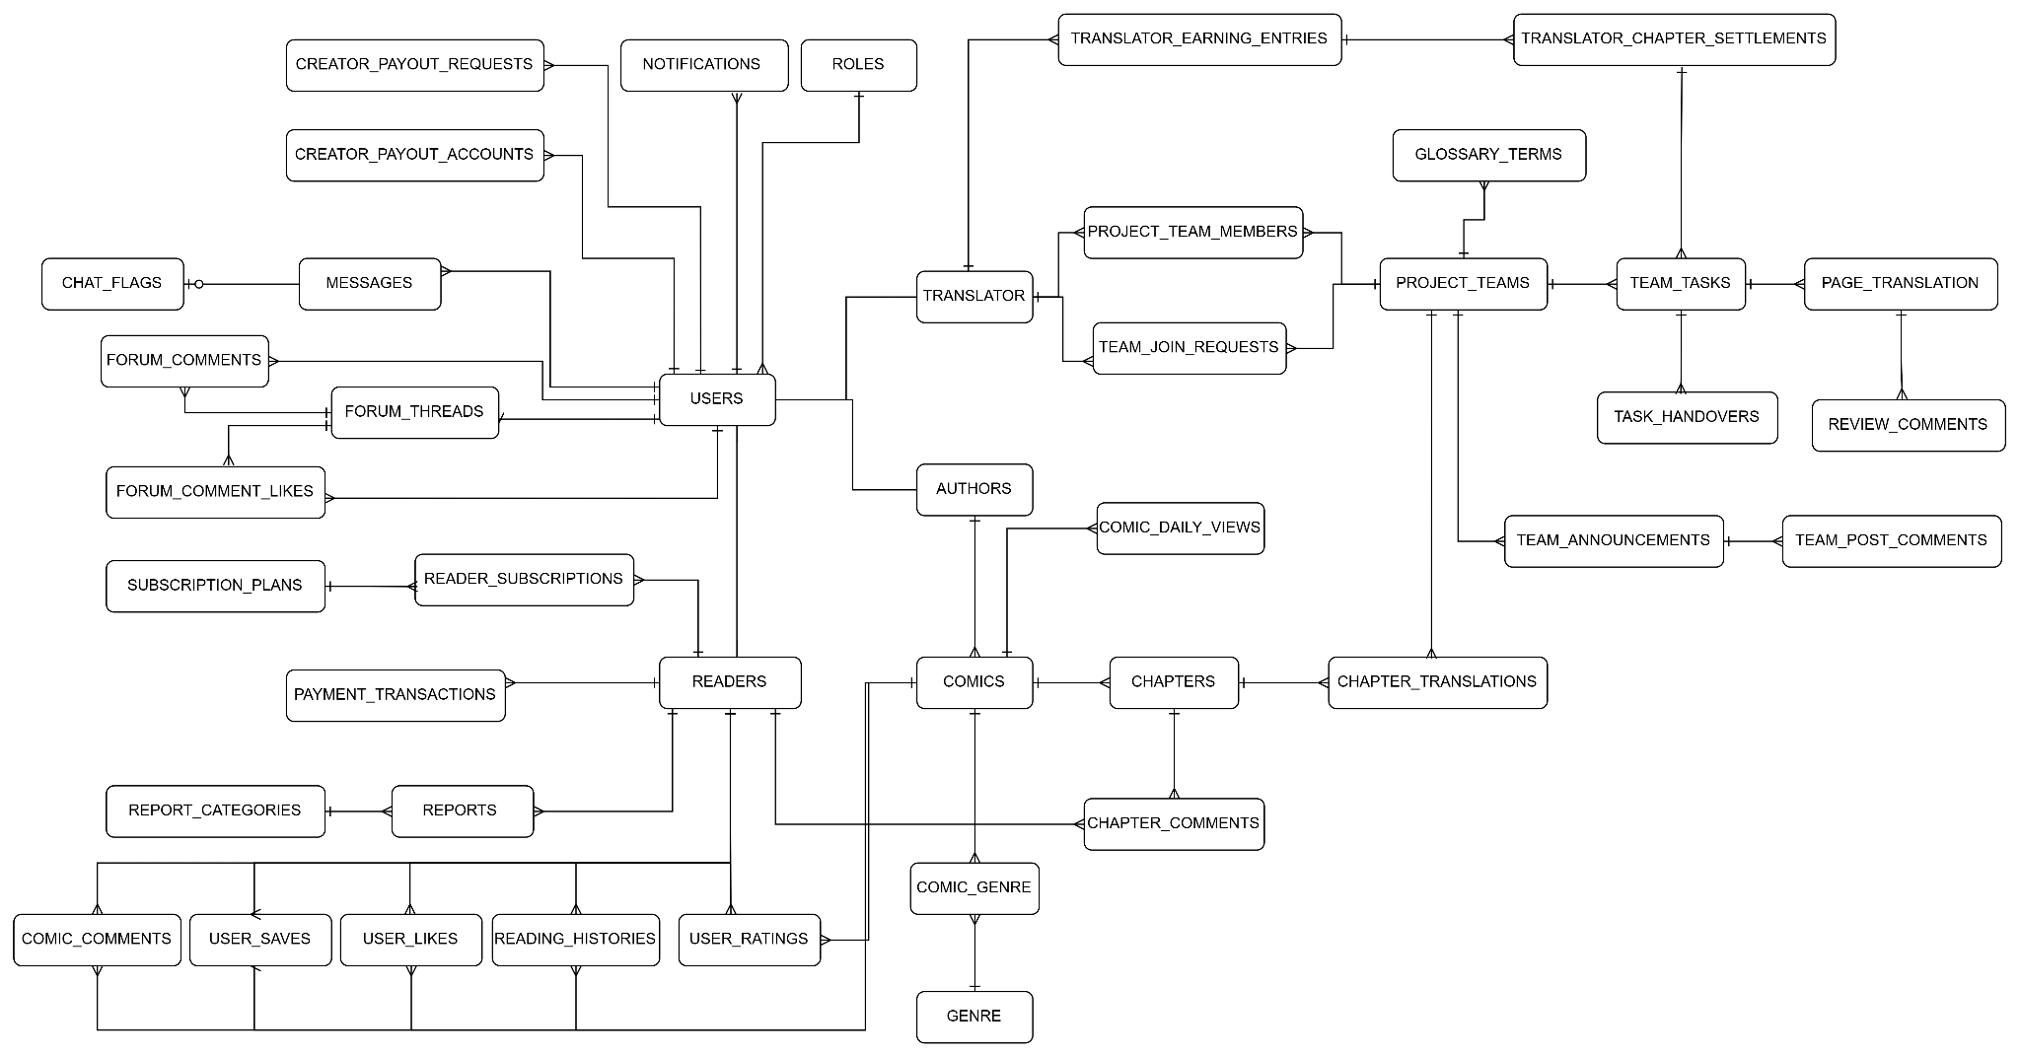

Entity | Purpose (one sentence) | Key Relationships | Full Attributes
USER | Stores core system identity credentials, secure authentication vectors, access role flags, and soft-delete states for all platform participants. | USER --< USER_ROLE  USER -- READER_PROFILE (1:1)  USER -- AUTHOR_PROFILE (1:1)  USER -- TRANSLATOR_PROFILE (1:1)  USER -- MODERATOR_PROFILE (1:1)  USER -- ADMIN_PROFILE (1:1)  USER --< COMMENT  USER --< FORUM_THREAD  USER --< FORUM_COMMENT  USER --< CHAT_MESSAGE  USER --< REPORT_TICKET  USER --< CHAPTER_REPORT  USER --< NOTIFICATION | RTW.xlsx Sheet 5
ROLE | Defines distinct groups of functional access permissions within the system to enforce the RBAC security framework. | ROLE --< USER_ROLE  ROLE --< ROLE_PERMISSION | RTW.xlsx Sheet 5
PERMISSION | Stores explicit granular action tokens allowed to be executed on specific system resources. | PERMISSION --< ROLE_PERMISSION | RTW.xlsx Sheet 5
USER_ROLE | Acts as a many-to-many junction bridge mapping individual users to their respective assigned system roles. | USER_ROLE >-- USER  USER_ROLE >-- ROLE | RTW.xlsx Sheet 5
ROLE_PERMISSION | Acts as a many-to-many junction bridge aggregating structural permission sets into specific role categories. | ROLE_PERMISSION >-- ROLE  ROLE_PERMISSION >-- PERMISSION | RTW.xlsx Sheet 5
READER_PROFILE | Extends the base user entity with consumer-centric preferences, layout settings, and metrics tailored for the reader interface. | READER_PROFILE -- USER (1:1)  READER_PROFILE --< BUYING  READER_PROFILE --< READING_PROGRESS  READER_PROFILE --< BOOKMARK  READER_PROFILE --< RATING  READER_PROFILE --< COMIC_LIKE  READER_PROFILE --< SUBSCRIPTION | RTW.xlsx Sheet 5
AUTHOR_PROFILE | Holds verified creator identities, public pen names, and legal contract status configurations for content upload and monetization. | AUTHOR_PROFILE -- USER (1:1)  AUTHOR_PROFILE --< COMIC  AUTHOR_PROFILE --< WITHDRAW_CASH | RTW.xlsx Sheet 5
TRANSLATOR_PROFILE | Manages localized profiles, primary/secondary translation dialects, and historical output statistics for community localizers. | TRANSLATOR_PROFILE -- USER (1:1)  TRANSLATOR_PROFILE --< PARTICIPATING  TRANSLATOR_PROFILE --< LOCALIZATION_TASK  TRANSLATOR_PROFILE --< PROJECT_CHAT_MESSAGE  TRANSLATOR_PROFILE --< WITHDRAW_CASH | RTW.xlsx Sheet 5
MODERATOR_PROFILE | Stores internal operational details, assigned monitoring scopes, and performance metrics for content review staff. | MODERATOR_PROFILE -- USER (1:1)  MODERATOR_PROFILE --< REPORT_TICKET  MODERATOR_PROFILE --< CHAPTER_REPORT | RTW.xlsx Sheet 5
ADMIN_PROFILE | Restricts superuser administrative tiers, emergency contact channels, and system-wide security clearance clearances. | ADMIN_PROFILE -- USER (1:1) | RTW.xlsx Sheet 5
COMIC | Serves as the central repository managing descriptive metadata, global interaction analytics, and publication status for an IP series. | COMIC >-- AUTHOR_PROFILE  COMIC --< CHAPTER  COMIC --< COMIC_GENRE  COMIC --< TRANSLATION_PROJECT  COMIC --< BOOKMARK  COMIC --< RATING  COMIC --< COMIC_LIKE  COMIC --< COMMENT  COMIC --< BUYING | RTW.xlsx Sheet 5
GENRE | Maintains a clean dictionary of categorization tags for comic indexing, filtering layout mechanisms, and search engines. | GENRE --< COMIC_GENRE | RTW.xlsx Sheet 5
COMIC_GENRE | Maps the multi-classification relationship connecting specific comic titles to their relevant structural categories. | COMIC_GENRE >-- COMIC  COMIC_GENRE >-- GENRE | RTW.xlsx Sheet 5
CHAPTER | Records individual serialized volume releases, handling chronological numbering, paywall states, and isolation metrics. | CHAPTER >-- COMIC  CHAPTER --< CHAPTER_PAGE  CHAPTER --< READING_PROGRESS  CHAPTER --< CHAPTER_REPORT  CHAPTER --< BUYING | RTW.xlsx Sheet 5
CHAPTER_PAGE | Manages exact file storage location paths, processing sequence indexes, and precise image dimensions for digital pages. | CHAPTER_PAGE >-- CHAPTER  CHAPTER_PAGE --< LOCALIZATION_TASK | RTW.xlsx Sheet 5
TRANSLATION_PROJECT | Manages the collaborative lifecycle and progress mapping of translating a specific comic into an individual target language. | TRANSLATION_PROJECT >-- COMIC  TRANSLATION_PROJECT --< PARTICIPATING  TRANSLATION_PROJECT --< LOCALIZATION_TASK  TRANSLATION_PROJECT --< PROJECT_CHAT_MESSAGE | RTW.xlsx Sheet 5
PARTICIPATING | Matches team roles, system access rights, and joining logs of community translators within an active translation hub. | PARTICIPATING >-- TRANSLATION_PROJECT  PARTICIPATING >-- TRANSLATOR_PROFILE | RTW.xlsx Sheet 5
PROJECT_CHAT_MESSAGE | Holds isolated project-bound conversation logs exchanged between localization team participants for task alignment. | PROJECT_CHAT_MESSAGE >-- TRANSLATION_PROJECT  PROJECT_CHAT_MESSAGE >-- TRANSLATOR_PROFILE | RTW.xlsx Sheet 5
LOCALIZATION_TASK | Breaks page assets down into modular processing queues, assigning distinct phases like raw cleaning or typesetting. | LOCALIZATION_TASK >-- TRANSLATION_PROJECT  LOCALIZATION_TASK >-- CHAPTER_PAGE  LOCALIZATION_TASK >-- TRANSLATOR_PROFILE | RTW.xlsx Sheet 5
BUYING | Records transactional token financial ledgers, tracking exact content authorization scopes purchased by profile balances. | BUYING >-- READER_PROFILE  BUYING >-- COMIC  BUYING >-- CHAPTER | RTW.xlsx Sheet 5
READING_PROGRESS | Persists real-time bookmark telemetry, tracking scroll coordinate save points to enable across-device synchronization. | READING_PROGRESS >-- READER_PROFILE  READING_PROGRESS >-- CHAPTER | RTW.xlsx Sheet 5
BOOKMARK | Links customer profile libraries to chosen catalog titles, setting up automatic release push notification parameters. | BOOKMARK >-- READER_PROFILE  BOOKMARK >-- COMIC | RTW.xlsx Sheet 5
RATING | Locks singular qualitative assessment scores submitted per reader, calculating system-wide score weight averages. | RATING >-- READER_PROFILE  RATING >-- COMIC | RTW.xlsx Sheet 5
COMIC_LIKE | Registers quick consumer upvote expressions used to inform algorithmic recommendation feeds and rankings. | COMIC_LIKE >-- READER_PROFILE  COMIC_LIKE >-- COMIC | RTW.xlsx Sheet 5
COMMENT | Manages a polymorphic text thread under comics, incorporating self-referential keys to support infinitely nested trees. | COMMENT >-- USER  COMMENT >-- COMIC | RTW.xlsx Sheet 5
FORUM_THREAD | Houses primary discussion headlines, main text data payloads, and access parameters for public forum categories. | FORUM_THREAD >-- USER  FORUM_THREAD --< FORUM_COMMENT | RTW.xlsx Sheet 5
FORUM_COMMENT | Contains sequentially indexed linear discussion responses posted inside an established board category thread. | FORUM_COMMENT >-- FORUM_THREAD  FORUM_COMMENT >-- USER | RTW.xlsx Sheet 5
CHAT_MESSAGE | Stores direct, encrypted peer-to-peer text records exchanged privately between distinct system accounts. | CHAT_MESSAGE >-- USER (Sender)  CHAT_MESSAGE >-- USER (Receiver) | RTW.xlsx Sheet 5
REPORT_CATEGORY | Defines standardized lookups for reporting classifications, regulating staff prioritization rules. | REPORT_CATEGORY --< REPORT_TICKET  REPORT_CATEGORY --< CHAPTER_REPORT | RTW.xlsx Sheet 5
REPORT_TICKET | Receives cross-entity abuse complaints via polymorphic mapping configurations, tracking automated routing queues. | REPORT_TICKET >-- USER (Reporter)  REPORT_TICKET >-- REPORT_CATEGORY  REPORT_TICKET >-- MODERATOR_PROFILE | RTW.xlsx Sheet 5
CHAPTER_REPORT | Isolates direct quality complaints tied to specific asset rendering faults like corrupted images or broken files. | CHAPTER_REPORT >-- USER (Reporter)  CHAPTER_REPORT >-- CHAPTER  CHAPTER_REPORT >-- REPORT_CATEGORY  CHAPTER_REPORT >-- MODERATOR_PROFILE | RTW.xlsx Sheet 5
NOTIFICATION | Drives internal messaging payloads, account alerts, system dispatches, and transactional receipts to client views. | NOTIFICATION >-- USER | RTW.xlsx Sheet 5
WITHDRAW_CASH | Audits legal payout procedures initiated by creative partners converting accrued wallet tokens into verified bank wires. | WITHDRAW_CASH >-- AUTHOR_PROFILE  WITHDRAW_CASH >-- TRANSLATOR_PROFILE | RTW.xlsx Sheet 5
SUBSCRIPTION | Manages VIP system tier authorization layers, validating premium access expirations across protected catalogs. | SUBSCRIPTION >-- READER_PROFILE

5.2 Data Constraints & Integrity Rules
ID | Constraint | Entities Affected | Violation Behaviour
DC-01 | Unique email and username | USER | Rejects registration / update; returns "Account already exists" error.
DC-02 | Valid foreign key mappings | All entities with FK fields | Rejects insertion or update; throws a database integrity exception.
DC-03 | Cascade deletion on profiles and utilities | USER, READER_PROFILE, AUTHOR_PROFILE, TRANSLATOR_PROFILE, MODERATOR_PROFILE, ADMIN_PROFILE, NOTIFICATION | Automatically purges or soft-deletes profile subtypes and alerts when the master user is deleted.
DC-04 | Valid score range (Scale: 1 to 5) | RATING | Restricts rating action; returns an out-of-bounds input error.
DC-05 | Parent comment must exist or be null | COMMENT | Blocks comment posts if the parent_comment_id does not map to a valid COMMENT.id.
DC-06 | Unique translation project per language | TRANSLATION_PROJECT | Prevents duplicate project creation for the same comic and target language.
DC-07 | Non-negative numeric metrics & financials | COMIC, CHAPTER, BUYING, WITHDRAW_CASH, SUBSCRIPTION | Rejects financial values, token amounts, or metric counters below zero.
DC-08 | Restrict task assignment to project members | LOCALIZATION_TASK, PARTICIPATING | Aborts assignment if the target translator_id does not hold an active row in the project's member registry.
DC-09 | Single Rating per Reader-Comic Pair | RATING | Rejects secondary rating inserts; throws a unique constraint violation exception.
DC-10 | Single Bookmark per Reader-Comic Pair | BOOKMARK | Prevents duplicate library tracking configurations; quietly returns success or ignores duplicate.

5.3 Data Retention & Ownership Policy
Data Type | Retention Period | Owner | Deletion Authority | Basis
User Accounts & Profiles | USER, USER_ROLE, ROLE_PERMISSION, READER_PROFILE, AUTHOR_PROFILE, TRANSLATOR_PROFILE, MODERATOR_PROFILE, ADMIN_PROFILE | 3 years after account closure or inactivity; personal data may be anonymized earlier upon valid user request. | Individual User / Platform Admin | User via request / System Admin / Automated Purge Job
Financial & Payout Data | BUYING, WITHDRAW_CASH, SUBSCRIPTION | 7 to 10 years depending on applicable tax, fiscal, and platform audit requirements. | Platform Finance Department | Immutable ledger; archived into cold storage, no manual deletion permitted.
Creator Content & Assets | COMIC, GENRE, COMIC_GENRE, CHAPTER, CHAPTER_PAGE | Indefinite while actively published or contractually active; may be unpublished or archived after valid removal request. | Author / Platform Operations | Author Request / Platform Moderator / System Admin
Localization Workspaces | TRANSLATION_PROJECT, PARTICIPATING, LOCALIZATION_TASK | Indefinite while the associated translation project is active; archived 1 year after project completion or abandonment. | Translation Team / Platform Operations | Project Leader / Translation Moderator / Automated System Cron
Social & Community Activity | COMMENT, FORUM_THREAD, FORUM_COMMENT | Indefinite while the parent thread or comic remains published; content is soft-deleted or masked as "[Deleted User]" upon user deletion. | Individual Poster / Community Moderator | User via UI delete / Community Moderator / Automated Flagging System
Ephemeral Communications | CHAT_MESSAGE, PROJECT_CHAT_MESSAGE | 30 to 90 days maximum on-disk availability; automatically purged sequentially by age. | Chat Participants / System Infrastructure | Automated Purge Job / System Infrastructure
Compliance & Moderation Logs | REPORT_CATEGORY, REPORT_TICKET, CHAPTER_REPORT, NOTIFICATION | 5 years post-resolution to evaluate repeated offenses and defend against platform liability claims. | Platform Trust & Safety Department | System Admin / Security Officer / Automated Retention Manager

Part 6 — Business Rules
BR ID | Description
BR-01 | Unregistered, Banned, or Inactive account profiles are strictly prohibited from authenticating; login access is restricted exclusively to Active account profiles.
BR-02 | Unauthenticated users (unlogged or expired session token) are restricted exclusively to viewing public pages and home content; API calls to private endpoints, personal profiles, moderation, and payment gateways are strictly prohibited.
BR-03 | Logout requests are permitted only upon presentation of a valid active session token, triggering mandatory token revocation and client cache purge.
BR-04 | Accounts locked out due to failed login attempts remain strictly blocked for a mandatory 15-minute duration; failed attempt counters are reset to zero only after the full 15-minute lockout period expires.
BR-05 | 100% of source code, database identifiers, comments, and UI strings must strictly use standard English; hardcoded non-English characters or locale strings are strictly prohibited.
BR-06 | Personal profile management features are accessible exclusively under a valid, active session token; unauthorized or unauthenticated requests are rejected immediately.
BR-07 | Bio strings must not exceed 500 characters and avatar uploads are restricted to standard formats (JPG/PNG/WEBP) under 5MB; non-compliant submissions are strictly rejected.
BR-08 | Password modification requests mandate successful verification of the existing active password before persisting new credentials.
BR-09 | Email OTP tokens expire after a strict 5-minute window; expired tokens are rendered permanently invalid.
BR-10 | Email OTP re-transmission is capped at a maximum of 3 requests per 15-minute interval per target email address to prevent abuse.
BR-11 | Comic catalog filtering supports multi-criteria queries across keyword tokens, genre tags, content tags, and publication statuses (Ongoing, Completed).
BR-12 | Public catalog and search result views enforce strict pagination capped at a maximum of 20 comic records per page.
BR-13 | Comic detail views display full series metadata, creator attributes, chapter indices, and trigger view-counter increments only upon verified reader chapter loads.
BR-14 | The comic reader interface dynamically renders chapter images in continuous vertical scroll (Webtoon) or horizontal page flip modes according to reader preferences.
BR-15 | Chapter image assets must load sequentially in full; asset fetch failures mandate displaying an inline retry action.
BR-16 | Authors or Translation Teams can initiate Payout Profile setup only after completing mandatory identity verification and linking valid banking details.
BR-17 | Beneficiary banking credentials provided during payout setup must strictly match verified user identity records.
BR-18 | UI locale switching renders translated interface text dynamically without mutating underlying domain data models or canonical identifiers.
BR-19 | Reading progress states (last chapter read, scroll offset) auto-synchronize to cloud persistence on page navigation or reader teardown.
BR-20 | Personal library bookmarks are capped at a maximum of 500 saved comic series per user account.
BR-21 | Reading history management permits readers to prune single entries or clear their entire personal reading history log.
BR-22 | Reading history automatically logs and retains a maximum of 100 recently read comic series per user account.
BR-23 | Personalized feed feeds aggregate comic recommendations evaluated against user reading logs, preferred genres, and recent interactions.
BR-24 | Project Leaders hold full authority to assign, reassign, or revoke translation task deadlines across team members.
BR-25 | Translators hold update permissions restricted exclusively to translation task records assigned directly to them.
BR-26 | In-progress translation text and typesetting edits trigger automatic local draft auto-saves at mandatory 2-minute intervals.
BR-27 | Authors hold creation and edit privileges strictly over comic series explicitly registered to their own Author profile.
BR-28 | Comic series titles must be unique across the platform and free from blacklisted offensive or restricted terminology.
BR-29 | Chapter creation mandates attaching the chapter to a valid owned comic series and assigning a strictly sequential positive chapter number.
BR-30 | The moderation publish queue enforces First-In, First-Out (FIFO) evaluation ordering based on submission timestamps.
BR-31 | Series ratings (1 to 5 stars) and Likes are restricted to a single vote per registered account per series, allowing subsequent score edits.
BR-32 | User comments must adhere to a length between 5 and 1000 characters and are automatically scanned to reject malicious URLs or blacklisted profanity.
BR-33 | Authors of personal comments retain edit and deletion privileges for a strict window of 24 hours post-creation.
BR-34 | Forum thread creation requires selecting a valid sub-forum category and providing a title between 10 and 200 characters.
BR-35 | Forum posts accumulating over 5 unique user reports trigger automatic transition to a hidden state pending Moderator review.
BR-36 | Moderators hold administrative privileges to lock, pin, hide, or permanently delete policy-violating forum posts.
BR-37 | Notification preference settings permit users to toggle email and push alerts independently across event categories.
BR-38 | Abuse reporting mandates selecting a valid violation category and supplying a explanatory description of at least 10 characters.
BR-39 | Report tickets mandate resolution (Actioned or Dismissed) and audit response dispatch by a Moderator within 48 hours.
BR-40 | System-wide broadcast announcements are restricted exclusively to Admin role execution.
BR-41 | Subscription plan benefits activate instantaneously upon verified gateway transaction confirmation.
BR-42 | VIP subscription entitlements persist strictly for the purchased duration (30, 90, 365 days) and expire automatically at term end.
BR-43 | Revenue payout requests trigger eligibility validation requiring accrued balance to meet or exceed the minimum threshold (e.g. 500,000 VND).
BR-44 | Approved revenue payout requests execute during fixed recurring settlement windows (15th and 30th of each month).
BR-45 | Transaction history logs render itemized records of transaction ID, timestamp, monetary value, payment rail, and status.
BR-46 | User registration requires a unique unregistered email address and a password fulfilling strict policy BR-146.
BR-47 | Content performance metrics (views, likes, ratings) recalculate and refresh hourly.
BR-48 | Revenue statistics break down earnings from VIP reads, donations, and royalties across configurable date ranges.
BR-49 | Analytics reporting tools support exporting aggregated system and content data to CSV and XLSX formats.
BR-50 | System taxonomy definitions (Genres, Tags) are managed exclusively by Moderators and Admins.
BR-51 | Admins hold global privileges to modify user roles, issue account bans, or reactivate suspended accounts.
BR-52 | Subscription pricing tiers are configured exclusively by Admins and apply to new subscription purchases post-update.
BR-53 | Community chat messages are capped at 500 characters and rate-limited to 1 message per 2 seconds per user.
BR-54 | Translation project team chat messages are private to active team members and logged permanently for project history.
BR-55 | Members leaving or removed from a translation project team immediately forfeit all team workspace access and asset permissions.
BR-56 | Translation teams mandate at least 1 designated Project Leader; Leader removal is blocked unless a successor Leader is designated.
BR-57 | Moderation of published content allows Moderators to unpublish or restrict access to copyright-infringed or illegal comic assets.
BR-58 | Executed payouts transition to Paid status and trigger an automated email receipt to the recipient.
BR-59 | Password reset flows issue time-limited signed verification tokens via email expiring after 15 minutes.
BR-60 | Moderation of community chat enables Moderators to purge messages and temporarily mute offending users (1 hour to 7 days).
BR-61 | Translation project glossaries are managed by Project Leaders, with Translators permitted to propose new term entries.
BR-62 | Translator role applications require submitting sample work and are reviewed by Moderators or Admins within 3 business days.
BR-63 | Team join requests require explicit Project Leader approval before granting project workspace membership.
BR-64 | Reader profiles applying for Freelance Translator status must complete identity verification and sign platform terms.
BR-65 | Project Leaders can claim unassigned translation projects subject to team level and capacity requirements.
BR-66 | Completed chapter translations must be submitted for review before becoming eligible for publication queue processing.
BR-67 | Project Leaders hold exclusive authority to approve submitted translations or request revisions.
BR-68 | Authors can submit moderation appeals within 7 days of receiving a content restriction or takedown notice.
BR-69 | Team announcements are published by Project Leaders and visible exclusively to internal team members.
BR-70 | Translation task handovers require mutual agreement between the assigned Translator, replacement Translator, and Project Leader approval.
BR-71 | Uploaded chapter page images must maintain a minimum width of 800px and a file size under 10MB per image.
BR-72 | Accepted chapter image file formats are strictly limited to JPG, JPEG, PNG, and WEBP.
BR-73 | Scheduled publication allows Authors or Team Leaders to set future publication timestamps for approved chapters.
BR-74 | Scheduled chapters automatically transition to Public status when the system clock matches or exceeds the scheduled timestamp.
BR-75 | Following a comic series registers the user for automated push and email notifications upon new chapter releases.
BR-76 | The followed comics list tracks unread chapter counts dynamically for each saved series in the user library.
BR-77 | Recent search history stores up to 10 recent search queries per user session or account.
BR-78 | Average rating scores compute the arithmetic mean of all valid user ratings rounded to 1 decimal place.
BR-79 | Total series view counts represent the cumulative sum of verified reader views across all published chapters in the series.
BR-80 | View count increments per reader per chapter are debounced to at most 1 increment per 30-minute window.
BR-81 | Comment filtering masks profane words automatically with asterisks (***) or flags them for manual moderation review.
BR-82 | Commenting rate limits block users sending more than 5 comments within a 60-second window.
BR-83 | Rich media attachments in forum posts require user accounts to hold a minimum community interaction tier.
BR-84 | Forum image attachments are capped at 3MB per image and a maximum of 5 images per forum post.
BR-85 | Non-critical email notifications are capped at a maximum of 5 emails per user per day to prevent spamming.
BR-86 | Resolved report tickets send automated status updates to the reporting user outlining the moderation outcome.
BR-87 | Pending payment checkout sessions expire automatically after 15 minutes of inactivity.
BR-88 | Promo vouchers are limited to 1 voucher code application per checkout transaction.
BR-89 | Discount vouchers enforce configured expiration dates, global usage limits, and maximum discount caps.
BR-90 | Royalty revenue sharing calculates author and translator revenue splits according to platform contract rates.
BR-91 | Eligible payout balances reflect cleared earnings past the mandatory 7-day security hold period.
BR-92 | Administrative and moderation actions (bans, takedowns, role edits, payouts) generate immutable Audit Log records.
BR-93 | Audit Log records store operator user ID, IP address, timestamp, action type, and before/after state snapshots.
BR-94 | System configuration parameters (service fees, payout thresholds, hold periods) are managed exclusively by Admins.
BR-95 | User passwords must be hashed using strong one-way algorithms (Bcrypt/Argon2) prior to database storage.
BR-96 | Five consecutive failed login attempts trigger mandatory CAPTCHA challenges or temporary 15-minute lockouts.
BR-97 | User sessions persist for 7 days when "Remember Me" is enabled, or 24 hours for standard sessions.
BR-98 | Overdue translation tasks exceeding deadlines more than 3 times in a month reduce translator reliability scores.
BR-99 | Translation tasks overdue by 48 hours without active translator progress automatically unassign for reassignment.
BR-100 | Completed comic series cannot accept new chapter uploads unless explicitly reopened by the Author or Admin.
BR-101 | Comments hidden by Authors or Project Leaders are suppressed from general public view.
BR-102 | Forum threads must be categorized under a valid sub-forum section matching the thread topic.
BR-103 | Forum thread authors or Moderators can lock threads to prevent new replies.
BR-104 | User blocking prevents blocked accounts from messaging, commenting, or interacting with the blocking user.
BR-105 | Personal block lists are managed in User Account Privacy Settings.
BR-106 | Subscription payment gateways support local options (VNPAY, MoMo) and international card networks (Visa/Mastercard).
BR-107 | Payout transfers deduct applicable payment gateway transaction fees from the net disbursement amount.
BR-108 | Payout history details request amounts, fee deductions, net payout, and bank reference numbers.
BR-109 | Read analytics support filtering by chapter, reader country, language, and device category.
BR-110 | Daily revenue and read metric aggregations freeze at 23:59:59 UTC+7 daily.
BR-111 | Platform backup tools allow Admins to export encrypted database snapshots for disaster recovery.
BR-121 | Newly registered accounts must complete email verification (BR-04) before unlocking interactive features (Comments, Ratings, Forum).
BR-122 | Search input queries sanitize special characters to prevent SQL Injection and XSS vulnerabilities.
BR-123 | The comic reader auto-saves reader scroll position when navigating away or closing the browser.
BR-124 | Forum thread listings support sorting by Newest, Most Recent Reply, or Most Viewed.
BR-125 | In-app notifications automatically mark as read when clicked by the user.
BR-126 | Closed report tickets cannot be reopened; new policy violations require filing a new report ticket.
BR-127 | Expired VIP subscriptions revert user accounts to Free tier status instantly.
BR-128 | Rejected payout requests mandate a rejection reason and automatically credit held funds back to the user's withdrawable balance.
BR-129 | Performance analytics render trend charts in line or bar chart formats.
BR-130 | Content tags must contain only alphanumeric characters or hyphens and range from 2 to 30 characters in length.
BR-131 | Banned user accounts trigger instant session revocation across all active authenticated devices.
BR-132 | Premium subscription pricing tiers must be configured between a minimum of 10,000 VND and a maximum of 10,000,000 VND.
BR-133 | Public chat logs automatically purge messages older than 30 days.
BR-134 | Project Leaders can toggle translation project visibility between Public (Recruiting) and Private.
BR-135 | Content moderation tools enable Moderators to restore accidentally unpublished comics or chapters.
BR-136 | Payout requests in Processing state cannot be cancelled by the requester.
BR-137 | Password changes trigger an automated security notification email to the account owner.
BR-138 | Chat mute actions require Moderators to select a predefined violation reason or log custom justification notes.
BR-139 | Translation glossaries support import and export in XLSX spreadsheet format.
BR-140 | Rejected Translator applicants must wait a mandatory 14-day cooldown period before reapplying.
BR-141 | Pending team join requests auto-expire if left unacted for 7 days by the Project Leader.
BR-142 | Freelance Translators can showcase verified platform translation contributions on their public portfolio page.
BR-143 | Translation teams are restricted to claiming at most 5 active concurrent translation projects.
BR-144 | Task status COMPLETED can only be attained via formal review approval flow; direct status mutations to COMPLETED are strictly blocked.
BR-145 | Comic Liking operates as a single toggle per Reader per comic; duplicate like records are strictly blocked by unique constraints.
BR-146 | Password policy mandates a minimum length of 8 characters containing at least 1 uppercase letter, 1 lowercase letter, 1 digit, and 1 special character.
BR-147 | A Translator profile is restricted to holding active membership in at most 20 translation project teams concurrently.
BR-148 | A Translator profile is restricted to holding at most 10 active incomplete translation task assignments concurrently.

Part 7 — Non-Functional Requirements

7.1 Performance
ID | Requirement | Condition | Priority
NFR-01 | Comic chapter pages must load efficiently. | A user clicks to open a chapter (target < 3 seconds). | NFR-01
NFR-09 | Search results for comics must return efficiently. | A user submits a keyword search query (target < 2 seconds). | NFR-09
NFR-13 | Image assets must be optimized for fast loading. | Loading comic page images (images are compressed and delivered in WebP). | NFR-13
NFR-18 | Static assets (images, CSS) must load fast. | Page initial render (target < 1.5 seconds asset load). | NFR-18
NFR-19 | Reading progress syncing must not flood the database. | Continuous user scrolling (requests are limited/debounced on client side). | NFR-19
NFR-28 | Large chapter uploads must be processed asynchronously without blocking the request. | Author uploads a chapter folder containing multiple page images (API returns HTTP 202 instantly). | NFR-28
NFR-32 | List APIs must prevent excessively large page requests. | Client requests a very large page size (capped at ≤ 100 records per request). | NFR-32

7.2 Scalability
ID | Requirement | Notes
NFR-02 | The system shall support a large volume of uploaded comic chapters. | At least 1,000 chapters are stored in the database.
NFR-11 | The system shall handle multiple API requests executed within a short period. | Multiple simulated requests are sent rapidly to the same API resources.

7.3 Availability & Reliability
ID | Requirement | Notes
NFR-05 | Translation progress must not be lost during temporary disconnection. | Translator saving draft while offline (data cached locally, synced on reconnection).
NFR-06 | Comic services must remain active during usage. | Regular user browsing and interaction (stable system performance without crashes).
NFR-14 | Database backup can be triggered easily. | Manual backup trigger by an admin (successful export of .sql file).
NFR-21 | Financial and points transactions must be fully processed or rolled back. | Simulating failed database step during purchase (no partial balance deduction).
NFR-26 | Creator payout processing must prevent duplicated payouts under concurrent requests. | Two Admin requests attempt to process the same payout simultaneously (at most one successful transfer).
NFR-27 | Comic and chapter reading must remain available when Redis is temporarily unavailable. | Redis connection is stopped (comics loaded successfully from PostgreSQL).
NFR-30 | External push notification failure must not rollback a successfully completed business operation. | Firebase is unavailable after a business operation (DB commit successful, FCM failure logged for retry).

7.4 Security
ID | Requirement | Notes
NFR-03 | Users must not access premium chapters without subscription. | Unauthorized access attempt via direct URL (100% blocked/redirected).
NFR-10 | Translation versions must not be published before Project Leader approval. | Translator attempts to bypass workflow (blocked by Role-Based Access Control).
NFR-15 | User passwords must be encrypted at rest. | Checking raw data in the users table (passwords stored as bcrypt/Argon2 hashes).
NFR-20 | API endpoints must validate token expiration. | Request with expired/cleared token (returns 401 Unauthorized).
NFR-23 | Enforce strict file upload constraints. | Author uploads >50MB chapter or unsupported format (rejected instantly).
NFR-24 | API rate limiting to prevent spam. | User posts 5 comments in 5s (returns 429 Too Many Requests on the 6th request).
NFR-25 | Stripe webhook requests must be authenticated and processed idempotently. | Invalid signature or duplicated Stripe event (invalid rejected, 0 duplicate transactions created).
NFR-29 | Real-time WebSocket connections and protected subscriptions must require valid authorization. | User connects without JWT or subscribes to unauthorized topic (returns 401 / 403).
NFR-31 | OTP verification and resend endpoints must resist brute-force and repeated requests. | Maximum 5 invalid attempts before lock; 60-second cooldown for resend (returns 429).
NFR-33 | Critical moderation and administrative actions must be traceable. | Moderator/Admin modifies controlled content (critical action records logged with actor ID).

7.5 Usability
ID | Requirement | Notes
NFR-04 | Users must easily navigate comic categories and chapters. | First-time user interaction (target chapter reachable within 3 clicks).
NFR-12 | Reader must support dark mode and customizable font sizes. | User adjusting reading settings (settings applied instantly in browser via LocalStorage).
NFR-16 | The system must support multiple languages. | User switching language preferences (interface updated immediately).
NFR-22 | Dashboard layouts must toggle theme contexts smoothly. | User toggles theme button (styles update globally without page reload).

7.6 Maintainability
ID | Requirement | Notes
NFR-07 | The source code shall follow a clear, modular, and separated structure. | Developers add new features, modify existing functions, or fix defects.
NFR-17 | Core business logic shall be covered by automated tests. | Backend and frontend test suites are executed locally or through the development pipeline.

7.7 Compliance
ID | Requirement | Regulatory Basis
NFR-08 | The comic reader shall function correctly across supported desktop and mobile browsers. | The reader is accessed using Chrome, Microsoft Edge, Safari, or a supported mobile browser.

Appendices

Appendix A — RTW Reference
Sheet 1: Overview Dashboard — Summary metrics of requirements, test coverage, and project health.
Sheet 2: Use Case List — The master register of all 44 Use Cases .
Sheet 3: Feature Traceability — The bidirectional mapping of Features to Epics, Use Cases, and DB Entities.
Sheet 4: Permission Matrix — Role-based Access Control mapping for Admin, Moderator, Project Leader, Translator, Author, Reader, and Guest.
Sheet 5: Data Dictionary — Database schema definitions and primary data entity structures.
Sheet 6: Business Rules Register — The central repository of all system integrity, financial transaction, and copyright rules
Sheet 7: NFR Tracker — The tracking index of Non-Functional Requirements.

Appendix B — Diagram Index
Diagram | Type | Referenced in | Source File
System Context Diagram | Context | Part 1 — Introduction | ComiVerse_Context.drawio
System Use Case Diagram | Use Case | Part 2 — System Use Cases | ComiVerse_UseCase.drawio
Authentication Flow | Activity / Scenario | Part 3 — Module Description | ComiVerse_Auth_Activity.drawio
Comic Submission Pipeline | Activity / Scenario | Part 3 — Module Description | ComiVerse_Submission_Activity.drawio
Moderation Gate Lifecycle | State Machine | Part 3 — Module Description | ComiVerse_Moderation_State.drawio
Translation Project Workspace | Activity / Scenario | Part 3 — Module Description | ComiVerse_Workspace_Activity.drawio
Token Transaction & Rollback | Sequence / Activity | Part 3 — Module Description | ComiVerse_Transaction_Sequence.drawio
Screen Flow |  | Part 3 - Module Decription | ComiVerse_ScreenFlow
Database Entity Relationship | ERD | Part 4 — Data Design | ComiVerse_ERD.drawio

